FFGC History—Our 9th Decade 2005-2014
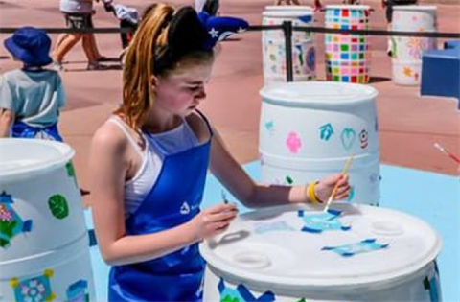
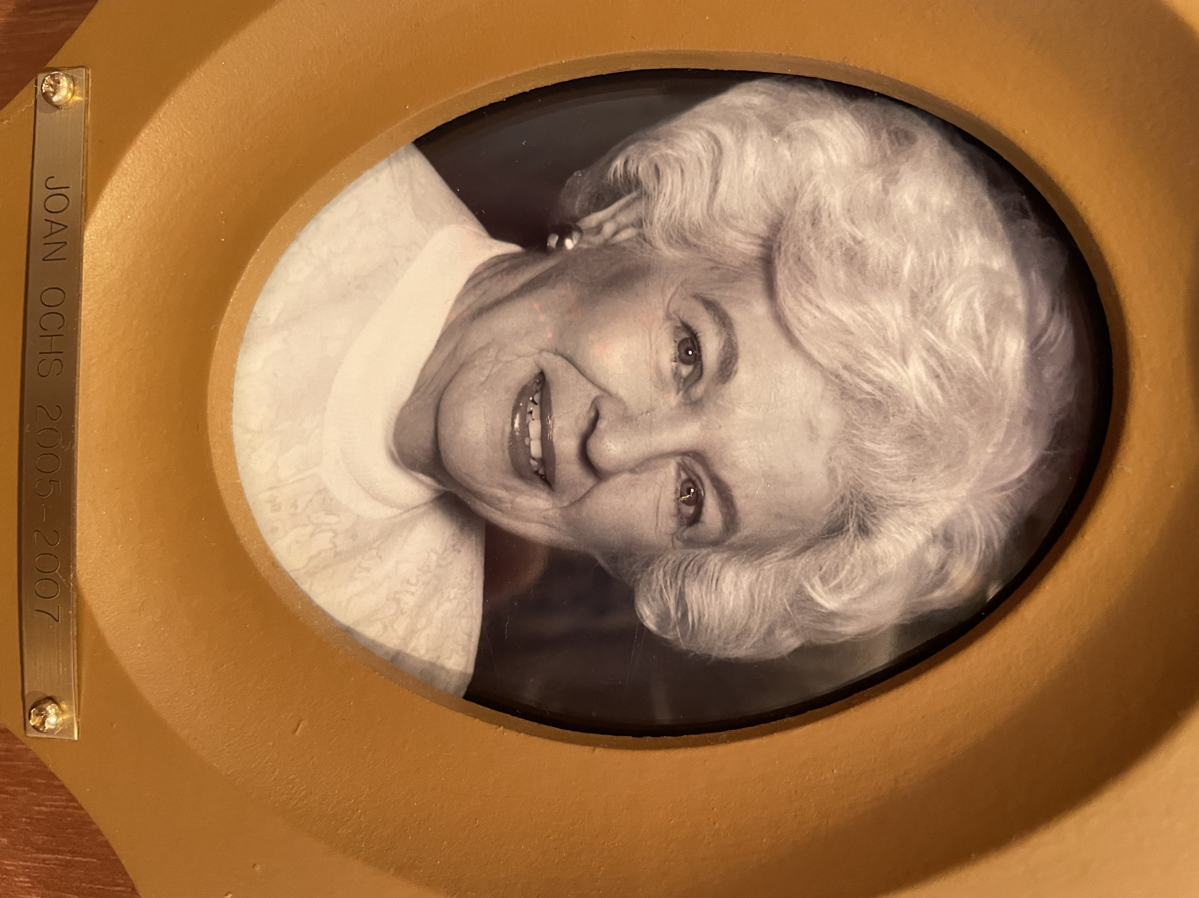
President Joan Ochs, 2005-2007, chose as her theme 'Keys to Harmony'. Membership was 16,122. During this administration, several new campaigns were developed along with a new membership brochure. NGC asked us to plant Patriotic Trees in remembrance of our veterans, firemen, and policemen, and the clubs wholeheartedly participated. Programs were held throughout the state to inform residents about Florida’s water issues. Districts held water rallies and water conferences to educate the public about water conservation, water management, and water protection. A special project related to the water issue and to the Deep South Regional Project was the Rain Barrel project promoted by Florida’s Youth Groups. In the Deep South ‘Kids Count’ challenge, Florida’s youth proved that they could help conserve water.
FFGC won many Deep South Awards in 2006 including High School Gardeners and the “Community Action Award”. A student from Tarpon Springs placed first in the Poster Contest. In 2007 FFGC won Special Achievement for Water Conservation and Ribault Garden Club won for Environmental Education. Individual clubs won first place for Historic Restoration, Landscape Design, Historic Preservation, Environmental Education, Butterfly Conservation, Adopt-a-Park, Historic Trails, Conservation Award, and Publicity Press Book. FFGC won NGC awards for The Florida Gardener and Yearbooks. An award for Literary Horticultural Interest went to Marie Harrison. In 2007 FFGC won two very prestigious awards: Conservation Efforts and Award of Excellence for State Garden Clubs. Two clubs won for Blue Star Memorial Marker Landscaping and two clubs won for Publicity Press Book. Other awards won were Civic Achievement and Landscape Design for an Outdoor Classroom. Seven clubs/circles received Standard Flower Show Achievement Awards.
FFGC hosted the 77th NGC Convention at the Rosen Centre Hotel in Orlando, ‘Paths to Sunshine’ and the one-day FFGC 80th State Convention with the theme ‘Sunrise and Shine!’ FFGCs 81st convention was held in Tampa, May 4-5 2007 and followed the theme ‘Harmony in the Garden’. Many informative workshops were offered. The 31st Biennial State Flower Show “Adventure Comes Naturally”, was held in conjunction with the Orlando Home and Garden Show at the Orange County Convention Center, March 9-11, 2007.
Blue Star Memorial Markers increased dramatically with Principal Financial Group grants to place a marker. The new total was 127.
There were six NGC Flower Show Schools and four Flower Show judges’ Symposiums held with 32 new flower show judges added to our roster. Other NGC schools included Landscape Design School, Gardening Courses in Districts I, X and IX. Environmental, in District VII, and Gardening, Environmental and Landscape Design Refresher courses offered in 2006 and 2007. Other Schools offered were four statewide Short Courses and two Wekiva Youth Camp Leadership Training sessions. Additionally, there were 23 series of Floral Design Study held, with 175 certificates issued, and two workshops on Floral Design during the State Convention plus a refresher course for instructors.
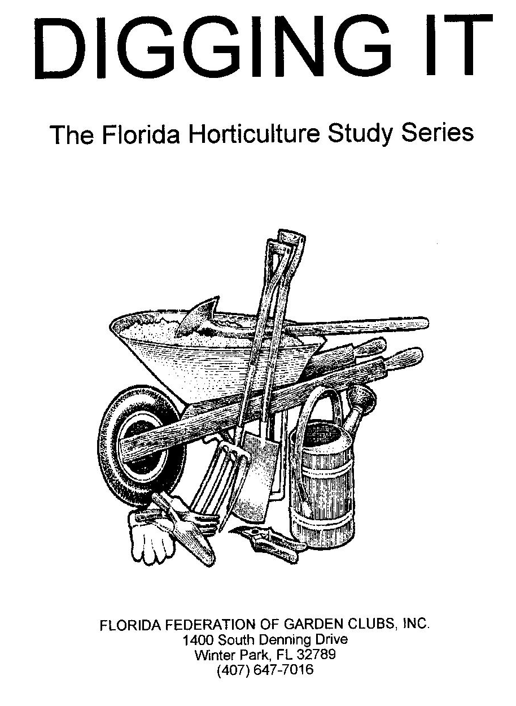
For Mothers’ Day weekend in 2006 and 2007, thirty designers created elegant designs for EPCOT, and other members served as hostesses. Florida Flower Arrangement Calendar, 56th edition (2007), debuted at the NGC Convention in Orlando. To increase calendar sales, a contest among Districts was developed with a $500 prize. ‘Fun with Flowers’ continued to be an excellent introductory program for floral design. At the Coleus Festival in Silver Springs, Jan Sillik demonstrated for three weekends, and other members provided floral designs to arouse public interest. NGC adopted a plan to ‘Replant the Gulf Coast’ after Hurricanes Katrina and Rita destroyed much of the vegetation. FFGC asked that clubs Pass the Hat, and a Habitat Walkathon donated $4000. Home Blitz for June, 2006 brought together clubs and 122 homes for a gigantic landscaping project. Over 150 flats of annual were donated to highlight this outstanding effort. $400 was made available to each District to landscape Habitat for Humanity homes. ‘Digging It’ was developed with a Student and an Instructors Manual published to facilitate the course. A new chairmanship for Men’s Membership was established to track the number of men in FFGC and to encourage men to join a local garden club. A new membership brochure was printed. Several innovative ideas such as ‘Mommy and Me’ were offered to recruit potential members. In 2006, FFGC won the award for the most NGC Life memberships with 33. FFGC boasted two five-star members. Sales of the Florida Wildflower license plate surpassed the million-dollar mark. FFGC received two education grants and four planting grants from the Florida Wildflower Advisory Council in 2006.
FFGC Scholarships from 2005-2006 amounted to $17,000 and were given to 8 college students. In 2006-2007, three scholarships, amounting to $5,625, were given. One Florida student won a Deep South Scholarship for $1000 and one Florida student received a $3,500 NGC scholarship.
SEEK continued to be a viable program for 70 high school students annually. Held at UF, the 3-day conference offered students subjects as diverse as Making Paint to Chasing Lightening to Global Warming. Youth groups maintained high numbers with 114 Eco-tot Gardeners, 3,247 Juniors, 32 Intermediates and 108 High School Gardeners. A ‘Youth Award’ booklet was prepared to assist Youth leaders find award and contact information for their youth groups. The Deep South Regional Youth Project, ‘Kids Count’, was to make Rain Barrels. Water Conservation was the foremost goal of this administration. A mini-Water conference was held in January 2006 and then, throughout the next year, eight districts held water conferences or festivals to promote the protection of our water resources. These activities contributed to FFGC receiving NGCs Award of Excellence. FFGC agreed to partner with Nature Wise in the production of a DVD entitled ‘Florida’s Water: Health of Our Future’ with a donation of $1,000. Wekiva Youth Camp added new programs such as horseback riding and high ropes plus Adventure Week for Girls to attract campers. Critter Camp and the 9th Grade Program for Leaders in Training were continued. A special endowment of $23,000 from the Conway Garden Club was established to provide special programs for Camp Wekiva. Garden clubs donated over $5K in 2005-2006 to World Gardening/Natural Disasters fund.

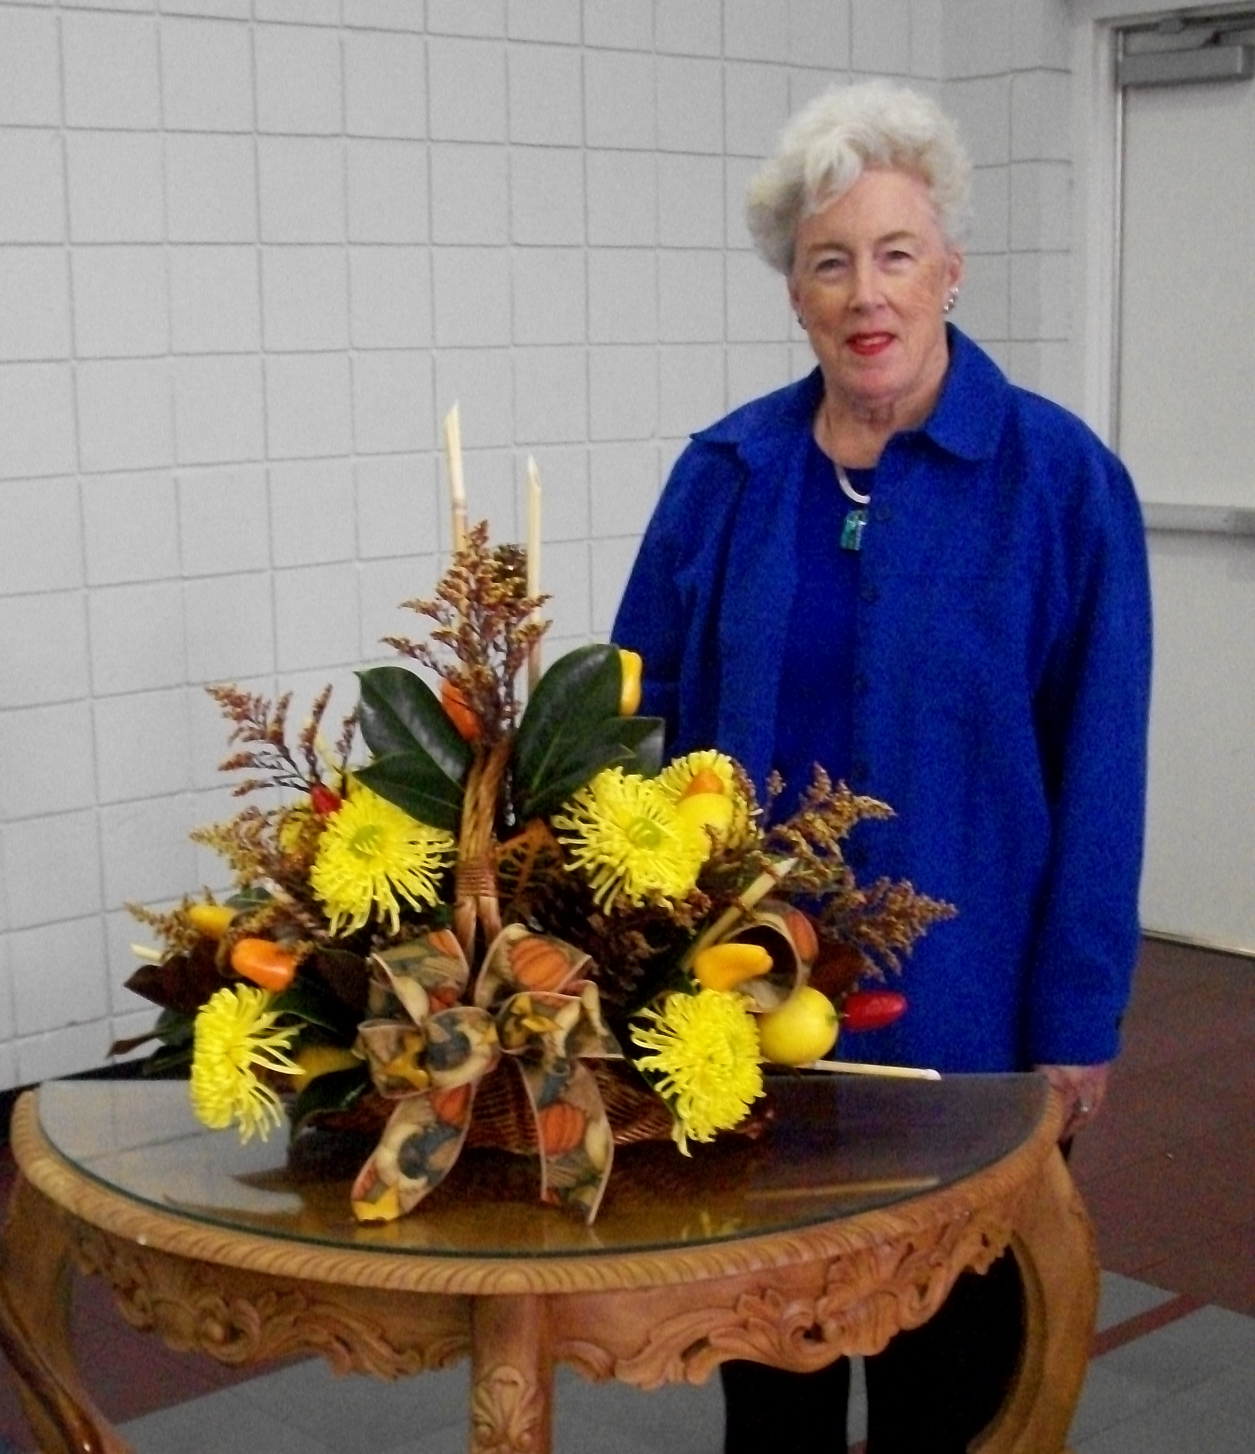
President Margaret O'Donnell, 2007 – 2009, chose as her theme 'Focus on Florida'. Our membership was 15,156. FFGC celebrated 85 years of Federation. Seven new garden clubs joined FFGC. To carry out the focus on Clean Water, videos of water programs were given to each District. The Water Conservation program was adopted by NGC as endorsed by FFGC with the Board voting to join the Clean Water Network. NGC President Barbara May’s Focus on Native Plants had all 12 Districts featuring projects involving our Florida native plants to help preserve water. The Gifts Today for Tomorrow Endowment Fund was established at the 2008 convention. Memorial gifts were given and a gift to honor the 2007-2009 FFGC Board of Directors was given by President O’Donnell. To focus on membership, packets of information about new club formation were created and given to District Directors. In addition, new Club Certificates were instituted.
Deep South Awards received in 2008 included School Ground Improvement, Tree Planting Award, Butterfly Conservation Award, and Wildflower Award. Deep South Life Membership Award was won by Florida in 2008. NGC awards won included Conservation, the ECHO Award (Educational Concerns for Hunger Organization), Native Plant Garden (Educational Publication), A Roadside Award, Standard Flower Show staged in a Public Building, and Junior Leadership Award. Deep South Awards received in 2009 included Butterfly Conservation, Publicity Press Book, and the Deep South Regional Smokey Bear/Woodsy Owl Poster Contest. NGC Awards received in 2009 included Educational Publications, Roadside Beautification, Award of Excellence for an Individual, Radio and/or TV, Butterfly, Publicity Press Book, Community Landscape Design, Youth Environmental Concerns, and Video/CD. Flower Show Awards went to two Garden Clubs as well as a State Standard Flower Show Certificate of Excellence, Patriotic Standard Flower Show, and a Petite Flower Show. NGC Regional School Garden Project and Notable School Garden Project were won. 2009 ‘Aqua Woman of the Year’ for leadership in defense of the Clean Water Act and dedication to protecting all our nations’ waters presented to former FFGC President Marion Hilliard at National Convention.
FFGC hosted the Deep South Regional convention ‘Going Coastal’ March 30-31, 2008 along with the Spring 2008 Judges’ symposium, March 27-28, and the 32nd Biennial State Flower Show and a Tri-refresher April 1-3, as well as the 82nd FFGC State Convention, April 2-3 all on Pensacola Beach. NGC President, Barbara May and Deep South Director Mary Summerville, were our guests for these events. The 83rd FFGC State Convention was held at The Plaza Resort and Spa, Daytona Beach, April 15-17, 2009 with the theme ‘The Sands of Time’, which included an appearance by Mrs. Ellicott, FFGCs first president and a tribute paid to the great ladies of FFGC.
Florida Arbor Day was observed with special programs and activities presented by 48 clubs. Trees planted from March 2007-February 2009 were 123,340. A two-year project featured community gardens where districts could reach out to neighborhoods, schools and churches. A handout was prepared “Pretty PEP Gardens”, to help get more people gardening and to attract new members. Many educational opportunities were made available such as NGC Flower Show Schools, Flower Show judges’ Symposium, Environmental Schools and Refreshers, Landscape Design Schools and Refreshers, Gardening Schools. Floral Design Study courses, both Basic and Advanced, with workshops at both Conventions and a refresher course for instructors. ‘Fun with Flowers’, a make-and-take workshop, and Horticulture partner ‘Digging It’, sponsored by clubs and both open to the public. 53rd Annual Tropical Short Course was held November 2008 and 73 members attended the FFGC/UF Short Course in March 2009.
2009 marked the 16th year FFGC participated in the EPCOT Flower and Garden Festival with 30 creative floral designs created for the Mother’s Day Flower Show. The 58th edition of the Florida Flower Arrangement Calendar had 42 designs which included photos and descriptions of the new NGC designs added for reference. A new pin for designers with a design in any of the 58 calendars was made available. A new booklet of ideas on ‘How to Stage Flower Shows’ was hot off the press and a second supplement to the original ‘Fun with Flowers’ Manual were on sale at headquarters. The ‘Stroll on the Beach’ at Deep South Convention raised $3,069 for Habitat for Humanity landscaping projects. Life memberships and honors given during this administration included 4 NGC Life, 9 DS Life, 64 FFGC Life, 31 Pillar of Pride, and 13 Hall of Fame. 2007-2009 Guardians of Gardening honorees included Jo Williams, Joan Pryor, Carolyn Schaag, Elise Haymans, Cinny O’Donnell, Gina Jogan, Phyllis Wood and Winifred Stanley. Patron honorees included Joan Ochs, Gina Jogan, Tina Tuttle, Karen Hall, Sara Johns, Ann Shandelmayer, and June Richcreek.
FFGCs Wildflower License plate boasted sales over $2,000,000 enabling the Florida Wildflower Foundation to accomplish many worthwhile projects. Significant progress was made with DOT accepting and planting wildflower seed donated by FFGC clubs. Mr. John Wood donated a large butterfly bench to the grounds at FFGC headquarters in honor of his wife, Ella, a former FFGC President. Pavers were installed and a flower garden was planted near the bench. Nine Scholarships were given for 2 freshman, 5 undergraduate, and 2 Master degrees.
SEEK (Save the Earth’s Environment through Knowledge) a 3-day conference for grades 10, 11 and 12 moved to Wakulla Springs State Park. Wekiva Youth Camp held its 3rd annual Open House in February following the annual Wekiva Leadership Training. Gardening and Nature photography were added to the curriculum as well as bicycles, thanks to the generous donations of many members and clubs. An environmental program with emphasis on water was offered to a limited number of 8th graders. The 2-night Wekiva Critter Camp for K-2nd grade was so popular in 2008, two sessions were scheduled. FFGC/UF Short Course moved to Crystal River in 2008 and focused on Landscaping with Native Plants, Water Issues, Community Gardens and ended with a trip to Homosassa Springs Wildlife Park. The 73rd 2009 Short Course held in Ocala March 4-5 with the title ‘Focus on Florida’s Future’ and qualified as a Tri-refresher. Short Course North was adopted and will take place August 2009 in District I, sponsored by District I, FFGC and the Friends of the Milton Gardens. World Gardening/National Disaster letters of thanks were received for donations given by FFGC to National Disasters Relief Fund, National Disasters International and ECHO.

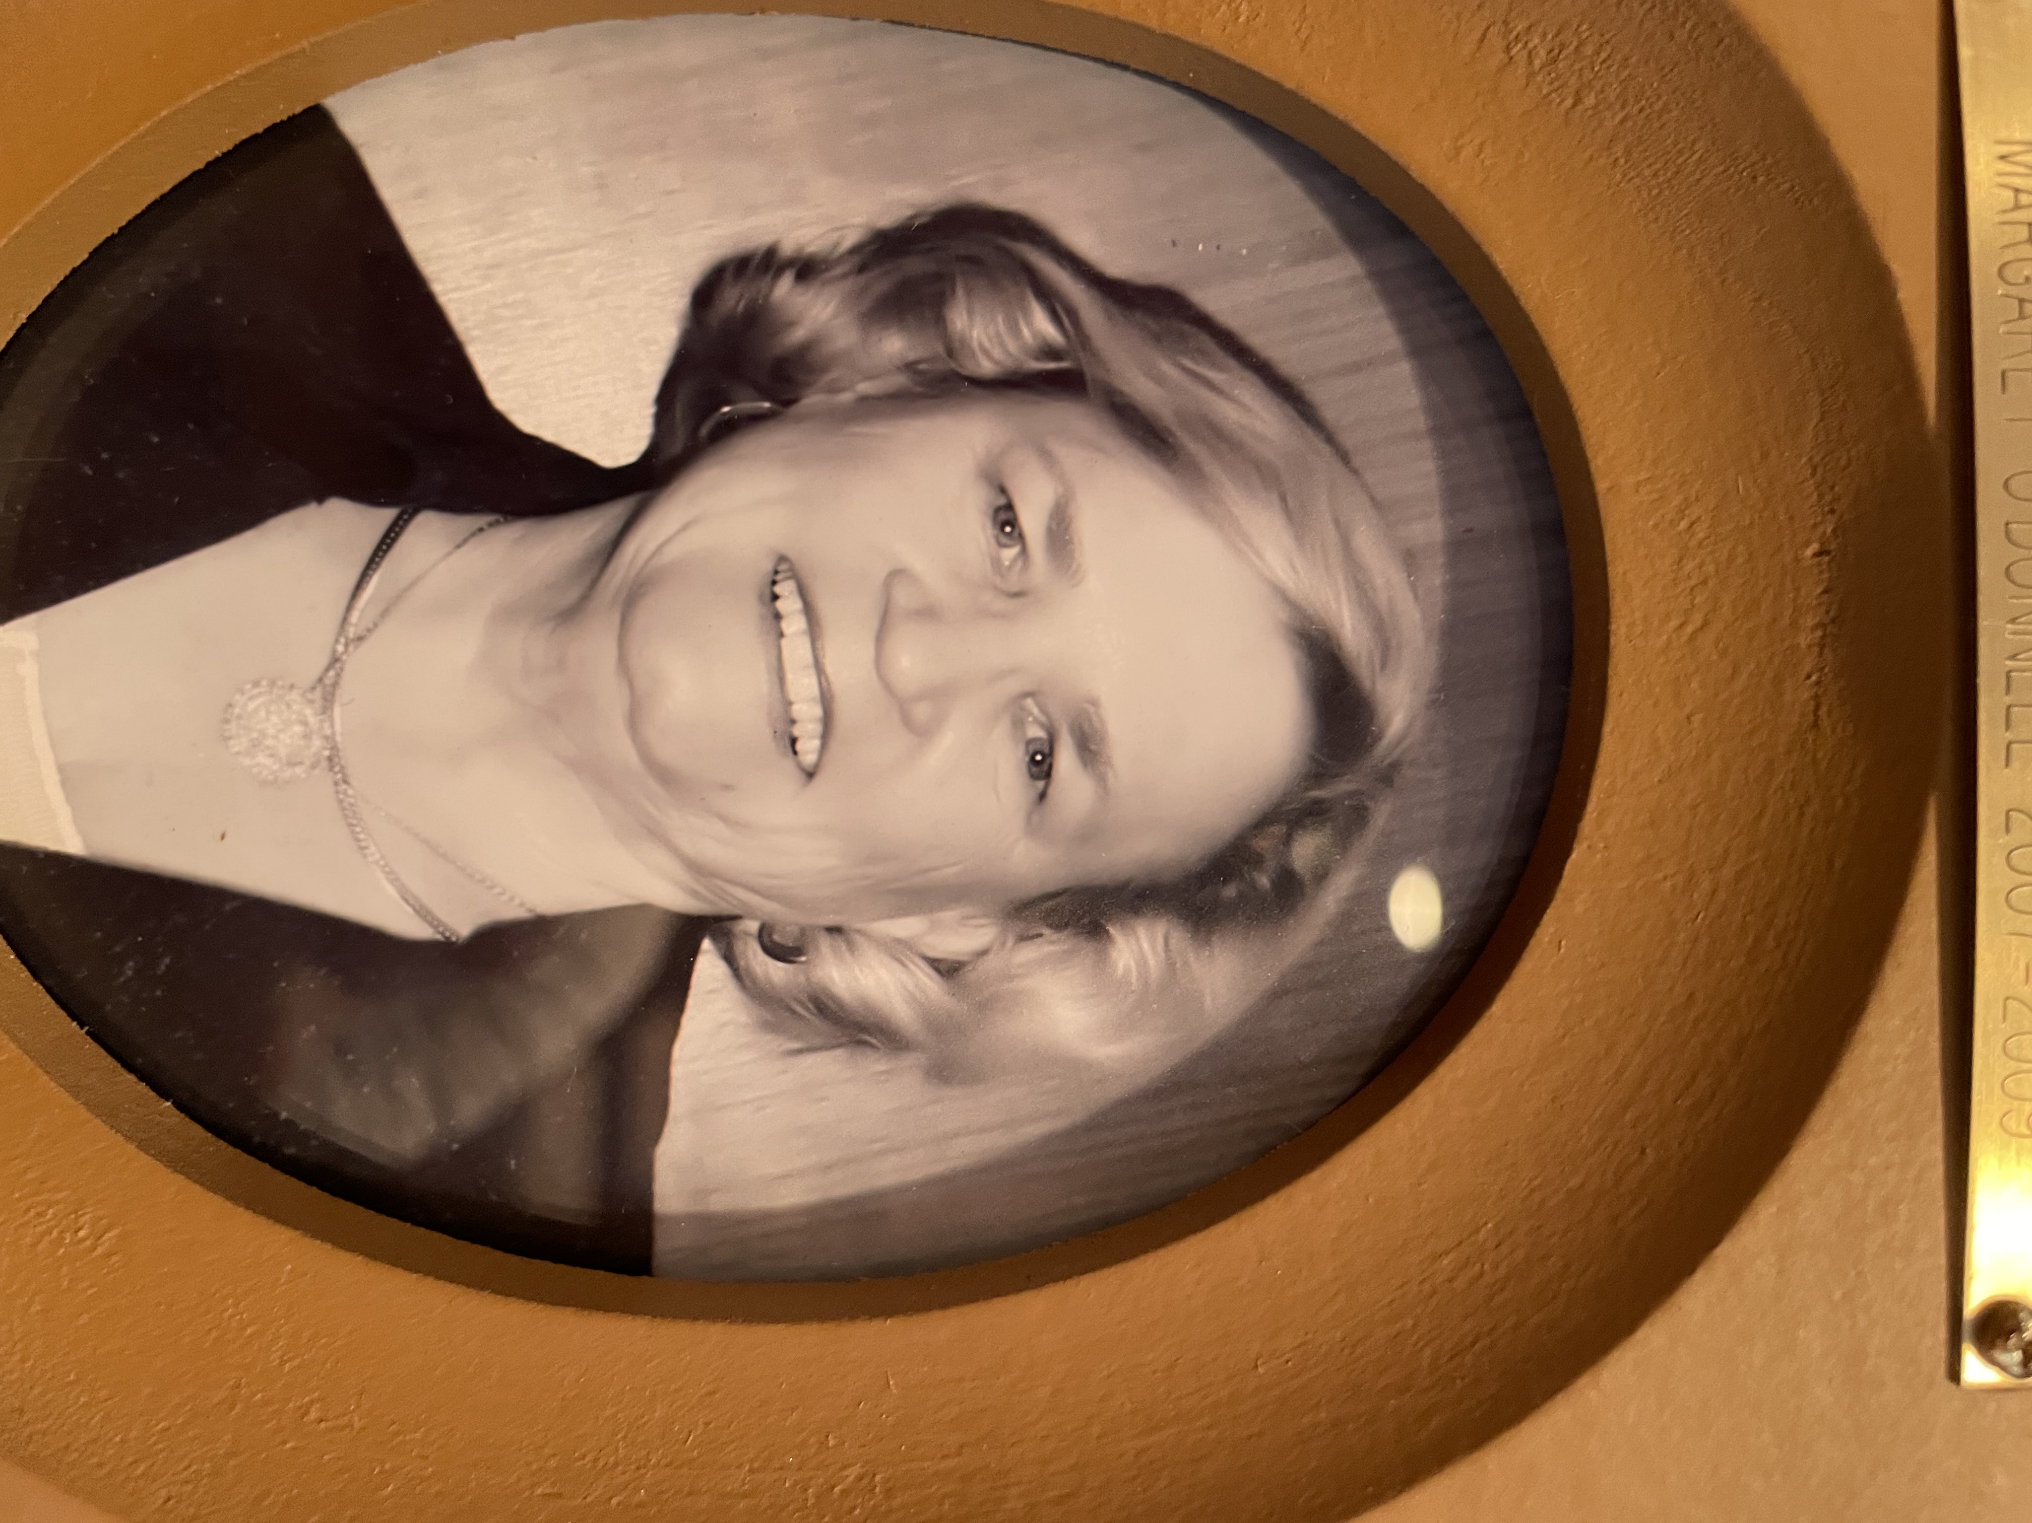
President Carol L. Hall, 2009–2011, chose as her theme, 'Reach out - Be a Mentor'. FFGC membership stood at 14,541. The FFGC Mission Statement was adopted: “To further the education of the members and the public in the fields of gardening, horticulture, botany, floral design, landscape design, environmental awareness through the conservation of natural resources, civic beautification, nature studies and to instill in our youth the love of gardening and the respect and protection of the environment.”
On February 16, 2010, 23 FFGC members participated with 19 other groups at a rally at the State Capitol Building to support springs protection legislation. FFGC members visited legislators and presented the FFGC Position Paper in Support of Clean Water. Districts were adopting at least one body of surface water that was degraded or impaired and took measures to improve this body of water. Legislative Days, March 21-22, 2011, was attended by 46 members who visited the State Capitol Building and its lawmakers and later toured environmental sites in Perry. Resolutions passed: To oppose portions of the I-75 Highway Beautification and Tourism Pilot Project submitted by the FDOT to the Federal Highway Administration and urge funding by the 2010 Legislature for the reauthorized Florida Forever Program.
Policies and Procedures of FFGC Finance, Headquarters and Endowment were reorganized and revised, including an updated manual and budget. Each district developed and voted on a district Policies and Procedures manual. Electronic communication was used to eliminate excess waste and expense in mass printing of FFGC material.
Flower Show Schools, 4: Flower Show Symposia: 2 per year, Environmental Schools: 1, Landscape Design Schools-1, Tri-Refresher for Gardening, Landscape Design and Environmental Consultants-2, Refresher for same-1, Tri-Council 2-year project was Landscaping and Gardening in an Environmentally Sensitive Way, plus Tri-Council prepared a workshop, ‘Making a Difference’, to assist members in communicating with decision makers. FFGC has eleven 4-star members and seven 5-star members. 51 Standard Flower Shows, 1 State Advanced Standard Petite Flower Show (Biennial), 1 Standard Youth Flower Show, FFGC members co-chaired 2011 Deep South Region Petite Advanced Standard Show March 14-15 in Lafayette, LA. FFGC participated in 2009 EPCOT Mother’s Day Flower Show at the EPCOT Flower and Garden Festival with 29 designs. In 2010 FFGC participated with 30 designs. The 59th edition of the FFGC Flower Arrangement Calendar for 2010 tied with the Georgia organization for the NGC Tommy Donnan Certificate of Merit. The 60th edition of the FFGC Flower Arrangement Calendar was published in memory of Wilma Paulauskas for 2011. Floral Design Study Units: 6 basic and 3 advanced classes; Digging It! A horticulture study series, Fun with Flowers, a hands-on program of creative activities to attract and inspire new and old members, all presented by clubs throughout Florida. The first FFGC Short Course North was held August 13-14, 2009 at Santa Rosa County Extension office in Milton, featuring the Nine Principles of a Florida Friendly Landscape. The second FFGC Short Course North, Conservation Begins in Your Garden was a Refresher held August 12-13, 2010 at the same location. The 54th Tropical Short Course, Tropical Gardens, a Tri-Refresher, was held January 26-27, 2010 at Mounts Botanical Gardens, West Palm Beach. The 55th Tropical Short Course, Tropical Horizons, was held January 25-26 2011 at the same location. FFGC /UF 74th Short Course, The Circle of Life: mentoring, a Tri-Refresher, was held March 11-12, 2010 at Pioneer Garden Club in Ocala. The 75th FFGC/UF Short Course was held June 8-9, 2011 in Gainesville. Wekiva Youth Camp was accredited by the American Camp Association. Wekiva Leadership Training, a weekend of training for new camp volunteers, was held in February of 2010 and 2011, followed by an Open House for the public. The 2010 summer session operated at 90% capacity. An air-conditioned cabin was completed in 2010. Three other cabins were renovated in 2011. The State of Florida granted WYC a special exemption: Retain the original camp colors of moss green and quarry. Labels for Education continued to be a popular fundraiser for WYC. SEEK (Saving the Earth’s Environment Through Knowledge) was held at Wakulla Springs State Park during the summers of 2009 and 2010 for 3-day conference. Activities and field trips were hands-one and exciting, with students staying in the historic Wakulla Springs Lodge. Junior Gardeners totaled 3,368, in 94clubs, Intermediate Gardeners totaled 79 in 6 clubs and High School Gardeners totaled 20 in 3 clubs. In 2009-2011, fourteen college students received a total of $27,000 in scholarships for study in fields related to garden club objectives. Many garden clubs award college scholarships as well as Camp Wekiva camperships and SEEK scholarships. Florida students won two NGC scholarships in 2010 and one in 2011, and one Deep South Region Scholarship in 2010.
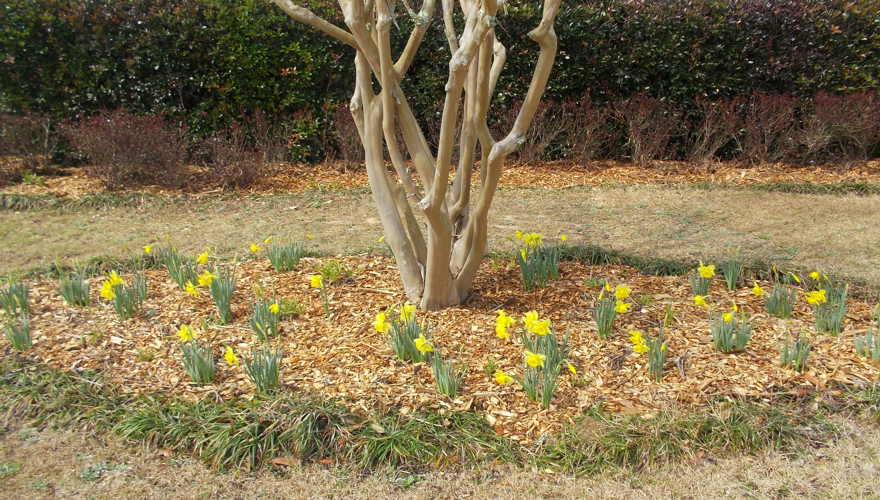
Both Habitat Landscaping and fundraising were on-going projects throughout the state. FFGC led the way in Habitat Walk-a-thon pledges ($23,006.68) at the 2010 NGC Convention. The sale of previously owned costume jewelry was profitable at both district and state levels, culminating in the Great Jewelry Exchange at the Deep South Convention. Seven new Blue Star Markers were placed and seven were refurbished and/or re-dedicated. ‘Golden Days’ honored our senior members with hundreds of daffodil bulbs planted in north Florida. An FFGC member created a contrived daffodil that could be used where the bulbs would not grow. Several garden clubs worked with civic organizations, applying for grants and designing community gardens. FFGC won the Deep South Unified Project ‘Protecting Our World, Living Green, Living Clean’. FFGC donated $1000 to Delaware Garden Club for the Dover Air Force Base memorial garden at the Center for the Families of the Fallen. $4,789 was contributed by FFGC to ECHO (Educational Concerns for Hunger Organization), World Children’s Fund and NGC Natural Disasters USA. $4,347 was sent to Global Partners for the purchase of water filters for Haiti. ‘Gifts Today for Tomorrow’ Endowment Fund collected $3,027 during this administration. 72 Butterfly Sanctuary Certificates were awarded. 8,369 trees were planted from February 2010-February 2011. Ten clubs observed Arbor Day. A new partnership was developed between FFGC and the Florida Wildflower Foundation for a wildlife education and planting program in schools. FFGC is represented on the Florida Wildflower Foundation Board. Since 2000 the license plate had generated $2,500,000 for wildflower projects. FFGC provided one of seven representatives appointed by the Commissioner of Agriculture to serve on Florida’s Endangered Plant Advisory Council.
Clubs celebrating 30, 40, 50, 60, 70, or 80-year anniversaries received “Precious Metal” certificates. Guardians of Gardening honor was given to Elizabeth Pate. Patron honorees included Elizabeth Pate, Addie Lou Harris, Cindy Rieger, Carolyn Whitmer and Carol Hall. Other honors given included 38 Hall of Fame, 61 Pillar of Pride, 98 FFGC Life Members, 7 Deep South Region Life members, and 6 NGC Life Members.
The 2010 Convention, “Tropical Treasures”, April 22-24 in Boca Raton, was our 84th state convention. The state flower show, “Shrunken Treasures”, won NGC State Flower Show Award in 2011. 2011 Convention, “The Race is on! The Stakes are High!”, April 14-16 in Ocala was our 85th State Convention. Deep South Region Awards in 2010 included Historic Preservation and/or Restoration, Special Achievement Award, Butterfly Conservation, Arbor Day Award, Publicity Press Book, Smokey Bear/Woodsy Owl Poster Contest, Youth Poetry Contest, “Our Beautiful World”, High School Essay contest, “Respect the World Around Us”. NGC Awards for 2010 included Literary Horticultural Interest, Award of Excellence for an Individual, Decoration of Historic Building, and 5 Standard Flower Show Achievement Awards. Deep South Region Awards in 2011 included School Gardens Project, Environmental Education Award, Adopt-A-Park Award, Community Action Award, Conservation Award, Smokey Bear/Woodsy Owl Poster Contest, High School Essay Contest, Deep South Unified Regional Project, Individual Club, Youth Division, School Gardens Project. NGC Awards for 2011included NGC Youth Poetry Contest, Literary Horticultural Interest, Special Achievement, Junior and/or Intermediate Garden Club, State Flower Show, Publications, (The Florida Gardener), Educational Membership, Calendars, Florida Flower Arrangement Calendar for 2010, three Standard Flower Shows, Presidential Citations, Community Landscape Design, and Civic Projects with Native Plants.

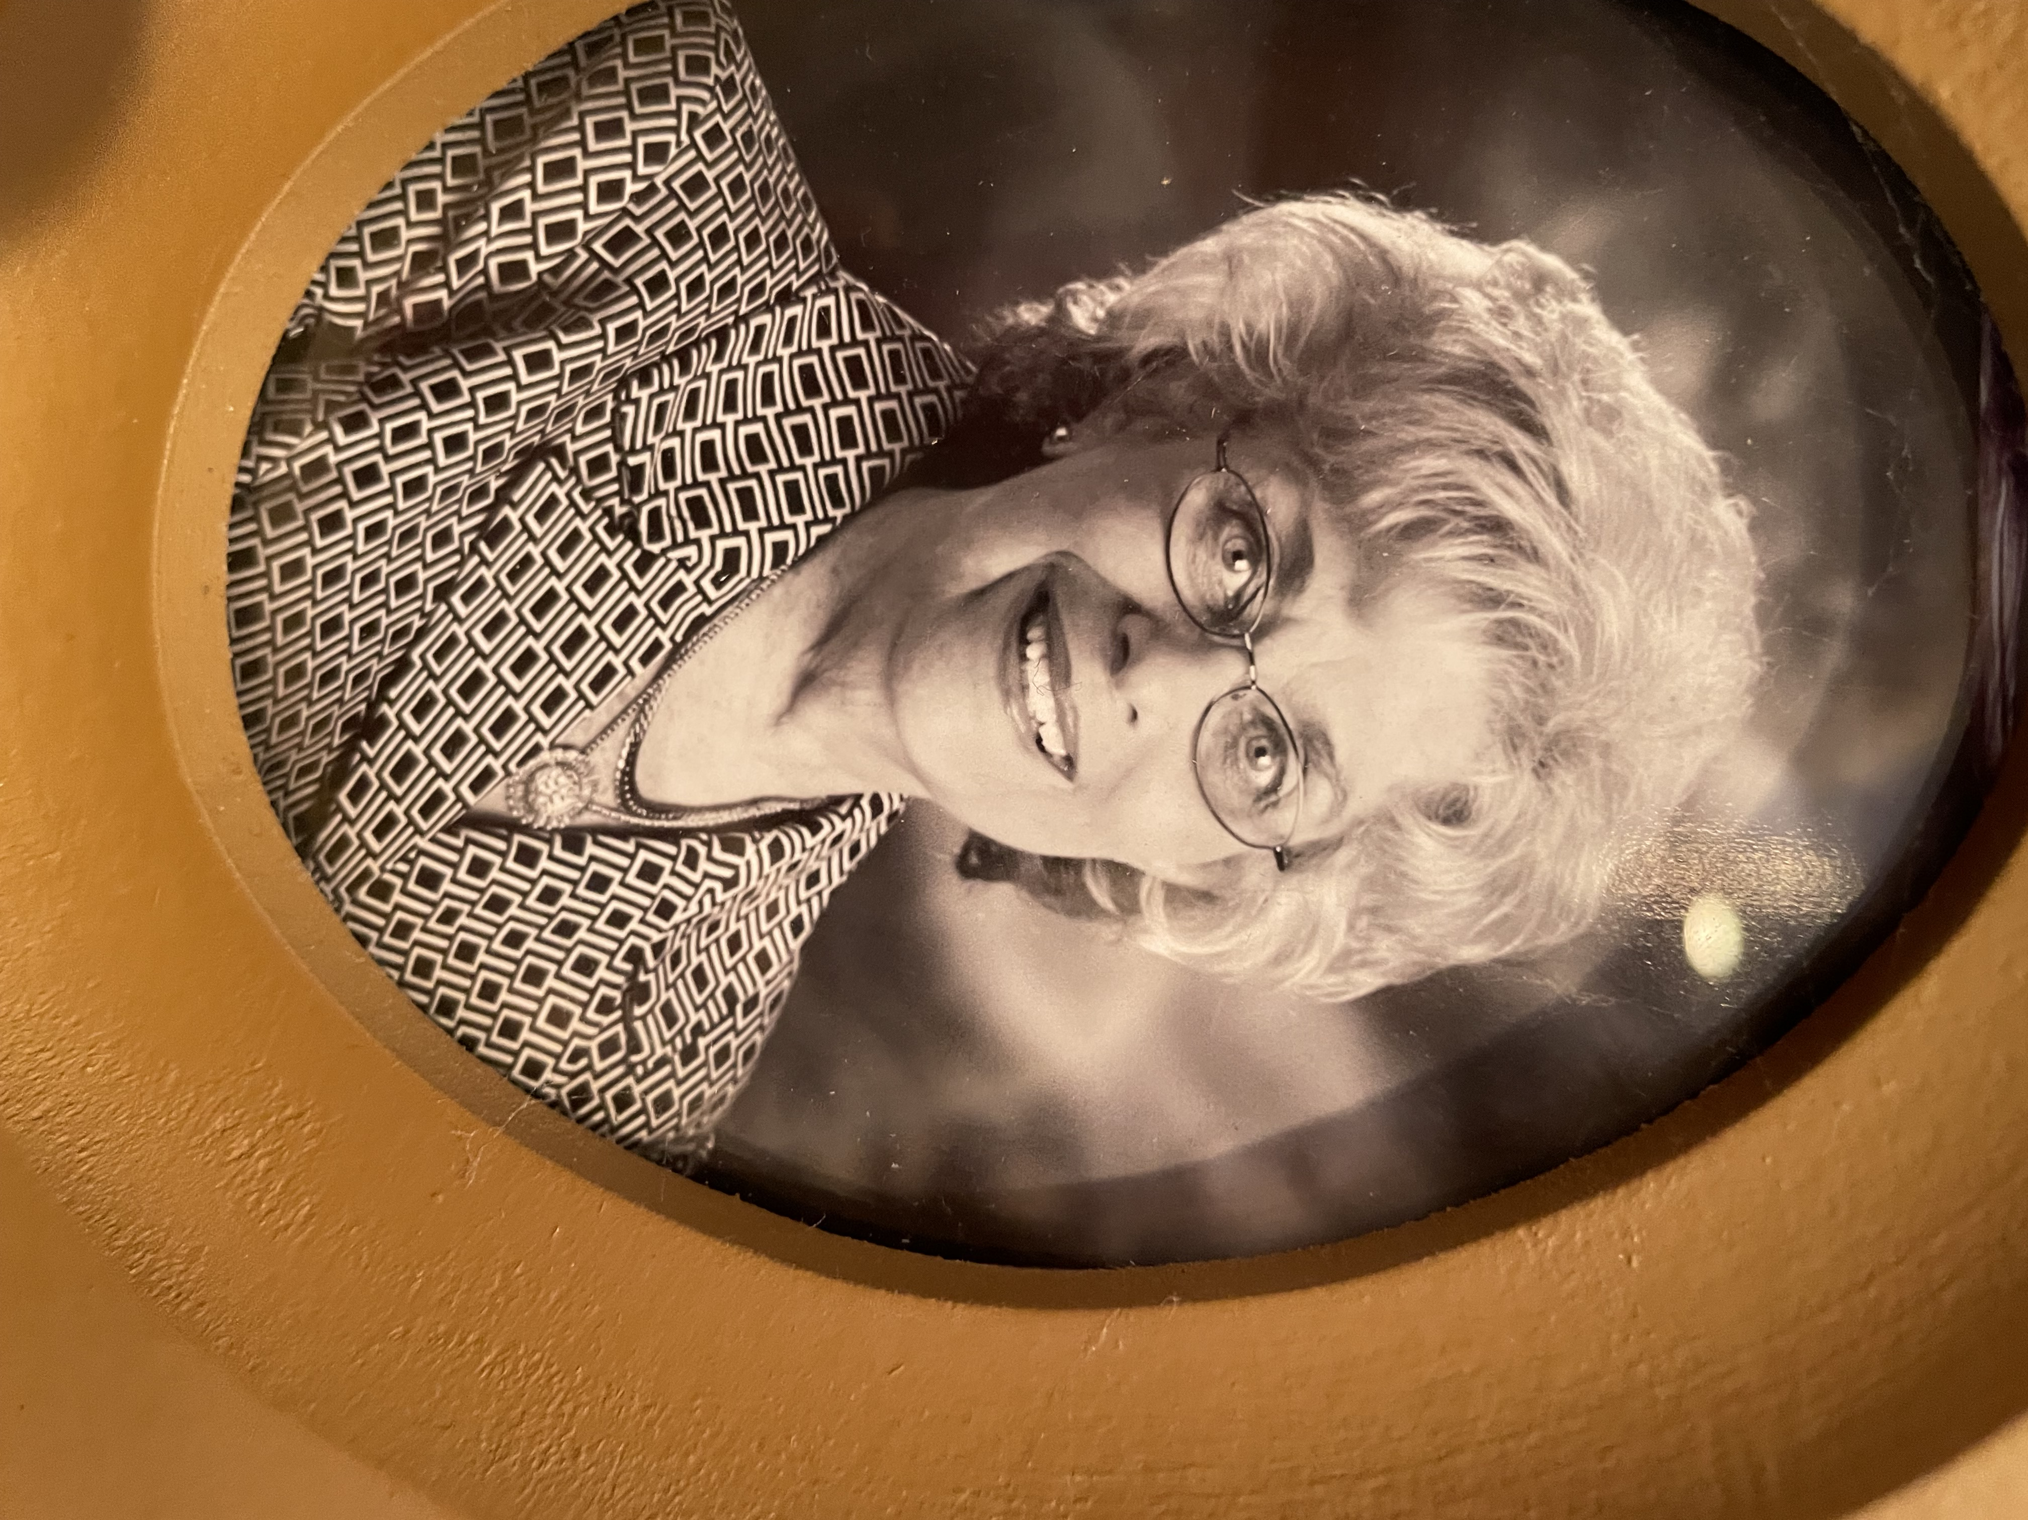
President Jan Sillik, 2011–2013, chose as her theme: “A Time to Know, Sow, and Grow”. We had 204 Clubs with 13,200 members. Trout Lake Nature Center, a 230-acre wildlife preserve located in Eustis. became an affiliate member. 144 Blue Star Memorial Markers are now in Florida. We held 5 Flower Show Schools and 2 Symposia and hosted the Instructor Symposium and gained 7 new Judges. We held 4 Environmental Schools, 2 Landscape Design Schools, 2 Tri-Refresher for Gardening. We gained 8 Five Star Members and 16 Four Star Members. 1 Bee Certificate was issued, 67 new Butterfly Sanctuary Certificates, and 19,847 trees planted /given with many clubs celebrating Arbor Day. We held 53 Standard Flower Shows, our biennial State Advanced Standard Flower Show and 1 Standard Youth Flower Show. Scholarship Fund has received $21,599.41 in 2011-2013. Many garden clubs award college scholarships as well as Camp Wekiva camperships and SEEK scholarships. Labels for Education earned 70,000 points and eight large free items were ordered for summer program at Wekiva Youth Camp.
45 Floral Design Study Units were offered with 285 Certificates issued. “Digging It” and ‘Fun with Flowers’ programs were held to attract new and inspire old members. Short Courses were held in south Florida, in Gainesville and in North Florida. FFGC boasted 3 High School Garden Groups registered in 2011 and 79 Youth Garden Clubs and in 2012, 93 Youth groups with membership of 4,398 Youth Gardeners. Wekiva Youth Camp, a partnership between FFGC and the State Park Service, had 540 children attend in summer of 2011 and about 600 in 2012. A yearly Wekiva Leadership Training was held for volunteers. S.E.E.K. (Save the Earth’s Environment through Knowledge) was based at Wakulla Springs Lodge with. 60 attending in spring 2011 and 2012.
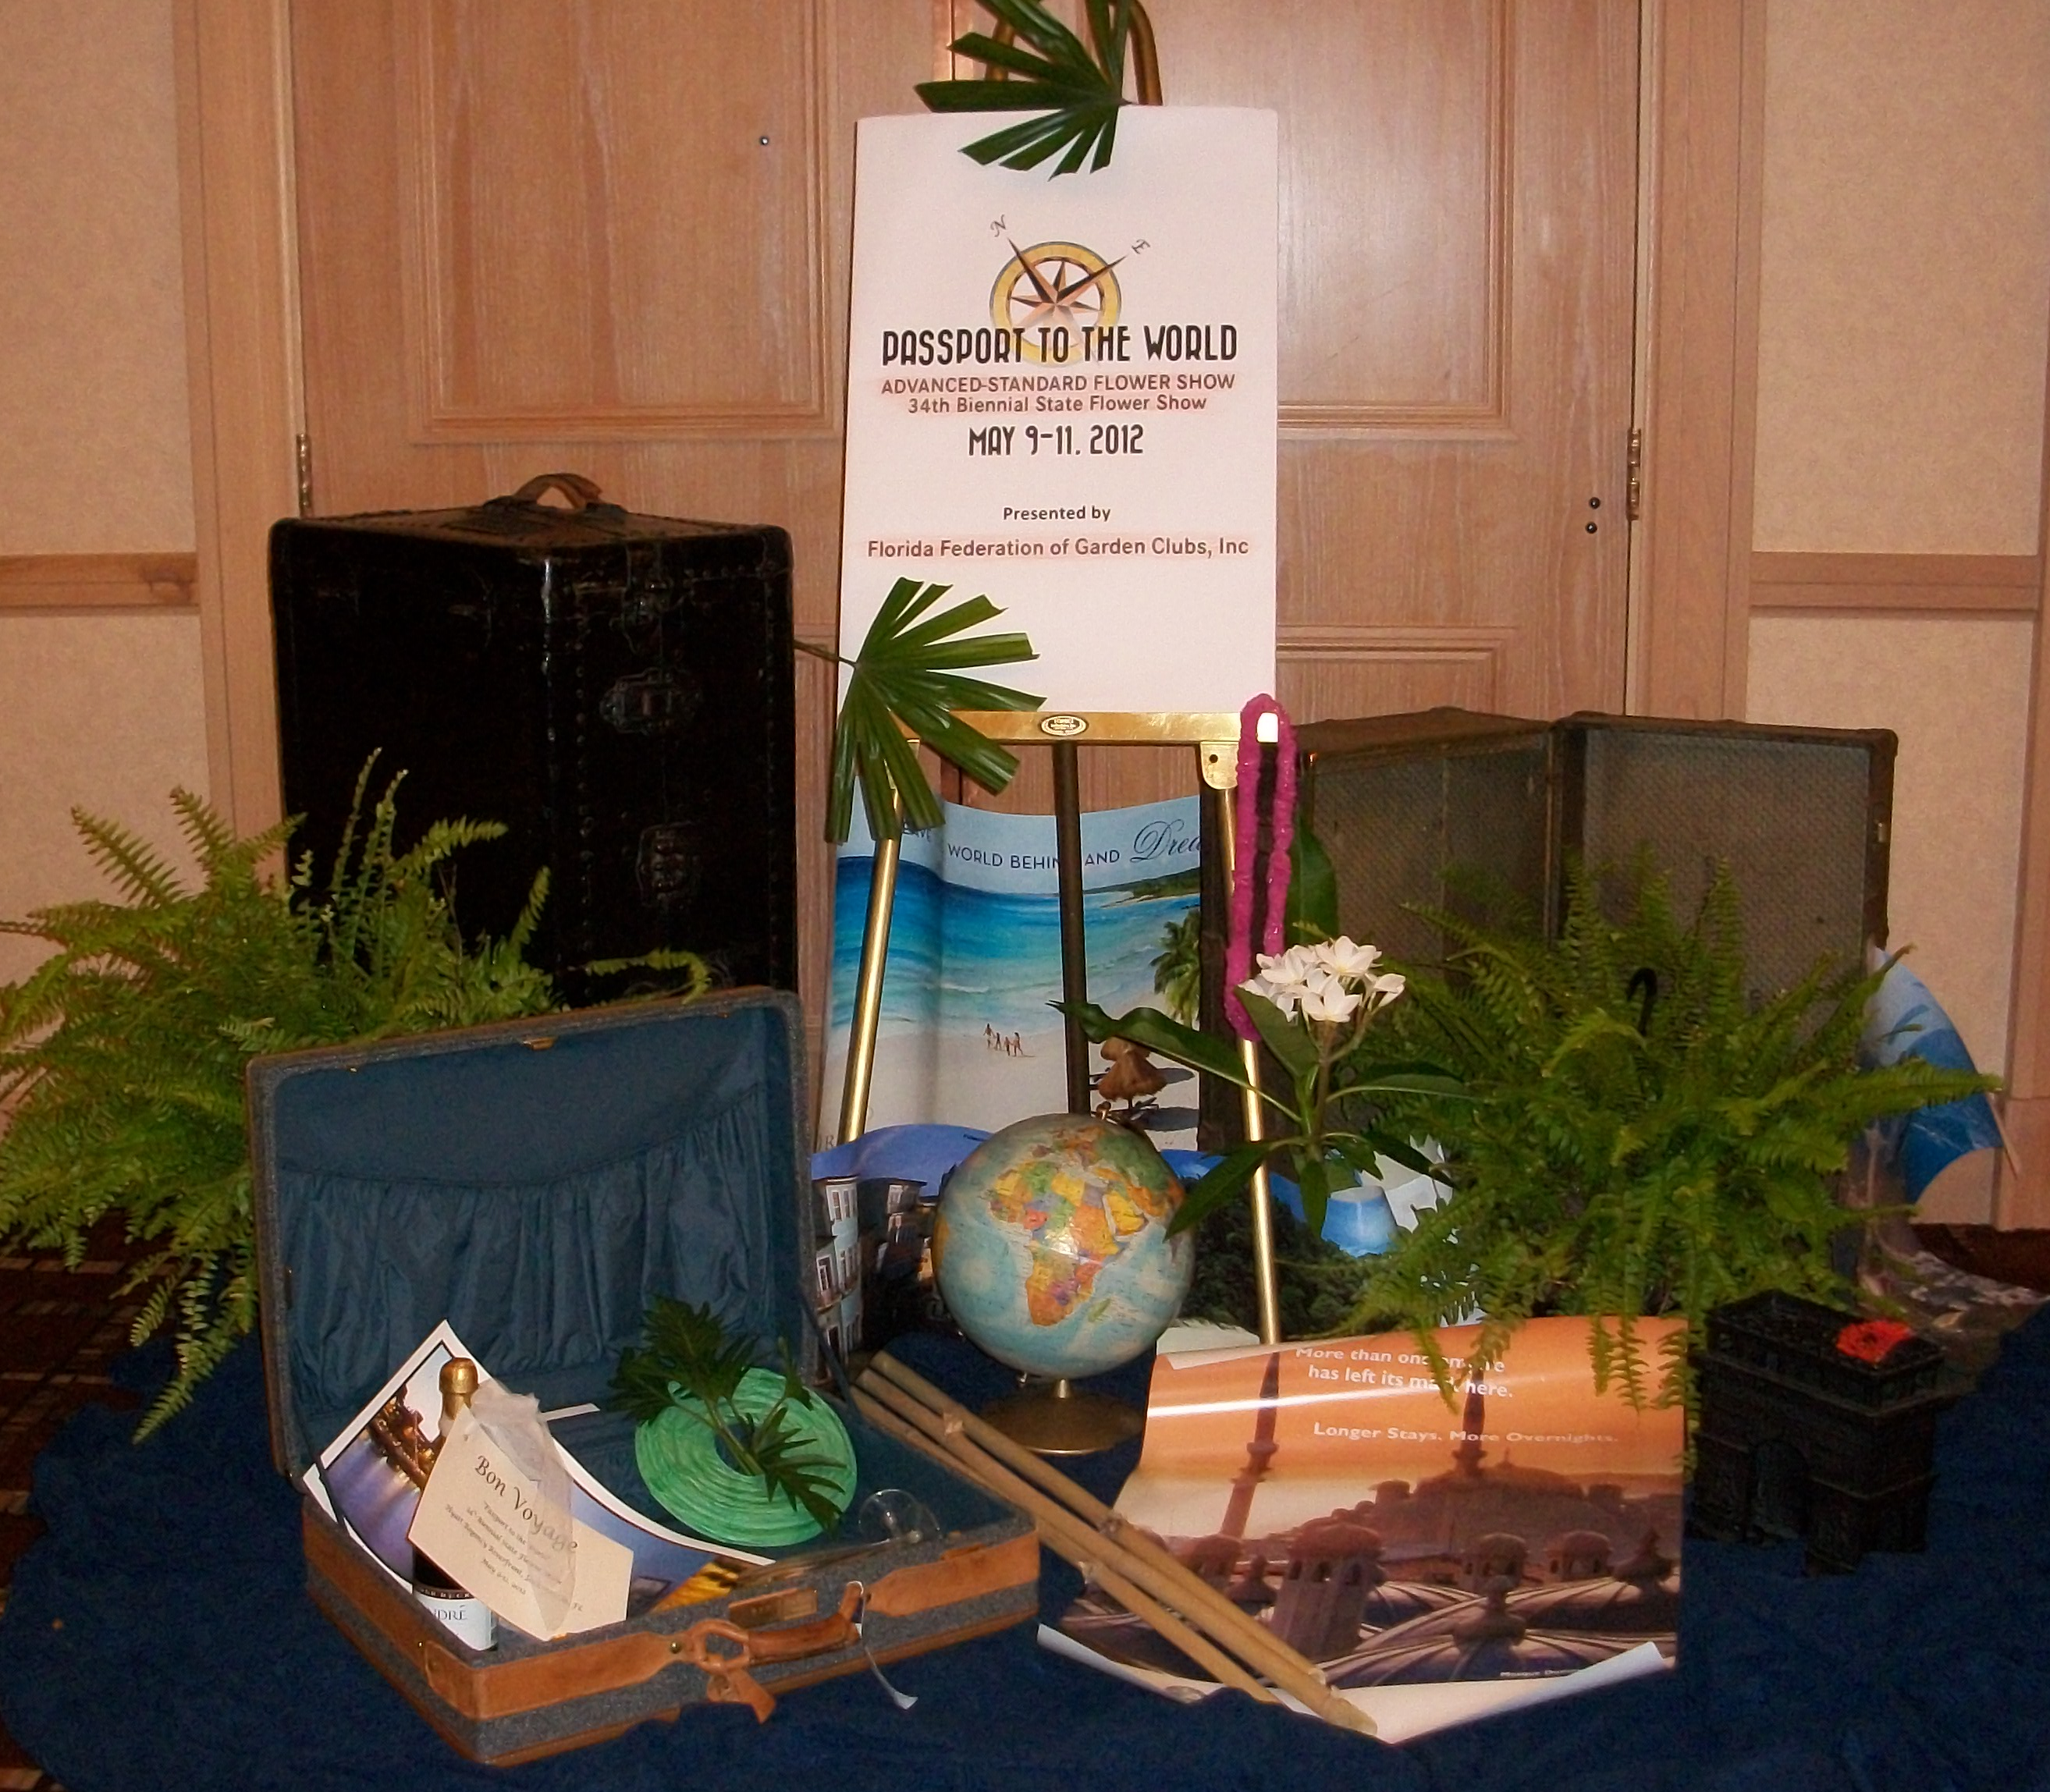
Our 86th Annual Convention was held in Jacksonville, May 10-11, 2012. The theme was “Ports of Call” and “Passport to the World” was our biennial State Flower Show. 2013Convention was held in Fort Myers, April 29-30, entitled “A Toast to the Coast”. The Florida Gardener, published four times a year, covered all facets of garden club activities, projects, educational opportunities, legislative alerts, book reviews as well as upcoming Flower Shows and events and news from 12 Districts. It also Included Youth Activities such as Wekiva Youth Camp and SEEK. Two new columns in The Florida Gardener and on our website are ‘FFGC Listens’ and ‘Take A Byte’. Our website, www.ffgc.org, is the model website for other states. District II Vernon Garden Club won Florida Highway Beautification Council grant for $100,000 to assist with beautification of State Highway 79.
“Welcome to our house” was the president’s special project to introduce the public to floral designs in the home. “Welcome to Our Home” fundraisers were held in Districts I, IV and VII and donations to FFGC totaled $2800. District Directors hosted Lunch and Learn Workshops, got involved with community action projects and tried new ideas to garner new members. FFGC published a new manual, “Tabletop Treasures: Centerpiece Ideas for Special Events” in which all districts participated and provided ideas. ‘Gala In the Garden’ was a held September 16, 2011 celebrating 50 years in our FFGC Building, profiting $16,610.
The Legislative Positions and Policies Committee presented four prospective position statements that were adopted by the FFGC Board of Directors including “Protect Aquatic Ecosystems”, “Control Invasive Species”, “Defend Our National Parks”, and “Love Florida State Parks”. FFGC joined Florida Conservation Coalition, a bipartisan group recently founded by former Florida Governor and US Senator Bob Graham and Nathaniel Reed.as an Affiliate Member. Position paper entitled “Conserves Natives Plants” shows FFGC’s commitment to ensuring the resiliency and long-term viability of native plants, especially rare and endangered species. Our Position Paper entitled “Supports Clean Air” shows our commitment to ensuring that we all can live in healthy environment. FFGC endorsed and supports Florida’s water and land legacy in their statewide campaign to restore Florida’s long-standing conservation commitment. A ‘Speak Up Wekiva’ event was held February 16, 2013 and was sponsored by Florida Conservation Coalition to raise awareness about the need to restore the impaired Wekiva River, the trouble Springs that feed it and all of Florida’s treasured waterways.
FFGC participated in EPCOT Mother’s Day Flower Show at the Flower and Garden Festival. 34 designers presented outstanding designs on May 6-7, 2011, and 35 designs April 27-29, 2012. In 2013 we celebrated 20 years of Mother’s Day Flower Shows. Penny Pines collected $6,807.89 to help with reforestation in Florida’s most damaged National forests. World Gardening/Natural Disasters raised $3,365.16 during 2011-2013 administration. 11 Hall of Fame awards were given in 2013 making a total of 492, ‘Gifts Today for Tomorrow’ Endowment Fund has a total of $4292.50. FFGC approved participation in Coral Restoration Foundation’s reef building project, “An Underwater Garden”.
FFGC’s Tri-Council established a new recognition honoring one who has made notable efforts in the stewardship of our natural resources. Earth Steward honorees included Pat Carver, Marion Hilliard, Jo Williams, Berne Davis, Alice Changstrom, and Joan Pryor. Former president, Marion Hilliard, was recognized by Clearwater Network as ‘one of the most valuable active members of their network’ and received a Deep South Directors Citation in recognition of her dedication.
Deep South Convention 2011 Awards included Environmental Education Award, Adopt-A-Park Award, Community Action Award, Smokey Bear/Woodsy Owl Poster Contest, High School Essay Contest “The Environment -Our Responsibility”; Deep South Convention 2012 Awards included 7 Certificates of Achievement, Scholarship Program, Paid Subscriptions to the National Gardener Magazine, Smokey Bear/ Woodsy Owl Poster, and Yearbook Awards. NGC Convention 2011 Awards included Literary Horticultural Interest, Special Achievement, Junior and/or Intermediate Garden club, Publications Award for The Florida Gardener, Educational Award, Membership Brochure. Presidential Citations, School Gardens Project, Community Landscape Design, Civic Projects with Native Plants, and 2 Standard Flower Shows. NGC Convention 2012 Awards included Publications, Membership, Yearbooks, and 5 Standard Flower Shows. One Second grader received first prize for Smokey Bear/Woodsy Owl Poster Contest. Deep South Awards won in 2013 included National Gardener Award, Historic Preservation/Restoration Award, Tree Planting, Horticulture, Environmental Education Award, Butterfly Conservation, Adopt-A-Park, Community Action Award, Wildflower Award, Arbor Day, DS Region Mentor of the Year, NGC Youth Sculpture Contest, Smokey Bear Woodsy Owl Poster Contest.
NGC Awards won a their 84th Annual Convention 2013 in Seattle, WA included
Garden Center Award for Valparaiso Garden, Special Achievement for District X, Youth Horticulture Education Award for Tampa Federation of Garden Circles, 6 Publications, Blue Star Memorial Landscaping, and Byway Marker for The Garden Club of Stuart, Horticulture Therapy Garden Project, Decoration of Historic Building, and Environmental Education. Three standard flower show awards and the NGC President’s Project, “Plantings for Public and Special Places”. The Youth Environmental Concern Award was won by Wekiva Youth Camp for the 7th grade program, and applicants won 2 NGC Scholarships.

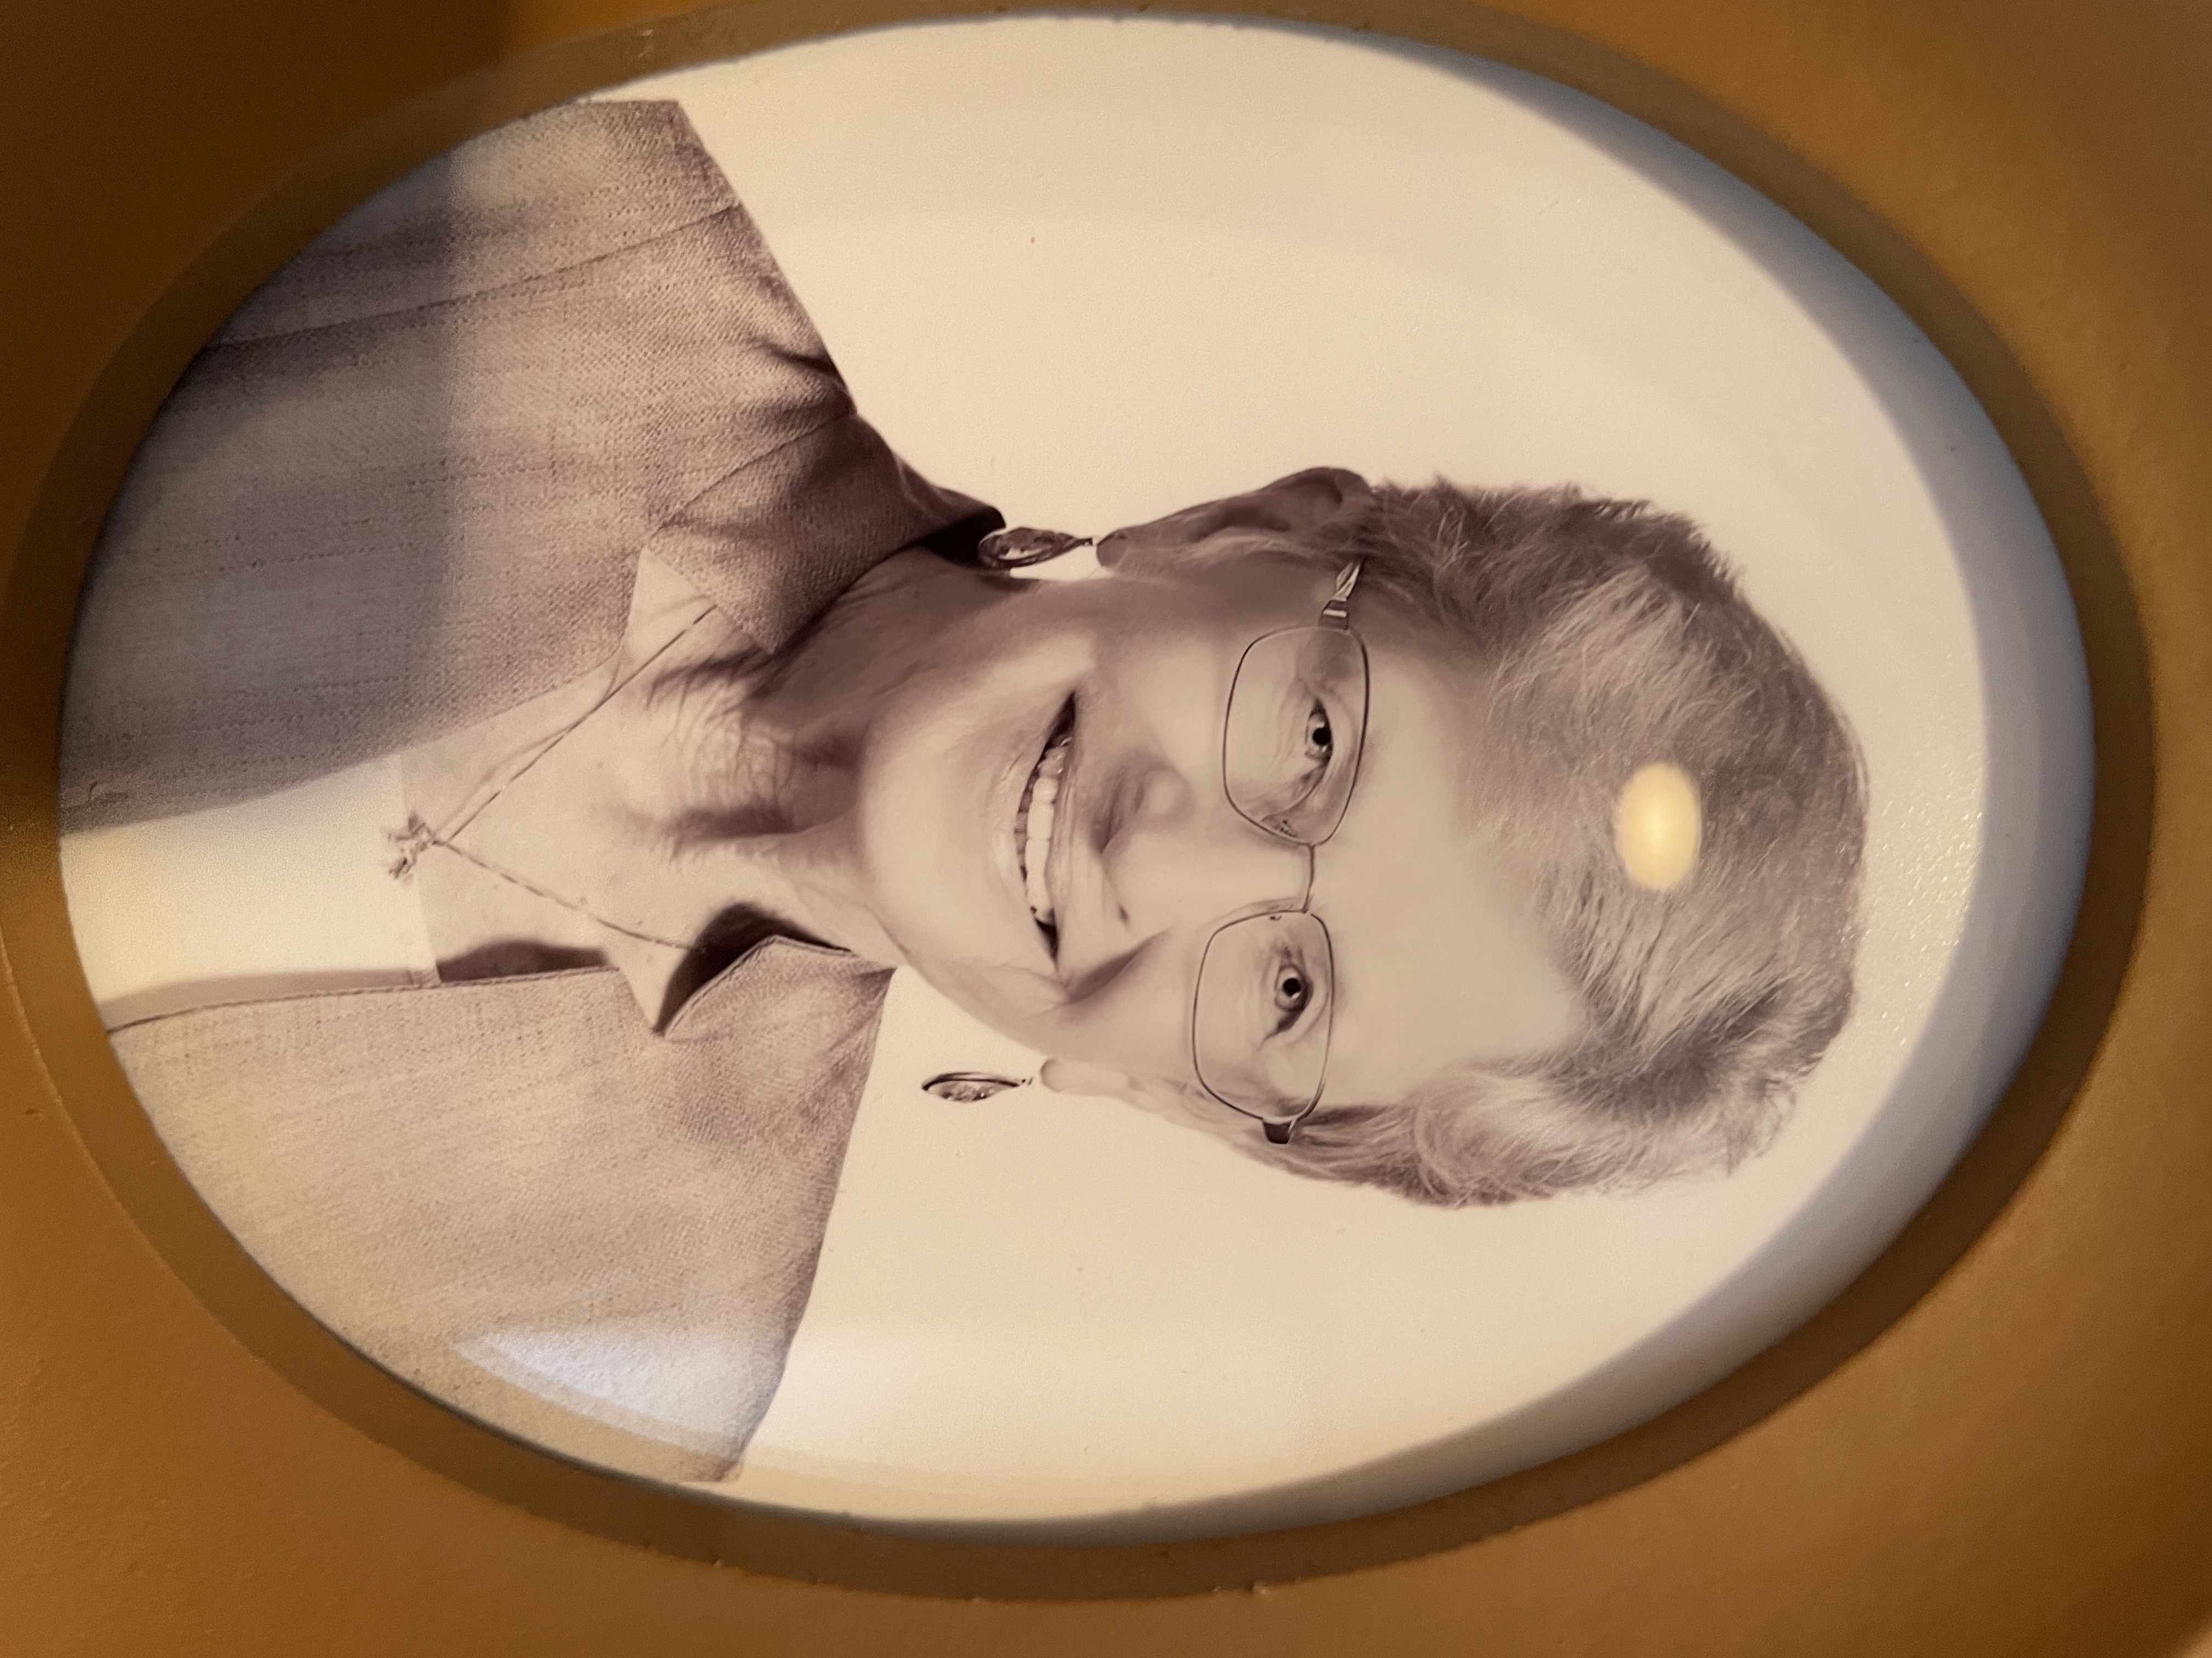
President Sue Angle, 2013 – 2015 chose as her theme: “Through the Garden Gate--Our Legacy and Our Future”. We had 200 Clubs with 12,737 members. Convention 2014 was held in St. Petersburg April 14-16, 2014 with the theme:” Florida Center Stage and included FFGC’s State Flower Show “In the Spotlight”. The 2015 Convention was held in Boca Raton April 17-19, 2015 with the theme, ”Rhythm of the Tropics”. The 2013 -2015 Presidents’ project encouraged clubs to showcase all they do to educate members and the community about floral design, horticulture/gardening, nature and the environment. The project encouraged clubs and/or districts to hold a one-day public event focusing on what garden clubs do as well as benefits from joining a garden club, and emphasized the need of documenting what we do for future generations.
Five Flower Show Schools were held along with two Flower Show Symposia (39 judges advanced status). We held four Environmental Study Schools, three Landscape Design Schools, two Tri-Refreshers for Gardening Schools. We hosted the NGC Instructor Symposium. We now had 7 Five Star Members and 11 Four Star Members. 58 Standard Flower Shows were held including our 35th Biennial Advanced Standard State Flower Show with 84 Designs and 358 Horticulture entries. We held 17 Basic and 8 Advanced Flower Design Study Units and 170 Certificates were issued. “Digging It, a Horticulture Study Series” courses were held as well as ‘Fun with Flowers’ to attract and inspire new and old members. Three Short Courses held: 59th Tropical Short Course, 78th FFGC/UF held in Gainesville and the 6th Short Course North held in North Florida.
Wekiva Youth Camp, the only residential youth camp sponsored by a state garden club and an ACA accredited camp, saw 15% growth for 2013 and 2014 sessions due to new EASYREG online registration. S.E.E.K. (Save the Earth’s Environment through Knowledge), in existence 40 years, was currently based at Wakulla Springs State Park and had 60 attendees in 2013 and 58 attendees in 2014. Junior Gardeners Chairmen serving for three or more years were awarded a newly designed FFGC Junior Gardeners Pin by President Angle.
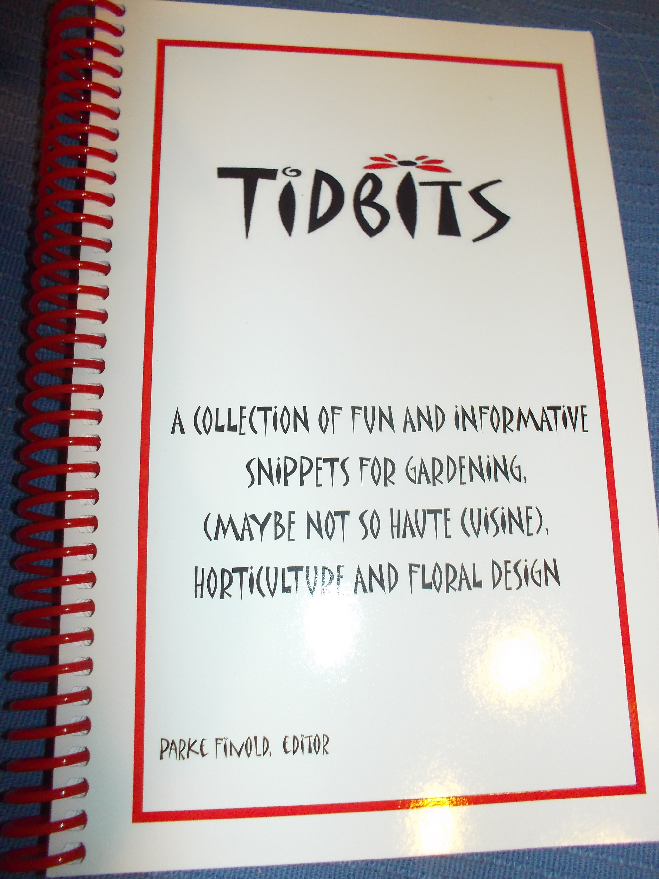
Our newly published book, “Tidbits”, contained information provided by members on a variety of topics of FFGC interest. Each submission was noted with member name and club. 750 copies were sold. All board members submitted electronic reports to save paper! All FFGC members now had access to board member reports through the FFGC website. Five $2000 Scholarships were given in 2013-2014 and Florida’s two eligible applicants won NGC scholarships. FFGC created the Earth Steward Award to honor anyone who had made notable efforts in the stewardship of our natural resources. President Angle presented an Earth Steward Award to former Governor and U. S. Senator, Bob Graham, for his dedication to Florida’s natural resources. In his thank you remarks he announced “there was no one he would rather have on his side than FFGC!” President Angle was presented an Earth Steward Award along with 53 deserving recipients in the 2013-2015 administration. FFGC members, along with 200 other groups in Florida, endorsed the campaign to place ‘Florida Water and Land Conservation’ constitutional amendment # 1 on the November 2014 ballot. The Water and Land Conservation Amendment passed!
16 garden enthusiasts traveled with FFGC to the World Flower Show in Dublin. Florida was proudly represented by our most creative designers. At the 20th annual EPCOT Mother’s Day Flower Show, 35 designers created floral designs. In 2014 FFGC clubs/ circles donated a phenomenal $11,579 to the National Forest Service for the Penny Pines Project.11 new Blue Star Memorial Markers were completed and 20 Butterfly Sanctuary Certificates were awarded.
Pratt & Whitney awarded the Wellington GC a $5000 Green Power Grant for work at an elementary school and landscaping Habitat for Humanity Homes.
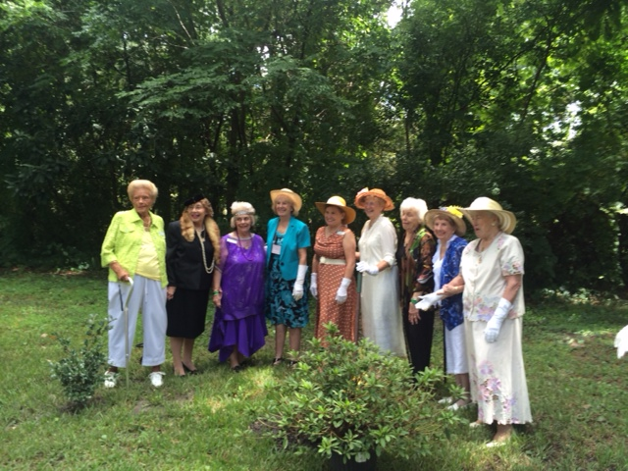
Two new Position Statements were approved in 2014: Reduce Marine Plastic Pollution and Ban Hydraulic Fracturing in Florida. We held detailed discussions about our newly selected membership platform and website, ffgc.wildapricot.org. We collected $2600 from our affiliation with Amazon.com in 2013.
FFGC’s 90th Year Anniversary in 2014 had an exciting start “Through the Garden Gate” with a well-attended Garden Party at headquarters in September which included a commemorative planting in our new President’s Garden, silent auction, raffle baskets, food, displays and designs.
The American Legion held a flag raising ceremony at headquarters with a flag that was flown over the Capitol on 9-11-2002. Members planted trees and wildflowers, held Flower Shows, Leadership, Lunch and Learn sessions, gave away thousands of native trees and held plant sales, won NGC Award Operation Wildflower for Roadside Beautification and $500 for their work on the William Bartram Trail, attended NGC and FFGC educational opportunities and held a variety of fundraisers. Many clubs were presented “Precious Metal Certificates” for their outstanding service.
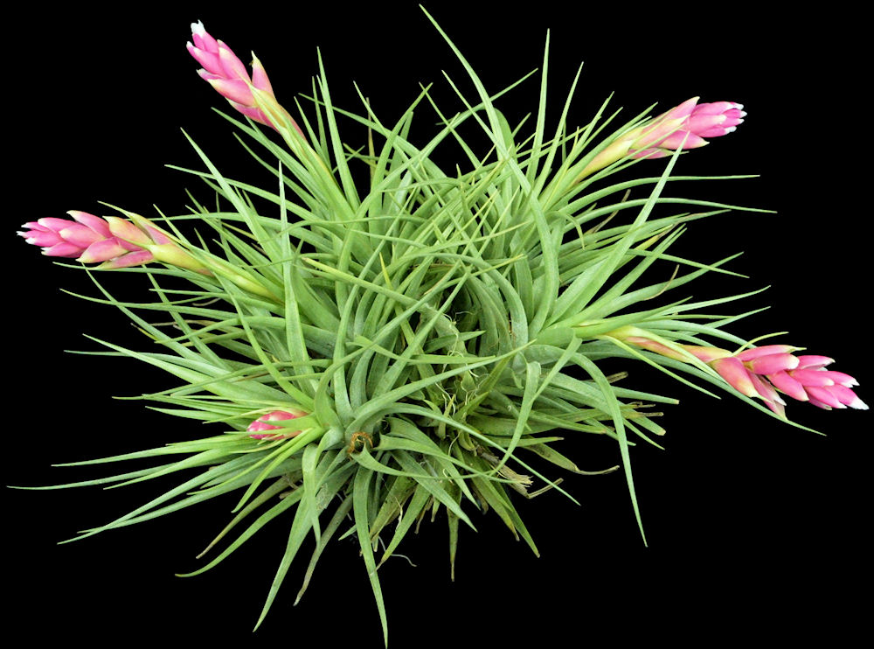
FFGC was represented by 17 members at the NGC Convention 2014 in Norman, OK, and created Invitational Designs to honor NGC President and Deep South Regional Director. A Blue Star Memorial Marker was given to FFGC, the result of a name being drawn from participants in the ‘Sage and Roses’ program.
At the 2015 FFGC Convention Boca Raton, President Angle was honored with a Guardian of Gardening from her district and a registered Bromeliad, Tillandsia ‘Sweet Sue’, was presented.
FFGC members were engaged in identifying environmentally threatened Aquatic Ecosystems, learning about them and supporting organizations actively involved with reducing threats. Member donations to the Coral Restoration project totaled over $20,000, and a coral reef was named for FFGC! 37 NGC Awards were presented at the 2015 NGC convention in Louisville, KY. NGC Award of Excellence was presented to Ken Nedimyer, founder and president of the Coral Reef Restoration project.
27 Deep South Awards won in 2013 in Savannah, GA at convention including, National Gardener Award, Historic Preservation/Restoration Award, Tree Planting, Horticulture, Environmental Education Award, Butterfly Conservation, Adopt-A-Park, Community Action Award, Wildflower Award, Arbor Day, Deep South Regional Mentor of the Year, Deep South Regional Project (State and Club), NGC Youth Sculpture Contest, Smokey Bear/Woodsy Owl Poster Contest. Deep South Awards for Convention 2014 in St. Petersburg included School Grounds Improvement Award, Historic Preservation, Tree Planting Award, Horticulture Award, Landscape Design Award, Educational Environment Award, Environmental Conservation Award, Butterfly Conservation Award, Adopt-A-Park Award, Community Action Award, Wildflower Award, Conservation Award, Deep South Regional Garden Club of the Year Award, Publicity Passbook Award, Youth Sculpture Contest. 2013 NGC Awards won in Buffalo, NY included three Publication Awards, Garden Center, Special Achievement, Blue Star Memorial Marker Landscaping, and Youth Environmental Concerns. Flower Show Awards included four Flower Show Achievement Awards. NGC Awards included Operation Wildflower Roadside Beautification, and two Scholarships. NGC Awards won in 2014 in Norman, OK included Cookbook Publication Award, Operation Wildflower, two Youth Recyclable Sculpture Contests and two scholarships. Awards for a Club Standard Flower Show, a Holiday Standard Flower Show, and a Standard Flower Show Staged in Public Building were also won.

