FFGC History—Our 8th Decade 1995-2004
President Marion B. Hilliard, 1995 – 1997, chose as her theme “Caring for Creation Through Service, Stewardship and Sunshine.” In 1995, membership was 21,600 and in 1997 was 22,500. The Nell Coe two-year project was ‘Establishing Urban Wildlife Habitat Areas’. A new Membership Brochure was published for 1995-1997. Jess Connor’s Kuggerand with bezel and chain presented to FFGC by former NCSGC and FFGC President Ellen Griffin in September 1995. President Hilliard represented FFGC at the 7th annual National Urban Forestry Conference in New York. Florida Forestry Council Urban Community Award received for our Hurricane Andrew Tree Project. Partnership plaques presented by Walt Disney World for FFGC participation in 1995 EPCOT International Flower and Garden Festival. A Floral Extravaganza at EPCOT was held featuring programs on Floral Design and a Mother’s Day flower show. Disney World 25th Community Service Award of $3000 and Silver Anniversary Trophy were presented to Wekiva Youth Camp program. Wekiva campers: 1995-610, 1996-598. New Wekiva Canteen dedicated June 1995. SEEK conference held at UF with 70 students each summer.
We amended our standing rule for Precious Metal status to include clubs with 30, 40 and 50 years in FFGC. Book of Information was published in loose-leaf format. Scenic Highways/Greenways/Rails to Trails and School and Backyard Gardening chairmanships were added to the FFGC Board. Headquarters ‘Color Our Garden’ program was initiated to renovate and re-landscape our headquarters grounds. The project received over $3,000 in donations. The first edition Florida Series Ornament design, the state with orange blossoms, was approved with profits to be shared 25% to General Operating Fund and 75% to Headquarters and Endowment Fund for Headquarters Renovation Projects.
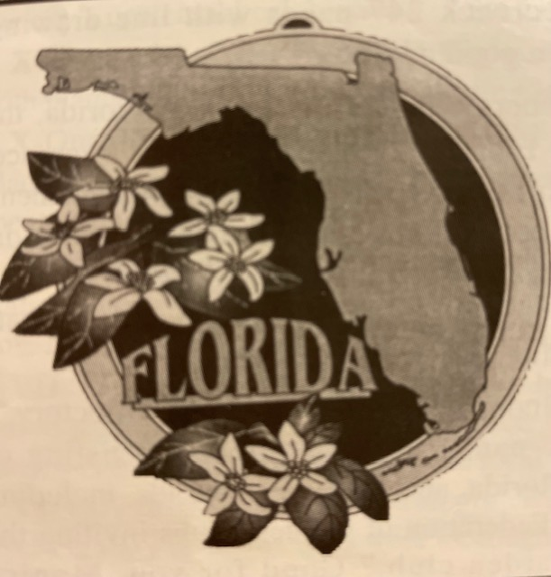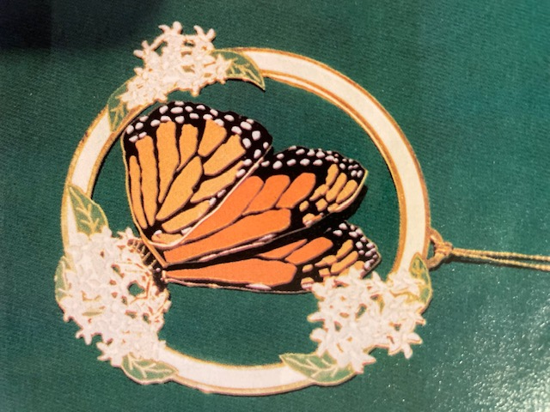 The second edition Florida Series Ornament, featuring the Monarch Butterfly, the official FFGC Butterfly, was introduced at 1997 Convention. $25,000 given to Scholarship Endowment Fund. Nine scholarships of $1500 and one for $3000 awarded in 1996. Ten scholarships given in 1997. ‘Tea and Croquet in the Park’ to kick off Miami’s Centennial Celebration. Two FFGC sponsored Legislative Days were held at the Capitol with Governor Lawton Chiles proclaiming the day “FFGC Legislative Day”. We had 5,560 Youth Gardeners registered in over 150 units. One youth flower show was held with 1,200 participants. We published a new Youth Manual for group leaders. A new VCR program on How to start a Youth Group was taped. Garden Club of Switzerland won National Gardening Association $500 seed and tool grant in recognition of their multi-level youth program. 121 school Butterfly Sanctuaries were registered and 67 Butterfly Sanctuary Certificates were presented to individuals, parks, hospitals, a prison and public areas and 8 Butterfly Gardens were certified. NCSGC/Shell Oil PETALS grant for I-10 Welcome center was co-sponsored by FDOT. NCSGC/Shell Oil PETALS grants were given to 15 clubs totaling $6,725. Hazel Hodges, former FFGC President, received the first Highway Beautification Partnership Award from the ‘Keep Florida Beautiful’ Commission. Hazel Dunlap Memorial Plaque relocated at new I-95 Welcome Center and Memorial tree dedicated in 1985. Landscaping was completed at I-95 Welcome Center entrance and parking corridors designated as a Special Project of FFGC and FDOT. Native Wildflower Seed Bank was active in collecting and sharing seeds throughout the state. 22,000 pounds of wildflower seeds were planted. The first FFGC sponsored Wildflower Conference: ‘Whose Roadsides are They Anyway’ held October 1996. Four Wildflower Education Information Display Boards were placed at I-10, I-75 and I-95 Welcome Centers. President Hilliard and Elizabeth Pate, Roadside Beautification Chairman, were appointed to the I-75 Tourism and Highway Beautification Task Force by the Florida Legislature. $15,000 grant was presented to FFGC/FDOT from the Federal Highway Administration. Five FDOT Maintenance Units received Ella P. Wood ‘Paths of Sunshine’ Awards. President Hillard honored with a plaque for her commitment, support, and cooperation from FDOT. President Hilliard represented FFGC at the Governor’s Council for Sustainable Florida, the Environmental Education Award dinner, dedication of Titusville Garden Club Garden Center and Specialty Gardens, the NE Florida Environmental Round Table, the Environmental Education Resource Council, Greenscapes annual meeting, and dedication of landscaping at Wekiva Youth Camp, winner of the Rucker Award for Landscape Design.
Four fall and spring Flower Show Schools Symposia were held (Tampa, Pensacola, Maitland, Jacksonville Beach). Four Flower Show Schools held, adding 22 judges. 26 Basic Floral Design Study Workshops with 100 Certificates awarded in 1997, 3 advanced series completed, and a 2-day refresher workshop for Floral Design Instructors was held in September, 1996. With Bob Thomas instructing, we introduced the Revised Floral Design Manual for instructors. Gardening Study Course was completed, four Short Courses were held, 2 at UF and 2 at West Palm Beach, and two Penal Therapy Horticulture shows held at Avon Park Correctional Institute. Two Horticulture Study Seminars were held in south Florida. Landscape Design School was held at headquarters. Two South Florida Tropical Horticulture shows were held with FFGC as co-sponsor. Two Blanche Covington Courses were held at Wekiwa Springs State Park. Our District Speakers Directory list was revised. A/V slide programs were reviewed, revised and new programs added. Monsanto Corporation donated 10 copies of A Natural Balance: restoring native habitats and Paradise Found: Protecting the Galapagos Archipelago. We published revised Bee a Winner booklet.
NGCSC 1996 Installation of Officers included Marion Hilliard, Phyllis Wood and Jean Villareal. Garden Clubs helped restore Hurricane Opal damage through contributions to Friends of Florida State Parks. A $7,000 goal for roof restoration of greenhouses at Avon Park Penal Correctional Institute was achieved. Penal Therapy Fund initiated to establish the first Botanical Garden at Avon Park. The 1997 Arbor Day “Pull a Pepper, Plant a Tree” youth activity resulted in pulling 3,380 Brazilian Pepper and planting of 27 specimen trees. Plans, funding for Wedding/Special Event Gazebo on Headquarters patio approved. Blue Star Memorial Marker originally dedicated at site on US 1, Fort Lauderdale, replaced during special ceremony.
FFGC won Emerald Award for Deep South project, ‘Networking with the Birds’. 829,525 trees were planted for ‘Millions of Trees for the Environment’. Approximately $10,000 contributed to World Gardening. $60,000 added to FFGC Scholarship Endowment Fund. Camellia Woodville, variety ‘Marion Hilliard’ presented by Anna Barfield, registered African Violet “Marion’s Enchanted Trail” presented and Euphorbia milii variety ‘Marion Hilliard’ presented by Frances Hunter. 1996 Deep South Awards included: The Florida Gardener, Membership, High School Gardeners, Junior Garden Club Award, Intermediate Gardeners Award, club awards for Historical Preservation & Restoration and Butterfly Conservation. Youth awards included ‘Keep America Beautiful’, High School speech contest, two youth poetry winners, three Smoky Bear & Woodsy Owl Poster Contest winners. 1996 NCSGC awards included NCSGC Silver Seal, Bronze Seal for Floral Extravaganza at EPCOT, six certificates for publications, Silver Trophy for Conservation Education at Wekiva Youth Camp, 10 Flower Show Awards, Exxon Civic Development Award, ‘Tell me about Energy’ award and two Publicity Press Book awards. 1997 Deep South awards included High School Gardeners, Intermediate Gardeners Awards, and club awards, Historic Preservation, and Tree Planting. Youth Award included ‘Our Strategy for Endangered Species Survival’ High School Essay Contest and one poetry winner. 1997 NCSGC awards included 14 flower show awards, Silver trophy for Conservation Education for Junior Ranger Program at Wekiva, a special certificate for SEEK ‘96 High School level conference, and six state and club publications awards. Operation Wildflower Roadside award won first place and $1,000, and PETALS State entry won cash award of $500.
Resolutions adopted: Opposition to the proposed Highway Advertising Equity Act, support of retaining Chapman Field as Miami USDA Horticulture Research Station, opposition to Property Taking legislation, support of the Roadside Beautification Act, opposition to a Florida Vegetative Logo Program, support of strong clean water policy, support of Revitilization of Oklawaha River, opposition to Closure of Division of Forestry Miami Coconut Palm Orchard, support of Office of Environmental Education, support of Acquisition of Perdido Pitcher Plant Prairie Preserve by CARL (Conservation and Recreation Lands) Program, support of consideration of Melaleuca mulch as an environmental alternative to Cypress mulch and support of Preservation 2000. We also supported the strengthening and protection of the Endangered Species Act, support of the Scenic Highway Protection Act, support of Clean Water Act, support of funding the Blueway Project (Indian River Lagoon) by the CARL program, support of revised land and resource management plan, and support of Blackwater Heritage Trail.
The 1996 Deep South Regional Convention ‘Wings and Things of Wonder’ was hosted by FFGC in Orlando with 298 attending. The 1996 FFGC convention, ‘A Gardening Celebration on Florida’s First Coast’ held in Jacksonville, hosted by Garden Club of Orange Park and District IV, registered 502. Bylaws amended to increase individual dues to $9; husband and wife dues to $10; and President to be Editor-in-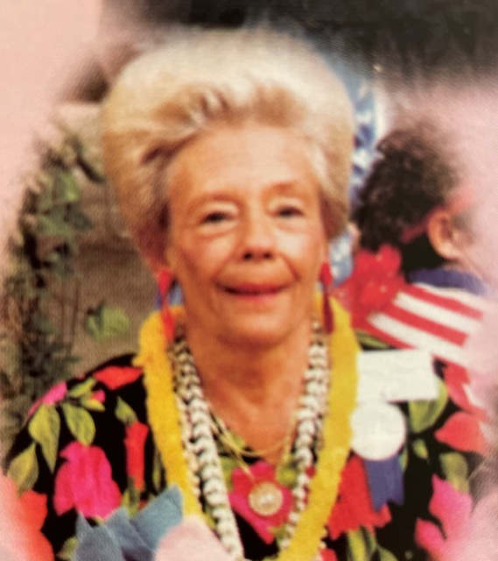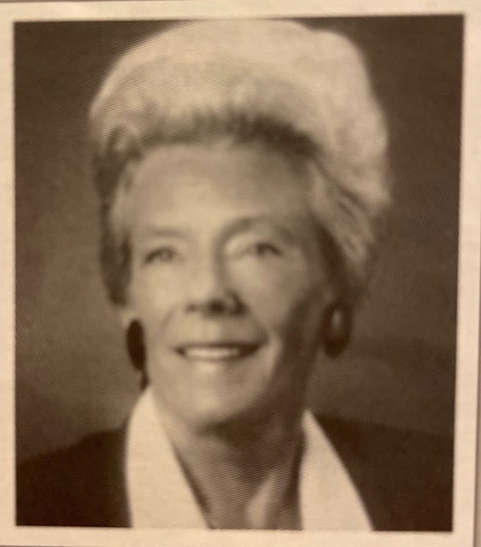chief of The Florida Gardener. Our 26th State Flower Show, “The Worlds of Gulliver”, was hosted by the Judges Councils of Districts VI and IV, held in Daytona Beach in conjunction with 1997 Convention, ‘Sea, Sand and Surf’ hosted by District VI, registered 542.
President Jo Williams, 1997 – 1999, chose as her theme, "Now is the Time to Touch Tomorrow". FFGC Membership was 20,000, making it the largest club in NCSGC. Membership was 19,199 as of December 1997. The total FFGC Life Memberships 2,005 in 1997 and 2,108 in 1998. Four organizations were accepted as affiliates: Harry P. Leu Gardens of Orlando, Audubon House and Tropical Gardens of Key West, Central Florida African Violet Society of Orlando, Botanic Gardens, Inc. of Naples. Silver Springs, recognized as new affiliate.
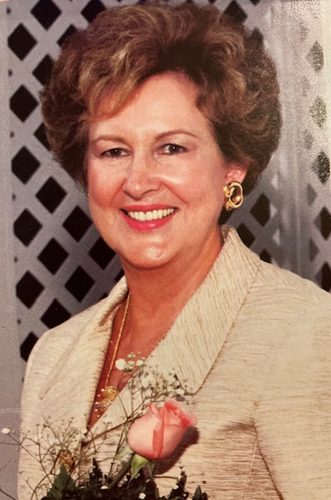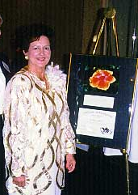Twenty-five national awards were presented, including 14 Flower Show rosettes. FFGC received the Governors Environmental Education award for Wekiva Youth Camp. A slide program of designs made by FFGC members was prepared. The special FFGC Youth Project was ‘Grandmother Stories for Youth Ears NATURE-LY’. FFGC donated $1,000 to the National Fund for the US Botanical Garden. At the 26th annual Community Service Awards Ceremony, the Walt Disney World presented a trophy and check for $3,000 to Wekiva Youth Camp. SEEK ’97 was held at UF with 68 students in attendance. Deep South Regional Project ‘Naturally Native’ was participated in by many clubs. Over 2,000 trees were planted in Miami’s Margaret Pace Park by members of District XII (founder and past president of the Miami Garden Club.).
FDOT agreed to provide $30,000 to fund efforts to obtain Coreopsis Specialty License Plate; FFGC furnished 10,000 signatures for the license plate. The sale of the plate provides a wildflower research center in Florida to sustain, enhance and expand Florida’s heritage of native wildflowers. 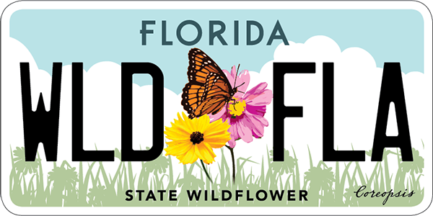
Special presentation held for membership and a tribute given to Ellen Griffin by Past Presidents of FFGC. Seven benches were added to the patio area at Headquarters. $40,000 from H&E Fund was used to remodel the FFGC Headquarters building entrance. Eight FFGC Scholarships for 1997-1998 were awarded. A Scholarship Tea entitled “Aura of Earth” was held at the 1924 historic home in Coral Gables, proceeds benefit the Scholarship Endowment Fund Program. The remainder of the Hurricane Andrew Fund ($2,200) was donated for trees for Habitat for Humanity projects in the Miami area. Landscape Design Courses were held in Jacksonville, Winter Park, and at the Garden Club of Jacksonville. Gardening Study Courses were held at Pinellas Extension Office, in Bradenton, and in District VIII at the Hillsborough Extension office in Seffner. Floral Design Study was sponsored by Garden Club of Crystal River and Palm Garden Club. Flower Show School held in St Petersburg. A Horticulture and Floral Design Show was held at Avon Park Correctional Institution on March 21. FFGC fall Symposium was held in Winter Haven and the spring Symposium held April 13-15 in District IV. Tampa Federation of Garden Clubs held a fall Symposium and the Spring Symposium held in Pensacola. President Williams assisted creating a book on creative design, a legacy of Bob Thomas’ life work. 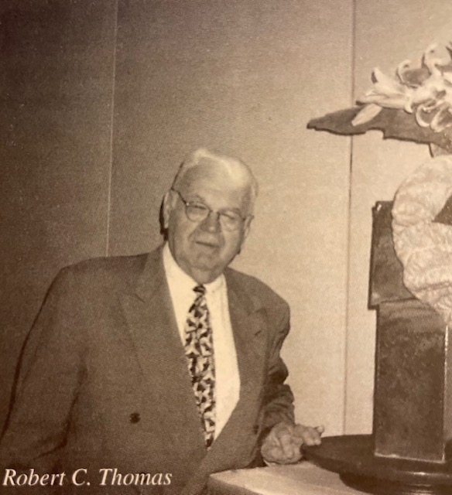 GALA ‘97 held in Tampa with a profit of $22,257. A total of 6,161 copies of the 1998 Florida Flower Arrangement Calendar were sold with a profit of $7,458.91. Blanche Covington Nature Study Course held January 22-25 at Seacamp, Newfound Harbor Marine Institute facility in Big Pine Key (for more info www.seacamp.org). The 42nd Annual Tropical Short Course, “Time out in the Tropics”, held in West Palm Beach. Guidelines for a proposed FFGC certified Butterfly Sanctuary were adopted. Two Environmental Awareness Seminars entitled “Protecting your Water: Every Citizens Responsibility” were held. Legislative Day was held and President Williams addressed the Cabinet of the State of Florida at the Capitol. In March 1997, Legislative Day was again held in Tallahassee. Two new FFGC Historic Preservation awards were adopted. Horticulture Study Course held in Miami. The FFGC, Winter Park Garden Club, the Federated Garden Circles of Fort Lauderdale and Berne Davis donated four engraved bluestone granite pavers to the National Garden in Washington, DC (for more info https://www.usbg.gov/national-garden). Thirty-four garden clubs applied for and received PETALS grants. FFGC Convention,’ Splendor in the Tropics’ was held in Fort Lauderdale April 29-30 with attendance of 457. ‘Path of Sunshine’ garden planned to complement the newly refurbished FFGC Headquarters. At the NCSGC convention in Denver, an Award of Excellence was presented to FFGCs nominee, Katy Moss Warner, Director of Horticulture and Environmental Initiatives for Disney. Twenty-two Florida clubs won Deep South and/or NCSGC awards for 1997-1998. 146 attended Short Course at UF in 1997 and UF Short Course ’98 was held June 10-12, theme “Florida Natives”, with 186 in attendance. FFGC donated $1,000 to NCSGC Disasters Fund. Receipts for the National Garden Project total $10,037.77 for the first year of the four-year project. Welcome Station Wildflower Information Boards on I-75 and I-10 were completed; brochures were created highlighting wildflowers and their locations throughout the state. FFGCs award winning website, www.ffgc.org, went online July 25th. Wekiva Youth Camp ’98 went on record as the hottest with 13 days of record heat! New camp Songbook was published. New award for Horticulture established. Third edition of the Florida Series ornament, the Ruby-throated Hummingbird, was introduced. 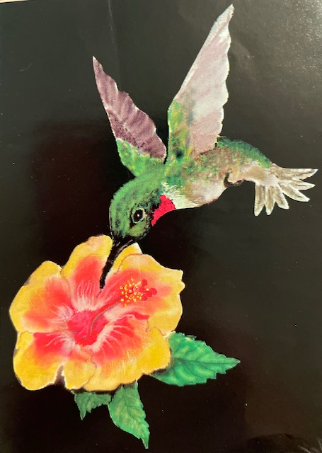
“Let’s Celebrate”, FFGC’s 27th State Flower Show, held at headquarters November 19-20. The ‘Path of Sunshine Garden’ was dedicated to Bob Thomas. As part of the celebration 150 butterflies were released into the garden. Bricks for the ‘Path of Sunshine Garden’ at FFGC Headquarters were sold for $30 each. The new foyer was named for Addie Lou Harris. NCSGC President, Babs Barnette, was present to help with the ribbon cutting.
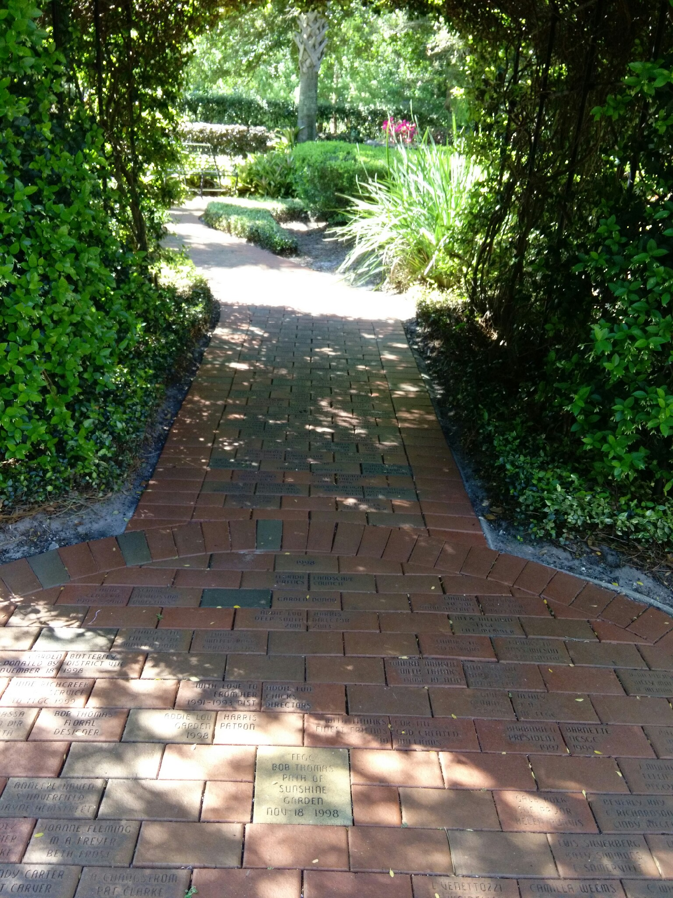
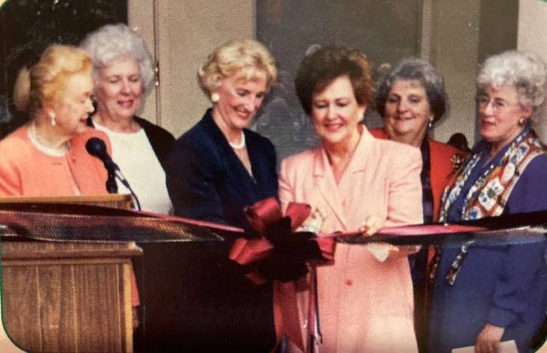
A dedication ceremony, hosted by the Federated Garden Circles of Fort Lauderdale, for a Medicinal Garden was held February 28 at Nova Southeastern University, College of Pharmacy. On March 6, the first Standard Flower Show held in a penal institution titled, ‘Putting our Act Together’, was staged at Avon Park Correctional Institute, accomplished through teamwork between inmates, administration and the Lake Placid GC, Hibiscus GC and the GC of Sebring. 1999 FFGC Convention “Celebrate! Diamond Jubilee” was held in St Petersburg hosted by Winter Haven Council of Garden Clubs, 446 in attendance.

President Carolyn Schaag, 1999 – 2001, chose as her theme: "Centuries in Blossom". In 1999 membership was 19,633, and in 2000 it was 19,362. 18 organizations joined FFGC as affiliate members. Youth Membership for 1990-2000 included 5,400 juniors, 282 intermediates and 143 high school and in 2000-2001, 3,610 juniors, 298 intermediates, 96 high school. 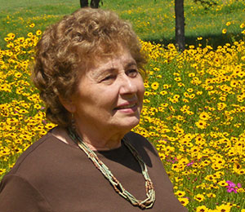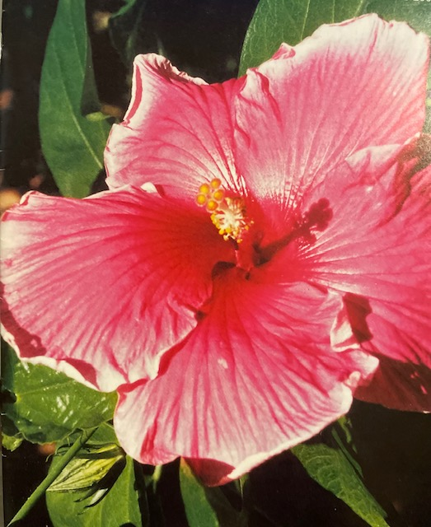 The Nell Coe two-year project was ‘Youth Achievement’. A hot pink hybrid hibiscus was named ‘Carolyn Schaag’.
The year 1999, was the 75th anniversary of organization of FFGC. The year 2000, our January Board meeting was the 75th anniversary of 1st FFGC Board meeting and drafting of constitution and bylaws.
2001 Florida Flower Arrangement Calendar was our 50th edition. Year 2001, FFGC 75th State Convention. The Florida Gardener 50th anniversary. New century and millennium commemorated with time capsule placed at Headquarters (in the safe), to be opened in 2100, and Living History tree, a George Washington Holly, was planted at Headquarters January 12, 2000.
Deep South awards, 18 in 2000 presented in Nashville, TN, 13 in 2001 presented in Calloway Gardens, GA. NCSGC awards, 26 in 2000 presented in San Diego, CA including Award of Excellence for Individuals to Dr. Thomas C. Emmel (butterfly expert), 26 in 2001 presented in Chicago, IL, including Award of Excellence for Individual to Thomas J. MacCubbin and $1000 Operation Wildflower Awards to Valparaiso GC, Palm Harbor GC and FFGC for ‘Crossroads in Blossom’ project. Butterfly Sanctuaries total of 122. Clubs planted 150 Century Trees in their communities to celebrate this new century plus over 132,500 trees. Short Course UF in Gainesville held in June 1999 and 2000. Tropical Short Course held in West Palm Beach in February 2000 and 2001. Landscape Design School held in Sebring. Environmental Studies School held in Bradenton. Wekiva Youth Camp Leadership Training held at Camp in February 2000. Blanche Covington Nature Study Course held at Sanibel Island in September 2000. Fifteen Flower Show courses held in Marathon, Orlando, Pensacola, Tallahassee and West Palm Beach. Four Flower Show Judges Symposiums in Altamonte Springs, St. Augustine, Palm Beach Gardens and DeLand. Floral Design classes in all districts with 27 of basic design and 14 of advanced designs. Two one-day workshops held for certified Floral Design Instructors. Two major Deep South Regional Project conferences held at Headquarters in 2000, in March, Blossoms and Butterflies, in September Environmentally Yours. FFGC members created floral arrangements for Mothers’ Day at EPCOT International Flower and Garden Festival each year. FFGC served as hostesses for NCSGCs Butterfly Garden at EPCOT in 2000. March 28, 2000 declared ‘FFGC Day’ when President Schaag addressed the Governor and Florida Cabinet at State Capitol in Tallahassee and planted a Heritage Tree on Capitol grounds.
The 74th annual convention, “A Century Awakening”, April 26-27, 2000, at Embassy Suites in Boca Raton, with NGC President Deen Smith as special guest and speaker, and Flower Show Judges Councils’ first Petite Standard Flower Show, “Jubilee Junket”, to celebrate their 50th anniversary. The 75th annual convention, “International Magic”, April 21-22 at Grosvenor Resort in Buena Vista, with Deep South Director Peggy White as special guest and speaker, State Flower Show, “EPCOT Escapades”, held at EPCOT.
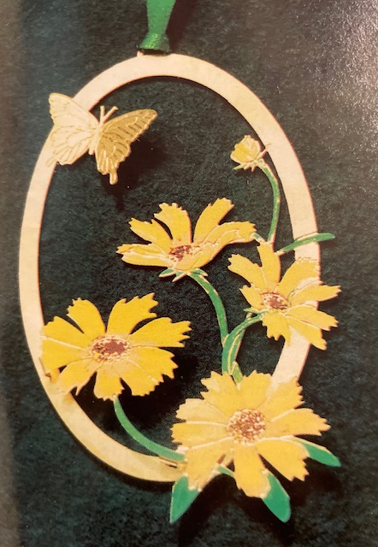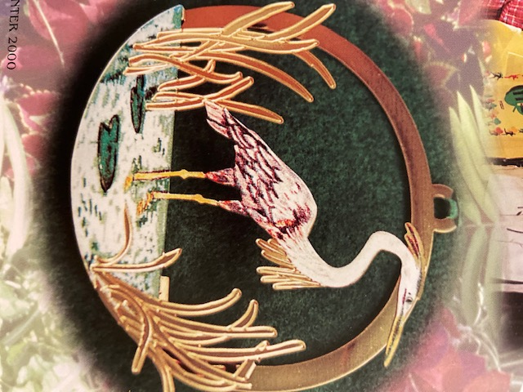
Fourth edition state ornament featured Coreopsis, Florida State Wildflower. Fifth edition featured Great Blue Heron. A bill establishing a special wildflowers license plate featuring Coreopsis was signed by Governor Jeb Bush in June 1999. Final design approval granted in February 2000 by Florida State Cabinet. President Schaag and former First Lady Anne MacKay hosted a coming out Garden Party at FFGC Headquarters for the new license plate. President Schaag appointed to the Florida Wildflower Advisory Council and Florida Wildflower Foundation. Garden clubs landscaped 100 Habitat for Humanity homes. Run, walk and rock and roll-athons were held throughout the state to raise funds. Headquarters rear patio improved, and garden path added with engravable bricks. Stepping stones featuring district flowers, a gift of Jeni Jordan, were placed in the garden.
FFGC Fall 1999 Board meeting postponed a week due to a hurricane. FFGC hosted NCSGC Executive Board meeting in Winter 2001 at Disney. FFGC Board Dinner in April 2001 was held at EPCOT. Three cruises to Panama Canal, Alaska and New Orleans earned $13,700 for FFGC.
A new pin signifying membership in FFGC National Garden Project was introduced: contributed over $23,000 to Butterfly Garden within National Garden in Washington, DC. Three FFGC members, Elise Haymens, Carolyn Schaag , and Joyce Droege won awards at the National Flower Show held in San Diego in May 2000. A $500 grant for ‘Crossroads in Blossom’ project to beautify I-75/I-10 intersection grew to $300,850 in partnership with FDOT.
Book of Information and Supplement, Presidents Kits, 2 Florida Flower Arrangements Calendars, new Florida Garden Club Manual, Headquarters Has it, The Florida Gardener (Quarterly), brochures for Wekiva Youth Camp and Junior Gardeners, flyer for Arboreta and Botanical Gardens in Florida and membership flyer “Plant, Grow, Blossom” were published. FFGC website recognized as “outstanding”.
A new wildflower poster was presented at 2001 FFGC Convention. Elizabeth Pate represented FFGC at ‘Managing Roadsides Naturally’ National Conference at Lady Bird Johnson Wildflower Center in Austin, TX.
We awarded 4 college scholarships in 1999 and 8 in 2000. Four new scholarships were established and 8 previous scholarships increased from $1500 to $2500. Both summers 80 high school students attended SEEK at UF in Gainesville. Both summers 600 campers attended WYC. In June 1999 FFGC celebrated 40th anniversary of a youth camp and was recognized for its 25th year anniversary of Wekiva Youth. Fran Mainella, Director of DEP Division of Recreations and Parks, attended the 25th Wekiva Youth Camp Birthday Bash summer of 1999 and presented an award. Camp improvements included new furniture, air conditioned dining hall, construction of roofed deck on Nature Hut, sun shelter at pool and a ground breaking ceremony for the 4 bedroom/2 bath cabin. Florida State Park system voted as Americas Best and presented state Parks Gold Medal and past FFGC WYC Chairmen received replica pins. New programs and chairmanship was established with emphasis on Childrens’ Gardens. Children involved in youth flower shows, planting trees at schools for Arbor Day and Earth Day.

President Gloria R. Blake, 2001 – 2003, chose as her theme 'Joy in Gardening'. Membership: 18,707. Fourteen organizations joined FFGC as affiliate members. The Nell Coe Award for Achievement in Education in horticulture, design, conservation or nature studies was offered during this administration.
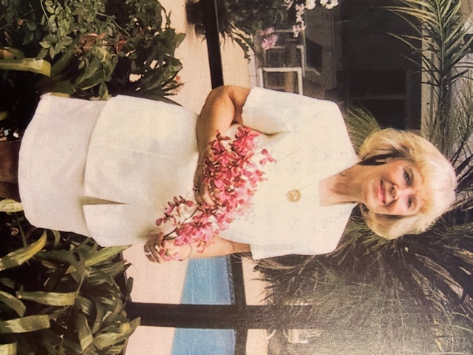
Deep South Awards, 6 first place winners in 2002 presented in Orlando, FL, including the Deep South Region Life Membership Award, the School Grounds Improvement Award, the High School Gardeners Award, the Butterfly Conservation Award, and the Garden Club of the Year Award. In 2003 at Gulf Shores AL, 7 first place winners, including the School Grounds Improvement Award, the Environmental Education Award, the Wildflower Award, the Deep South Unified Regional Project Award, and the Deep South Life Membership Award, plus the NGC Publicity Press Book Award, the Member Award of Honor, the Deep South Life Membership Trophy. In 2002, on an NGC Convention cruise to Bermuda, Florida received 7 Certificates of Merit for publications, 6 rosettes for flower shows, a Certificate of Merit for Blue Star Memorial Marker, 2 NGC scholarship winners from Florida, the Award of Excellence for the FFGC website, won for State Flower Show, and received the May Duff Walters Trophy for Preservation of Beauty. In 2003, at the NGC Convention in Biloxi, MS, FFGC received 9 flower show rosettes, 4 Certificates of Merit for publications, a Certificate of Merit for National Garden Week, 2 NGC scholarship winners from Florida, Special Achievement Certificate, won Hazel Johnson Trophy for Conservation for work at Wekiva Youth Camp, received the Jessie M. Connor for Environmental Education, plus won ‘Leaf Our Way into Century 21’, and for FFGCs project, ‘Crossroads in Blossom’, received Operation Wildflower.
FFGC 76th State Convention, April 17-18, 2002 at the Radisson Resort in Cape Canaveral had as its theme, ‘FFGC Blast Off’. Special speakers included Addie Lou Harris, Deep South Region Director and Link Johnson, Floral Designer. A Petite Flower Show, ‘Out to Launch’ was sponsored by the Florida Council of Nationally Accredited Flower Show Judges. FFGC 77th State Convention, April 30-May 1, held at the Adams Mark Hotel, Jacksonville with the theme of ‘Rainbows on the River’ and guests and speakers included Lois Shuster, NGC President and Penny Decker, Floral Designer. Biennial State Flower Show, “Cruising Down the River”, was held in conjunction with the convention.
We sponsored the following NGC Schools: 6 Flower Show Schools, 4 Flower Show Judges symposiums, Landscape Design Study and Refresher Course. Gardening Study Refresher course. Four statewide Short Courses (2 Tropical and 2 in conjunction with the UF); 28 Floral Design classes held with 447 certificates issued. Two 1-day workshops for Floral Design Instructors, several Presidents Summits held, a Nature Study leadership conference as well as the Wekiva Youth Camp Leadership Training, and an Environmental Awareness Seminar entitled “Today’s Challenge: Good Earth Keeping”. Mothers’ Day at EPCOT in conjunction with the Flower and Garden Festival featured 30 FFGC designers in 2002 and 31 in 2003. In addition, FFGC members presented two floral design demonstrations every Sunday for 6 weeks. Sixth in Florida ornament series (2001-2003) featured the Zebra Longwing Butterfly, the official State of Florida butterfly. The specialty license plate has been purchased by 24,536 loyal gardeners and has thus provided funds of $383,040 for wildflower research. New wildflower poster featuring Coreopsis lanceolata distributed to all district directors for 2001-2003 and FFGC purchased coreopsis seed for distribution. Garden clubs in every district sponsored landscape projects for Habitat for Humanity homes. Funds available from FFGC to assist clubs in landscaping projects total $4,482.50, raised by Habitat walk-a-thons, plus donations of $12,416 and donations of plants from nurseries. Major Headquarters renovations included a new irrigation system, remodeling of the kitchen with new appliances, and a handicapped bathroom. Construction of a new addition for extra storage plus two extra meeting rooms and another bathroom began. In 2002 President Blake and several FFGC members visited the State Capitol and spoke to the Florida cabinet about FFGCs youth programs and in 2003 FFGC was represented by officers and members at the Florida Cabinet for Legislative Day with President Blake again addressing the Governor and the Cabinet about environmental concerns and goals of FFGC. During the presentation, Governor Bush expressed his wish to join FFGC, which he did! Over $5,000 received from FFGC sponsored cruises to the Caribbean and Hawaii. Donations to the Nature Conservancy of Tiger Creek totaled more than $5,000. Fourteen clubs and one district received PETALS grants totaling $4,700 and FFGC received a PETALS grant of $1000 for beautifying the I-75 Ellisville Rest Centers for a total of $5,700. Book of Information and Supplement, two Presidents Kits, two Florida Flower Arrangement Calendars, ‘Headquarters Has It’ brochure, The Florida Gardener (quarterly), membership flyer, ‘Joy in Gardening’, and new brochures Forming a Garden Club Made Easy and Mentoring members were published. A new endowed scholarship given in memory of former FFGC President Ella Wood. 15 scholarships were made available ranging from $2,500 to $3,500. Seven scholarships were awarded from 2001-2002 and 9 scholarships were awarded for 2002-2003. SEEK with 60 students, was held at UF in the summers of 2001 and 2002. In 2002 it was extended to 4 days to allow more coverage of topics such as The Weather and The Lightning Stalker. Florida reported a two-year total of 770,145 trees planted. Wekiva Youth Camp served over 600 students each summer. The 4-bedroom volunteer cabin was christened Tequesta and occupied for the first time. An addition to the program in 2002 was Critter Camp for Kindergarten through second grade. A new Camp Wekiva slide show was made available from headquarters. Over $11,000 was donated to FFGCs World Gardening and Natural Disasters project.
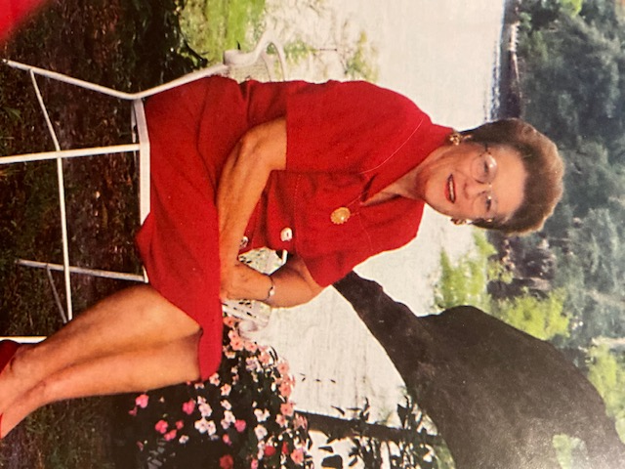
President Joan Webb Pryor, 2003 – 2005, chose as her theme: 'Keep Growing'. Membership was 17,700. The Nell Coe Award was given for best stand of wildflowers or native plants on a trail in Florida.
The 2004 Deep South Regional convention was held in Baton Rouge, LA. FFGC received first place in School Grounds Improvement, Historic Preservation, Membership Award, Butterfly Conservation Award, Adopt-a-Park, Community Action Award, and Intermediate Gardeners Award, plus the Deep South Member Award of Honor to Eugene J. Spargos of Lakeland. In 2005 at Tunica, MS, FFGC received first place in ‘Volunteers with 20/20 Vision’, the Deep South Regional Project, School Grounds Improvement, Historic Preservation, Membership, High School Gardeners Award, and Butterfly Conservation, plus the Deep South Member of Honor to Marie Harrison of Valparaiso. At the National Garden Clubs Convention in 2004 in St. Louis, MO, FFGC received the Award for State Garden Clubs, two publication certificates, eight flower show awards, first place awards for High School Gardeners, Conservation Education, Butterfly, Civic Projects with Native Plants, plus the Member Award of Honor to Eugene J. Spargos. In 2005 at Milwaukee, WI, FFGC received eight flower show awards, two publication awards, the NGC Conservation Award, Roadside Beautification Award, and DeFuniak Springs received the NGC Special Award for Historic Gardens. The Member Award of Honor was given to Marie Harrison, the Helen S. Hull Award to Inez Brooker, and the Award of Excellence to Jim Thomas.
FFGC 78th State Convention, April 19-21, 2004, was held at the Hilton-UF Conference Center, Gainesville. The theme was ‘Ready, Set, Go’ with special speaker June Wood, NGC President, Lorraine Gabler and Sue Kerslake, Designers, Charlotte Porter, Bartram Historian, Don Goodman, Director of Kanapaha Botanical Gardens, John Moran, Nature Photographer, and Eddie Payne, Floral Designer for Rose Parade, plus tours to Kanahapa Botanical Gardens and Paynes Prairie, both described by William Bartram in Travels. FFGC State Convention ‘Beauty by the Bay’ and 30th Biennial Flower Show, ‘Bay in Bloom’, April 28-30, 2005, was held at the Grand Hyatt Hotel, Tampa. Guest speakers were Bonnie T. Borne, Deep South Regional Director, Jennie Lee Zipperer, Woman of the Year in Agriculture, Joe Parr, Busch Gardens Horticulturist, and Kenn Stephens, Floral Designer.
Many of Florida’s Blue Star Markers were refurbished and rededicated during this administration and several new ones have been added bringing the total to 117.
An innovative approach for the Winter Board meeting of 2004 divided members into Cluster Meetings that allowed an exchange of ideas pertinent to each group. The Fall Board meeting of 2004 was cancelled due to hurricanes.
Flower Show Schools were held, along with four Flower Show Judges Symposiums, Landscape Design School, Garden Study School and Refresher Courses for Gardening, Environmental and Landscape Design. Other Schools offered included two Tropical Short courses, two Gardening and Design Seminars, a Blanche Covington Nature Study Leadership Conference, two Wekiva Youth Camp Leadership training sessions, 21 Floral Design classes with 14 in basic design and 7 in advanced design, two one-day workshops for Floral Design Instructors, several Presidents Summits and one Deep South Regional Workshop, ‘Project Wet’.
For the 10th and 11th years, FFGC participated in the EPCOT Flower and Garden Festival with over 30 designers participating in the Mother’s Day Flower Show and seven members giving demonstrations throughout the weekend. The publication of the 55th Florida Arrangement Calendar was notable for being photographed digitally.
NGC recognized members who completed the four NGC schools. The first Four Star Members in Florida were Joan Pryor, Joan Garrison, Jean Skoien, Carol Lucia, Rose Vickers, Barbara Jones and Betty Waterfield. During this administration, ‘Fun with Flowers’ was established as a statewide program and a copyrighted manual was created for distribution in 2004. FFGC continued partnership with Habitat for Humanity by landscaping over 100 homes and raising over $14,000 for the program. In addition to the emphasis placed on planting Native Plants and Wildflowers on Trails in Florida, a separate thrust was made to encourage the use of native eco-type seeds in Florida. A new award, Pillar of Pride, was established to recognize members of purpose, pride and productivity. In the first two years, 37 members were given this honor. To recognize clubs that have existed for more than 80 years, the Precious Metals status of Double Diamond was approved. Presidents Kits were prepared. Four Principal Financial Group Historic Grants totaling $6,000 were given to four clubs, Fort Myers, Tallahassee, DeFuniak Springs and Tampa. Throughout this administration, eight special publicity releases were prepared for clubs to use in their hometown papers. In 2004, five students and in 2005 nine students each received scholarships of $2,500. Donations to the scholarship endowment fund totaled $6,736.50.
Cruises from New York to Maine and Nova Scotia and from Miami to Bermuda and a trip to the Rose Bowl Parade New Year’s Day, 2005, highlighted FFGCs trips.
In fulfilling the goal of America-a-Bloom, garden members planted 10,797 flowering. Sale of the red daisy pin in 2004 and the long-winged zebra butterfly pin in 2005 were special fund projects. Wekiva Youth Camp was accredited by the American Camp Association (ACA). A new program started at Wekiva in 2003 was a 9th grade program, Leaders in Training (LIT). This invitational program is limited to those campers who have been recommended by the 8th grade leaders. Wekiva Leadership Training emphasized water in 2004 and black bears in 2005. Improvements to counselor’s cabins, bathrooms, dining hall, and the craft hall were completed at Wekiva Youth Camp.
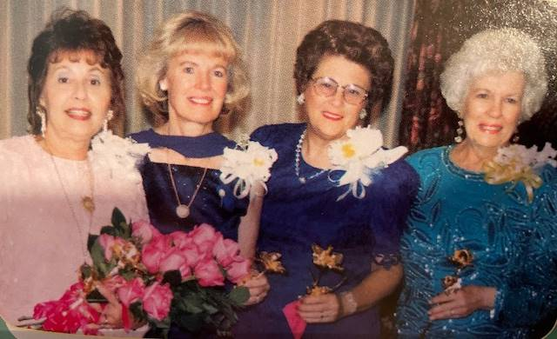
Joan passed away June 28, 2012.

