September 2019 Board Meeting -- Officers and District Director Reports
Note: To access a specific page go to lower left corner, click on ‘Page: 1 of 22” and then enter page number in the Go-To dialog box that will appear.
Table of Contents
President’s Report 2
1st Vice President’s Report 4
2nd Vice President’s Report 5
3rd Vice President’s Report 6
District I Report 7
District II Report 8
District III Report 9
District IV Report 12
District V Report 13
District VI Report 14
District VII Report 15
District VIII Report 16
District IX Report 17
District X Report 20
District XI Report 21
District XII Report 22

President’s Report
President’s Address
Al Latina
September 11, 2019
It’s difficult to imagine that it has already been over 4 months since installation of the new Administration in April. Much has happened since then, and your President and others have been busy all summer carrying out the work of FFGC. Reports given by District Directors and Committee Chairmen today and tomorrow will attest to all that has been done throughout the months since Convention.
Your President is pleased to report that almost every Chairman position have been filled thanks to the positive response from members. Thanks to Karen Smith the BOI has been updated and the printed copies are available for pickup at this meeting. District Directors have been busy communicating with their constituents, and we are ready for many important activities going forward.
All of you have been notified that Liea Ward, Office Manager, requested and was approved for a leave of absence beginning on August 27, and we look forward to her return on October 20. In the mean-time office duties will be handled by our very capable Temporary Office Assistant, Robyn Clifton. Sue Angle, Chairman of Headquarters and Endowment Trustees and your President have conferred and developed a plan for covering FFGC responsibilities during Liea’s absence. We are confident that with Robyn on duty Tuesdays, Wednesdays, and Thursdays from 9:00 a.m. until 1:00 p.m. each week and members who will be helping in various activities, there will be little to no disruption of activities.
The message on the telephone answering machine reflects the changes in place until Liea returns with instructions to request help for answers to questions. The recorded message gives callers the option to leave a message or call Sue Angle or the President with questions which need immediate attention. Robyn will forward emails received to Sue Angle and your President on a regular basis for response if necessary. Our thanks also to Sue Roberts who will maintain and update the website with corrections or additions. Please contact Sue Roberts if you have any comments to make about the website. Ingrid Velez will continue to receive requests for including activities on the FFGC calendar. She will review your Calendar requests and then send them to Sue Roberts for input to the website.
We want our website to be as accurate as possible, and to accomplish that we need your help. Please review your committee on the website for which you are Chair. If anything needs to be updated with new forms or changes need to be made, contact Sue Roberts with the information. District Directors have been asked to review the list of clubs, circles for any needed changes.
Your President is insisting that all Board Members submit a written report for each Board Meeting, regardless of whether an oral report is given. Within a reasonable time after the Board meeting it is expected that every Chairman will check to see if the submitted report is on the website. If it isn’t please contact Linda Feiferek-Johnson, Recording Secretary, to be sure it was received. It is also important that every Board Member check the website for your Board position to be sure a correct description is available.
Please do not forget the theme for this administration of FFGC, “Diversity in the Garden.” Your President is pleased that positive feedback to the theme have been received, and there is good evidence that the theme is “alive and well.” We now have 4 male Board members, and we are beginning to see other signs of Diversity increasing among our membership.
KEEP UP THE GOOD WORK. AS HAS BEEN SAID “TOGETHER WE CAN MAKE A DIFFERENCE.”

1st Vice President’s Report
FFGC 1st VP Report
Marjorie H. Hendon
September 11, 2019

This 1st Vice President is so excited about attending all the events since the April 2019 FFGC convention. Deep South, National Garden Clubs. Inc.’s convention, two weeks at Wekiva Youth Camp, a visit to SEEK, UF Short Course, Short Course North, and July’s Finance Committee meeting were some of the events that this 1st VP attended.
Once becoming 1st VP it was time to attend a Deep South and National Garden Clubs’ convention. They were informative, fun, and worth going to in every way.
The 2nd VP asked if it was possible for this VP to cover Wekiva Youth Camp for two weeks, since she covered two weeks during this VP’s six weeks of camp in 2018. It was such a pleasure going back to be a part of such a positive experience. During my two weeks at Wekiva, a day trip was taken to experience the classes taking place at SEEK, at Chinsegut Conservation Center, Brooksville, FL. The students were watching as Forest Rangers set fires to teach about controlled burns. Lunch followed and then more guest speakers.
The summer wouldn’t be complete without attending UF Short Course and Short Course North. UF’s was held in Gainesville. Bees, FL native plants, how plants land on the invasive plant list, caladiums, and eating your way around your yard were great topics to learn about. Short Course North was held in Milton, Fl. We studied photography in nature, native milkweed varieties, sand dunes, and growing weird vegetables in your garden. We also had the opportunity to make and arrange fantasy flowers.
Marjorie H. Hendon
1st VP FFGC
This VP attended DEEP South, NGC convention, Wekiva, SEEK, UF and Short Course North, and was Chairman of the July Finance Committee meeting since convention 2019.

2nd Vice President’s Report
FFGC 2VP Report
Tina V. Tuttle
10 September 2020

25-26 April Wekiva clinic and office building burned to the ground. Attributed to electrical causes.
April- May (ongoing) Financial aid to parents (processed over 30 requests for money—gave no more than 50% or $120 per camper), fingerprinting volunteers/kitchen staff/park host—processed over 80 resubmissions or screenings), ordered necessary items for camp through Amazon, etc.
2 May Attended NGC installation in Biloxi, MS.
10 May Met with Wekiwa Springs State park personnel about burned down clinic/office building. Discussed replacing building and preferred site.
12-13 May NGC 2022 convention site visit to Orlando, St Augustine and Jacksonville with Mary Warshauer, 2VP NGC.
May 11 EPCOT Mother’s Day at Flower and Garden Festival participant creating take-home designs for guests.
June 9-11 Attended FFGC/UF Short Course Gainesville.
June 11-17 Wekiva Youth Camp Orientation and opening day for boys’ week 1, purchased washer and dryer for dining hall (B&M account for $800), 7th grade tent camping supplies (over $800), clinic star-up supplies (over $350), etc. Canteen spent (over $900 for starting weeks)
June 15 Attended Blue Star Memorial Marker dedication in Tampa and gave Military Tribute
June 17-18 Attended one day of SEEK at Chinsegut Hill as chaperone/counselor
June 30-July 13 Wekiva Youth Camp weeks 3 and 4, Coed/Critter/LIT and girls’ week. Helped with Naturalist Program all of week 4.
July 17 Burned/destroyed 2007 Camp medical and personnel records.
July 20-27 Wekiva Youth Camp girls’ week 6 and pack out
July 22 End of Camp meetings with program coordinators/directors and state park personnel.
July 24 Attended FFGC Finance meeting at HQ. Presented a 10% raise in registration fee to Wekiva and 10% raise for all Wekiva staff personnel.
August 8-9 Attended Short Course North. Provided door prizes and plants.
August 19-20 Attended and taught FSP for Flower Show School II in Gulf Breeze, FL and provided all meal service.

3rd Vice President’s Report
FFGC 3rd Vice President Report
Christy Linke
September 9th, 2019

This 3rd Vice President is excited about being on the FFGC Board. Learning the responsibilities of the position is what I’ve been doing.

Attending SEEK for the first time and experiencing the education and knowledge that was gained was amazing. So much is learned at SEEK and the kids as well as the adults loved it.

Taking on the role as camp Chairman for 1 week, and attending Critter Camp got this VP excited about the years to come.

The Wekiva Volunteer Training proposed budget has been submitted for 2020, Open House Flyer for 2020 completed and all have been put on the FFGC Calendar.

Served as Secretary for the Finance Committee and informed all who submitted budgets for approval.

In August the inventory was done in the gift shop at FFGC Headquarters.

Convention 2020 has been keeping this chairman busy throughout the summer. Budgets, Opportunity Drawings, Advertisement, Sponsorships, Registration Form, Programs and Workshops as well as meetings have been a priority.

District I Report
District I Fall Activity Report
Kathy “Kat” Spieker, Director
spkfreedom@embarqmail.com
FFGC Board of Directors Meeting Sept 10-12, 2019

District one is way out in the Northwestern part of the state, and although our climate is much cooler than some of yours, our very active clubs don’t let that stop them. In January a number of clubs held Arbor Day programs that included lots of tree give aways.
Green Thumb Garden Club held the Floral Design Studies classes last fall and they are going to do the series again in January as it was a huge success.
Preparations are under way for the Fall officer’s tour. District I is so proud to welcome our new officers! Navarre Garden Club is hosting the event on October 8, 2019 at a beautiful venue in Navarre.
Several garden clubs held flower shows during this past year. All were well attended and the Valparaiso Garden Club Youth section was the hit of their show!
Clubs continue to create innovative ways to raise funds to support their various projects and educate the public about NGC goals and principles.
Several of District I’s clubs have very active Junior Gardener programs and they are growing all the time! One club reported their junior gardeners grew from 6 kids to 22 in just one year.
During the summer months one of our clubs put on programs at the public library on container grown herbs and also participated with the local museum for a children’s day camp at which they taught about pollinators.
District I hosted Short Course North again this past August with GREAT presenters, vendors and programs.

Respectfully Submitted,
Kathy “Kat” Spieker

District II Report
District II Fall Activity Report
September 10, 2019

District II is still in the rebuilding status/ But, just as in the book “The Rising of the Phoenix” the most beautiful bird arose from the ashes. District II will do the same – bigger and better than before.
The trials and tribulations have resulted in BONIFAY doing the “disappear and reappear” act. I am quite confident that they will be back. This is not the first time that this has happened.
The clubs are getting their programs together and looking forward to the visits. I have learned that a PALM TREE is not a tree, but a GRASS.
We are eagerly awaiting the OFFICERS TOUR on October 9.

District III Report
District III Report
September 11.2019
Mickey Nyberg
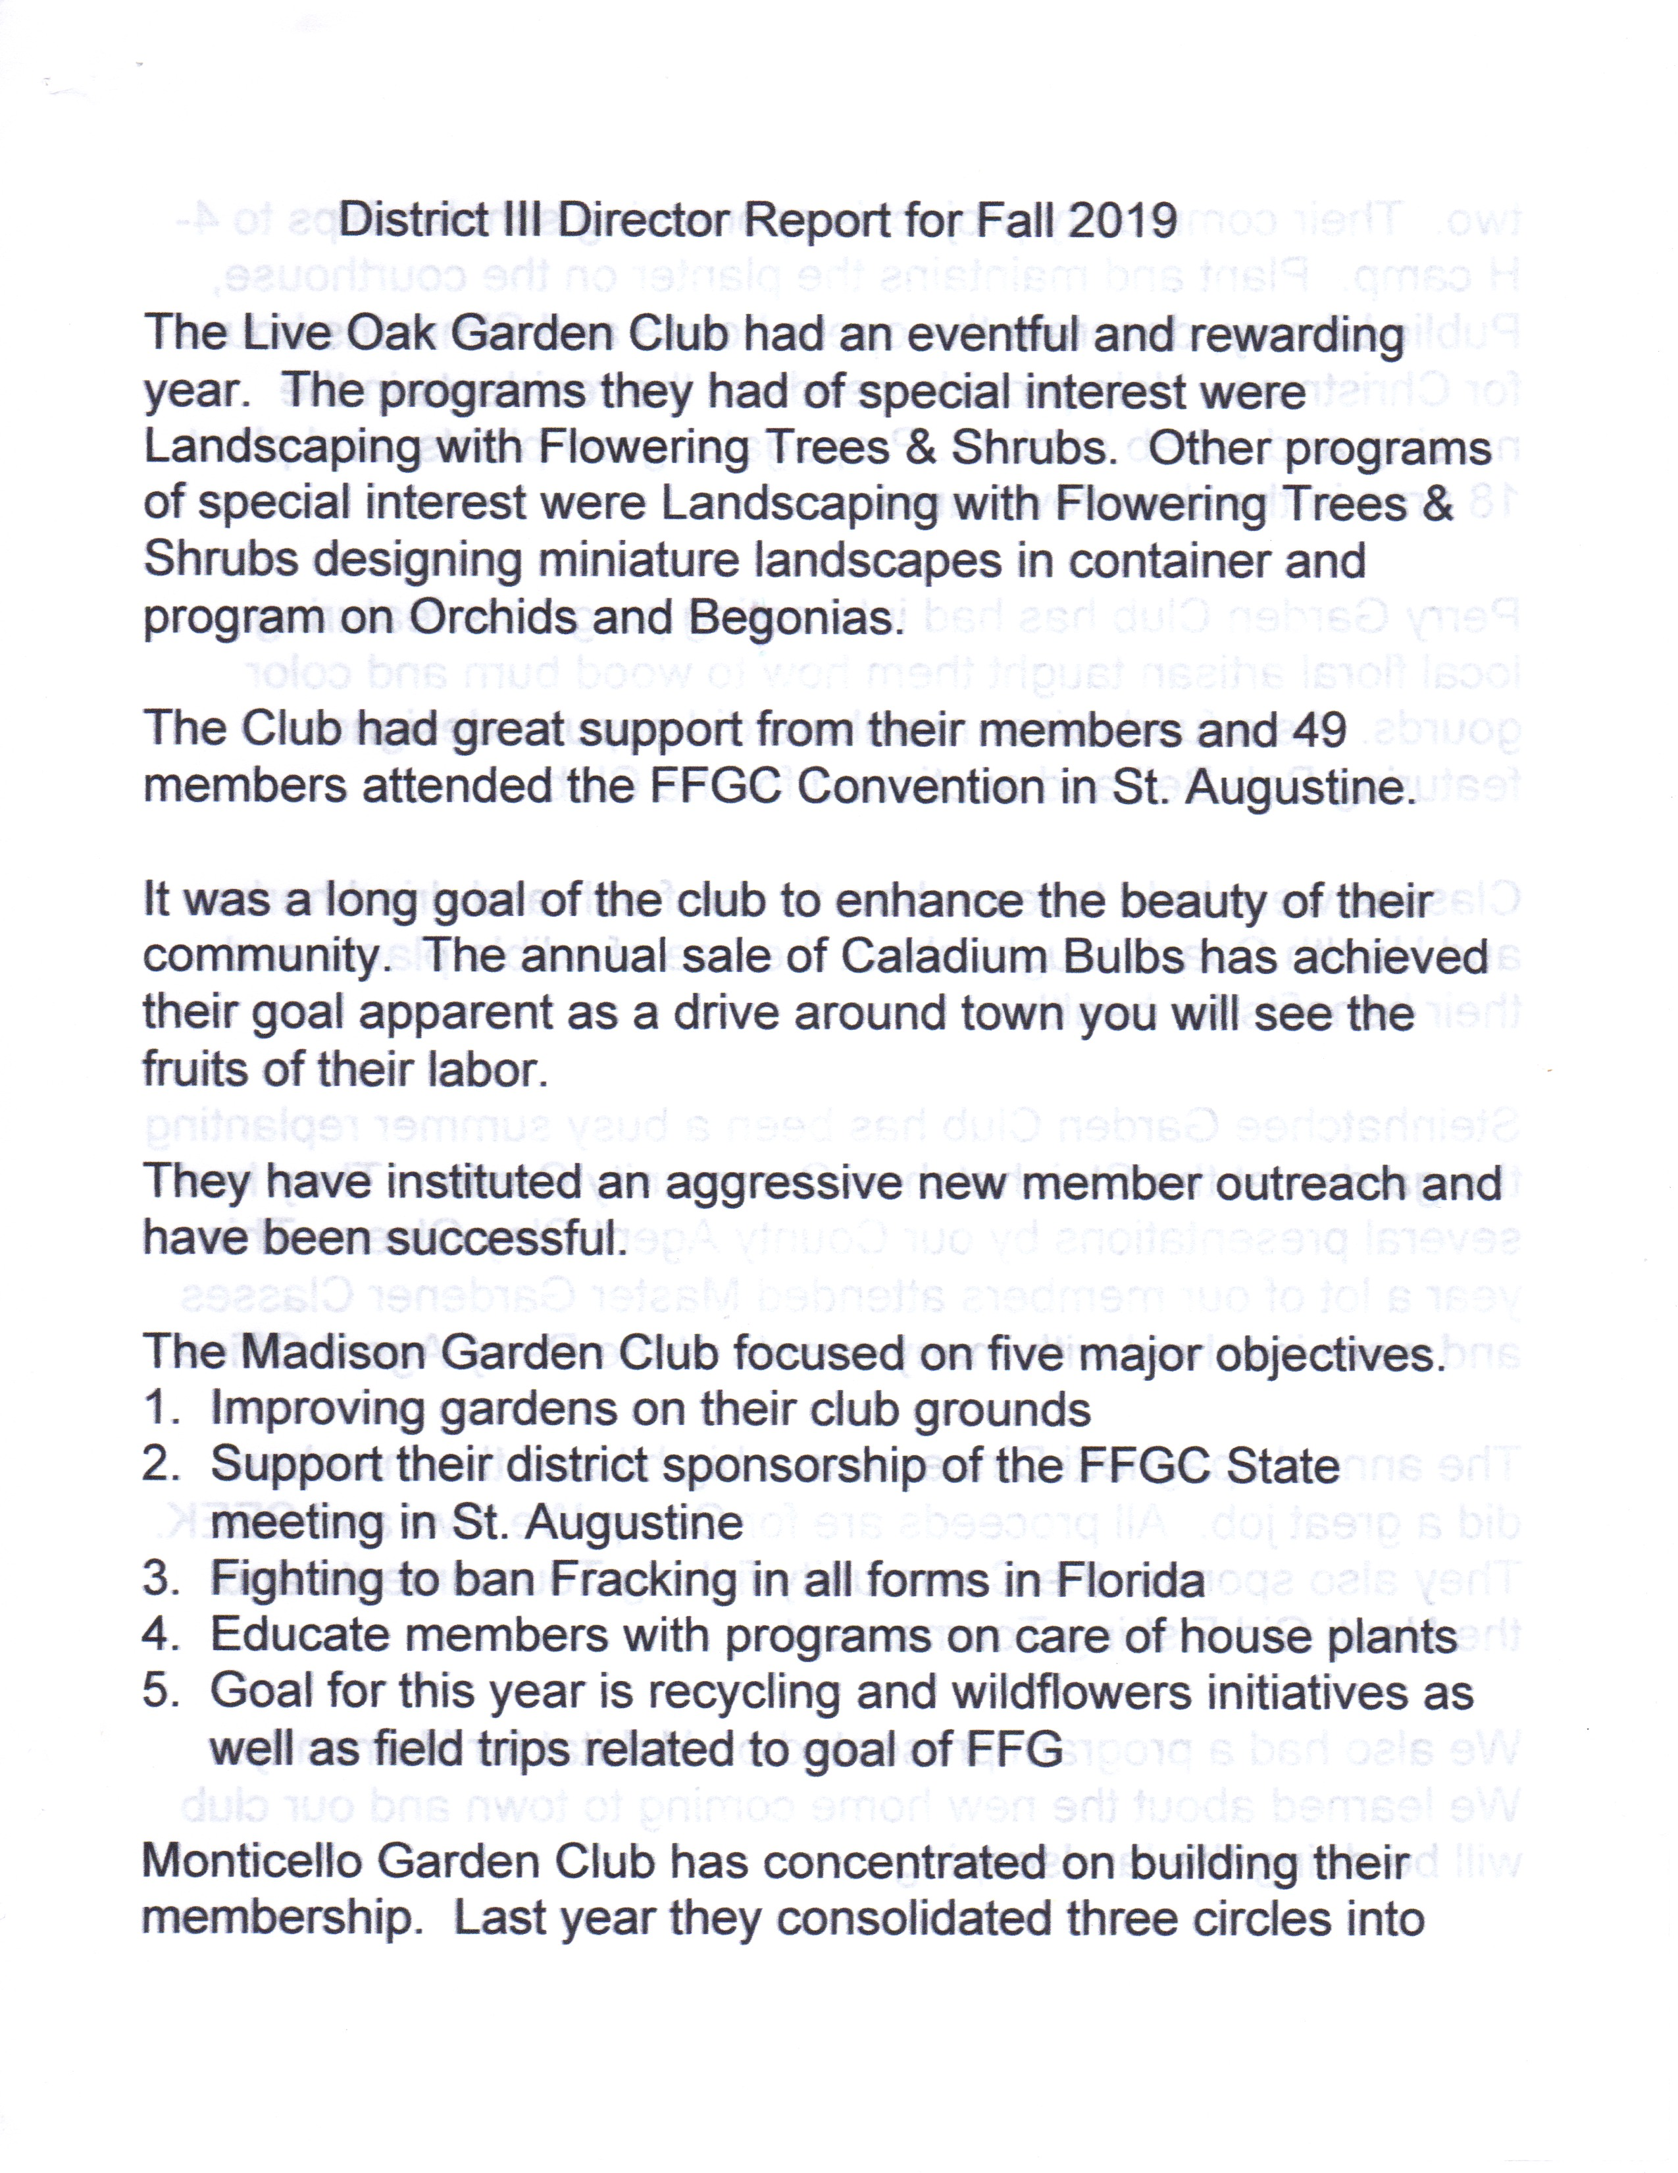
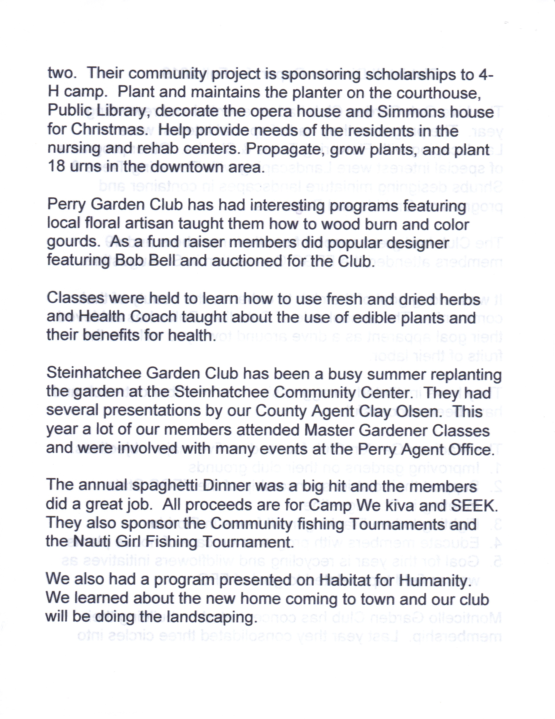

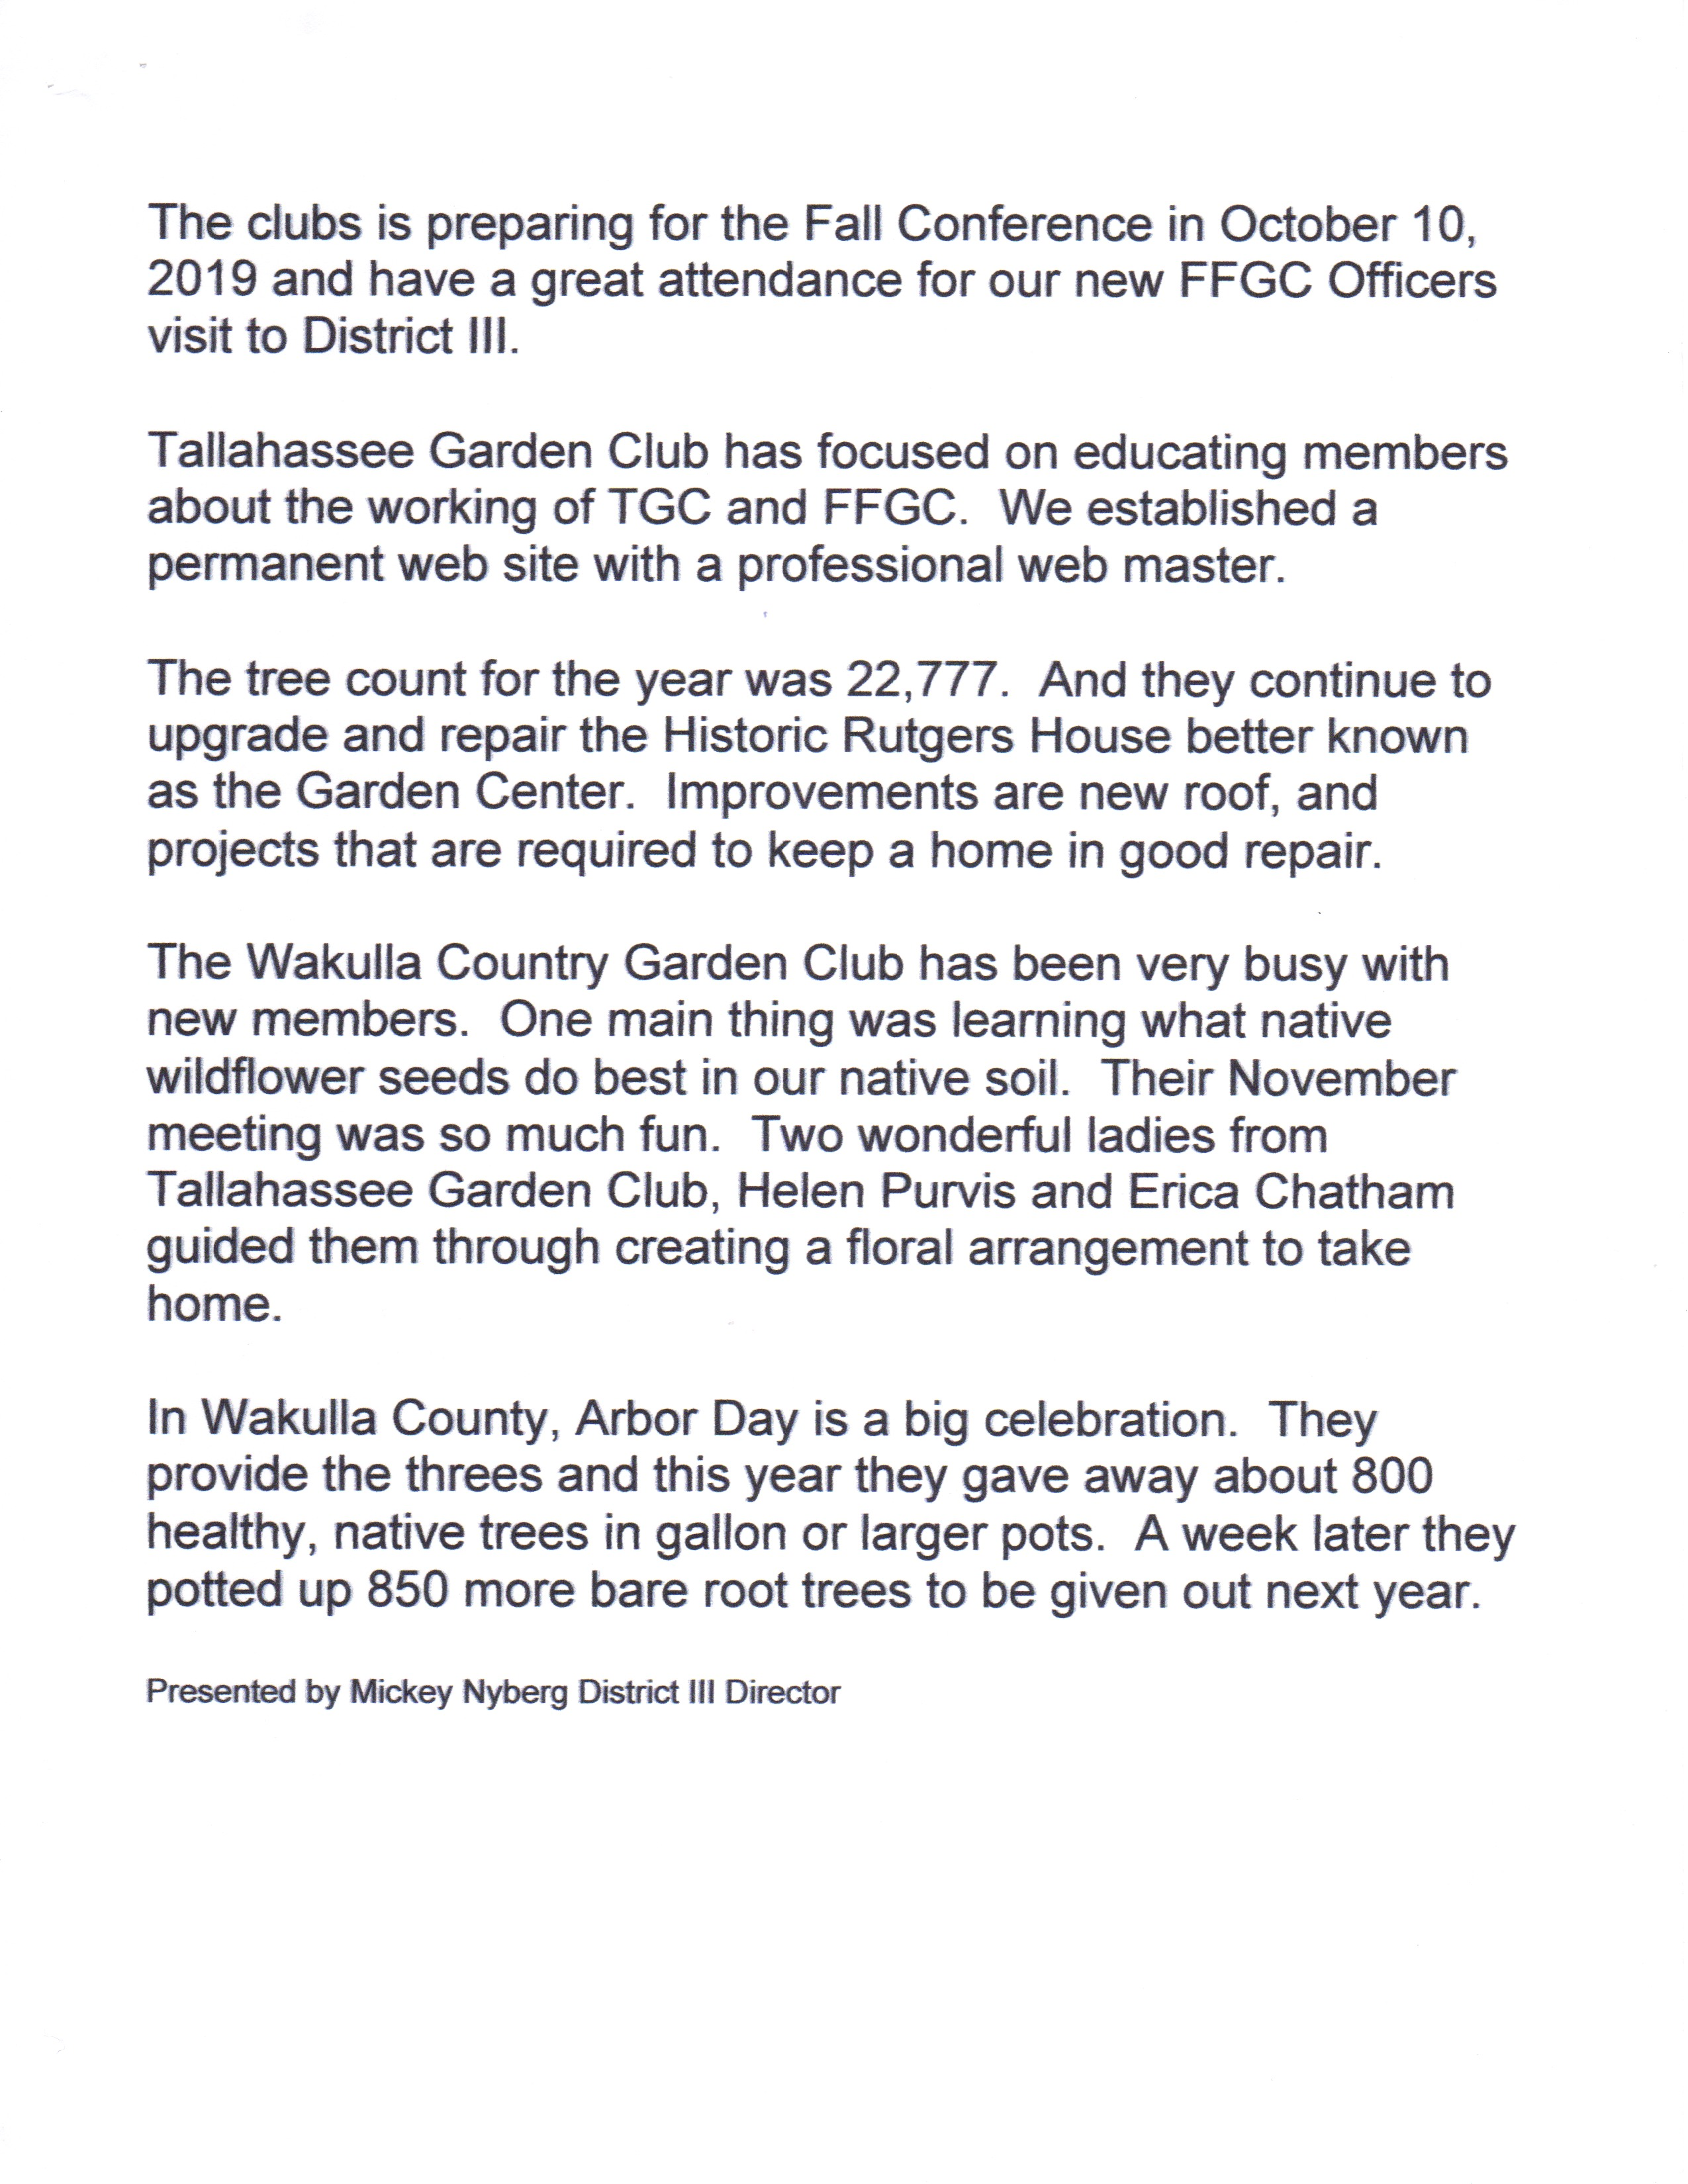

District IV Report
District 1 Report
September 11, 2019
Joy Elrod
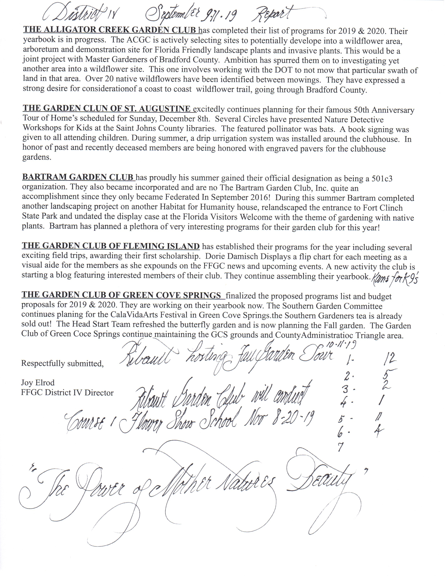

District V Report
Report: District V
Director
Jeanice Gage
September 12, 2019

After reading the end of year reports this Director is very impressed
and so proud of the accomplishments of the Garden club members
of District V for their dedication to the many projects that they do for
their club and their community. Each club is different in the projects
they choose; whether it be Wekiva Youth Camp, S.E.E.K., or FFGC/
UF Short Course….we proudly support these FFGC Chairmen!
Many clubs choose Scholarships, Planting trees and flowers- even
a bed of wildflowers that thrilled drivers along a busy street, the
distribution of tree seedlings on Arbor Day, the purchase of fruit
trees for a sustainable orchard to feed the hungry. Using Fun with
Flowers as a means to make and then to share. One club will soon
landscape the 150 Habitat for Humanity home! Imagine your
delight to find that your yard was chosen “Yard of the Month!”. They
have many ways and means projects to support all the wonderful
projects that the Clubs do for their members and their community.

We plan to continue these projects and to add to them. To give
more to Penny Pines to reforest the area that Hurricane Michael
destroyed. To support the Plant America project of our National
Garden Club President, Gay L. Austin. To make ourselves more
aware of the importance of Florida Federation of Garden Clubs
President Al Latina’s theme, Diversity in the Garden and all the
facets of membership in FFGC that it encompasses. To be more
careful to include everyone. And, to encourage our clubs and
circles to apply for the awards that they so richly deserve.

The mission statement for National Garden Clubs is:”At National
Garden Clubs, we do more than just green your thumbs, we
connect you with people, plants, and programs that provide
inspiration, information, and valuable resources”.
HEY! That sounds a lot like Fantastic Five!

Summary: District V is very active in supporting the goals of NGC,FFGC,
District V, and their local clubs. District V runs 134 miles from Lake City to
Brooksville through eight counties. Over 750 members of District V donate a lot of time and money to support the many projects of their clubs and district V.

District VI Report
REPORT
District VI Director
Judi Jodoin
September 11-12, 2019

August 27, 2019

Past District Directors told me that being a District Director was a “fun” position. I approached this with skepticism however but soon learned that they were correct. Being District VI Director offered me the opportunity to meet with Garden Club Presidents and members of Brevard, Flagler and Volusia Counties.
I was enlightened to learn about their many projects and formed a network of individuals who soon became my new friends.
Soon after Convention it became apparent that the District VI Spring meeting would soon be upon us. Brevard County Indian Harbour Garden Club offered to host the Spring meeting. I was overwhelmed with their organization and hospitality at this event. May 15th, 2019 was a day to remember with a record 101 in attendance. All 12 districts submitted articles to the “Florida Gardener” highlighting their projects, goals and accomplishments.
In June, as District Director, I held a meeting of Garden Club Presidents. Twenty-eight attended as we discussed and addressed their questions, concerns, commitments and ideas stressing upon including all Garden Clubs. Policies, procedures, scholarships and the District VI Fall 2019 Meeting and 2020 Spring meeting were topics of discussion.
The “Call” for District VI Fall Meeting with Tour Team will be published on September 2nd, 2019. The Garden Club at Palm Coast Inc. has graciously offered to host this event.
Special notice to the Cherry Laurel Garden Club who will host the District VI Spring Meeting for they have attained RUBY status being federated in February of 1951. The New Smyrna Beach Garden Club will also celebrate their 90th birthday on November 15, 2019.
This Director is pleased to announce that her calendar is filling up with invitations to visit District VI Garden Clubs. My goal is to meet all of you during my tenure.

Summary:
This Director’s goal is to meet and listen to all District Presidents and members in order to meet their needs and strengthen District VI.

District VII Report
District VII Director
Gwen Carter
September 11, 2019
District VII clubs are eager to continue and start projects and programs in the community to promote the love of gardening, floral design, civic beautification, plus promote environmental education opportunities for our youth.
However, District VII clubs have not been sleeping during the summer. Phases 1 and 2 of a beautification project for the entrance at Health Central Park, in Winter Garden, has been completed adding 20 lovely drift roses to the 100 holly ferns that was planted during phase 1.
In August, the first sold out” Fun with Flowers” Program was held with participants coming from various District VII clubs and community residents.
A Youth Gardening Program for students in grades 3 – 6 has been created and will hold the first meeting in September 2019.
District VII clubs collect labels for Wekiva Youth Camp and sponsor a Thanksgiving Basket Community Project each year.
District VII and the Judges Council will sponsor a Floral Design Study, Units 1 – 6, starting in October,2019.
A Standard Flower Show is also on the horizon for District VII.
This past summer, District VII sent 18 students to Wekiva Youth Camp, 1 student to SEEK, and 2 leaders/counselors in training to Wekiva Youth Camp. $ 1150 was donated to Wekiva Youth Camp and $ 1150 was donated to SEEK. Education labels were also sent to Wekiva Youth Camp.
District VII is looking forward to having our clubs come together at the District VII Fall Meeting, with the FFGC Tour Team, in attendance, hosted by Clermont Garden Club.
Currently, District VII has 17 individual clubs, 1 advanced design club, and 2 district clubs working to promote floral design, civic beautification, environmental education opportunities for our youth, and to stimulate a love of gardening for all.
Finally, Mr. President, District VII is pleased to submit St. Cloud Garden Club’s application for admission into the Florida Federation of Garden Clubs, Inc.
Thank you

District VIII Report
REPORT For FFGC Fall Board Meeting
DISTRICT DIRECTOR VIII
BARBARA RAO
FALL 2019, (SEPTEMBER 11-12)
WHAT WE DID ON SUMMER VACATION
In June District VIII sponsored a LUNCH AND LEARN for the garden club presidents and its members. What a success! Almost every one of the clubs in our district had a representative there. There were over fifty ladies and men who came to Sarasota Garden Club for a day of sharing, caring and learning about Garden Club life in general. This was good timing as many of the clubs had just installed brand new Presidents. Fun way to learn the ropes! We had presentations by our Awards Chair, Treasurer, Membership, and Social Media group. Awards spoke about the new administration’s Nell Coe award for Diversity in the Garden.
Our Treasurer explained about the dues. She gave information about budgets and how funds are used. Membership Chair gave detailed ways and means to recruit and retain members. Social Media was full of timely information on how to use our website, calendar and the new Face Book page. Our Recording Secretary found an interesting piece of information about how long one should keep records. This was quite timely as many of us were unsure of this and ready to throw out the old and begin with the new… Explanations like these go a long way in making new Presidents feel comfortable doing their job and make them able to direct their Executive Board properly.
The day was not all serious business talk, we had lively discussions during a buffet lunch and garden tour. The day ended with prizes given to the trivia winners about District VIII and FFGC.
During the Summer District VIII had many celebrations with lively gatherings and some somber moments. A beautiful new Blue Star marker was dedicated in Tampa with all pomp and ceremony befitting American Legion USS Tampa Post 5 remembering its heroes. Dunedin Garden Club celebrated 90 years and Dade City celebrated 70 years as a garden club. You would never believe the age of these clubs with all the hoopla and festivities. With all these celebrations came Cake!
Programs and activities were well planned and attended during the summer making our vacation full of fun events- camps in Tampa, workshops in Lemon Bay, Garden renovations all over, building updates in Sarasota and Manatee River.
Most exciting news is Garden Club at Hunter’s Green, North Tampa, is requesting to become a New Garden Club in District VIII this fall.
Summary: FLOWER SHOWS/ HORTICULTURE PROGRAMS, GARDEN TOURS and especially a NEW CLUB are all events that have been planned during the quiet summer to happen in the fall. Colorful flyers, face book mentions, calendar entries are all items that we worked on during our summer vacation. Wait till you hear about our Fall activities!

District IX Report
District IX Report
September 11, 2019
Leslie Montwid
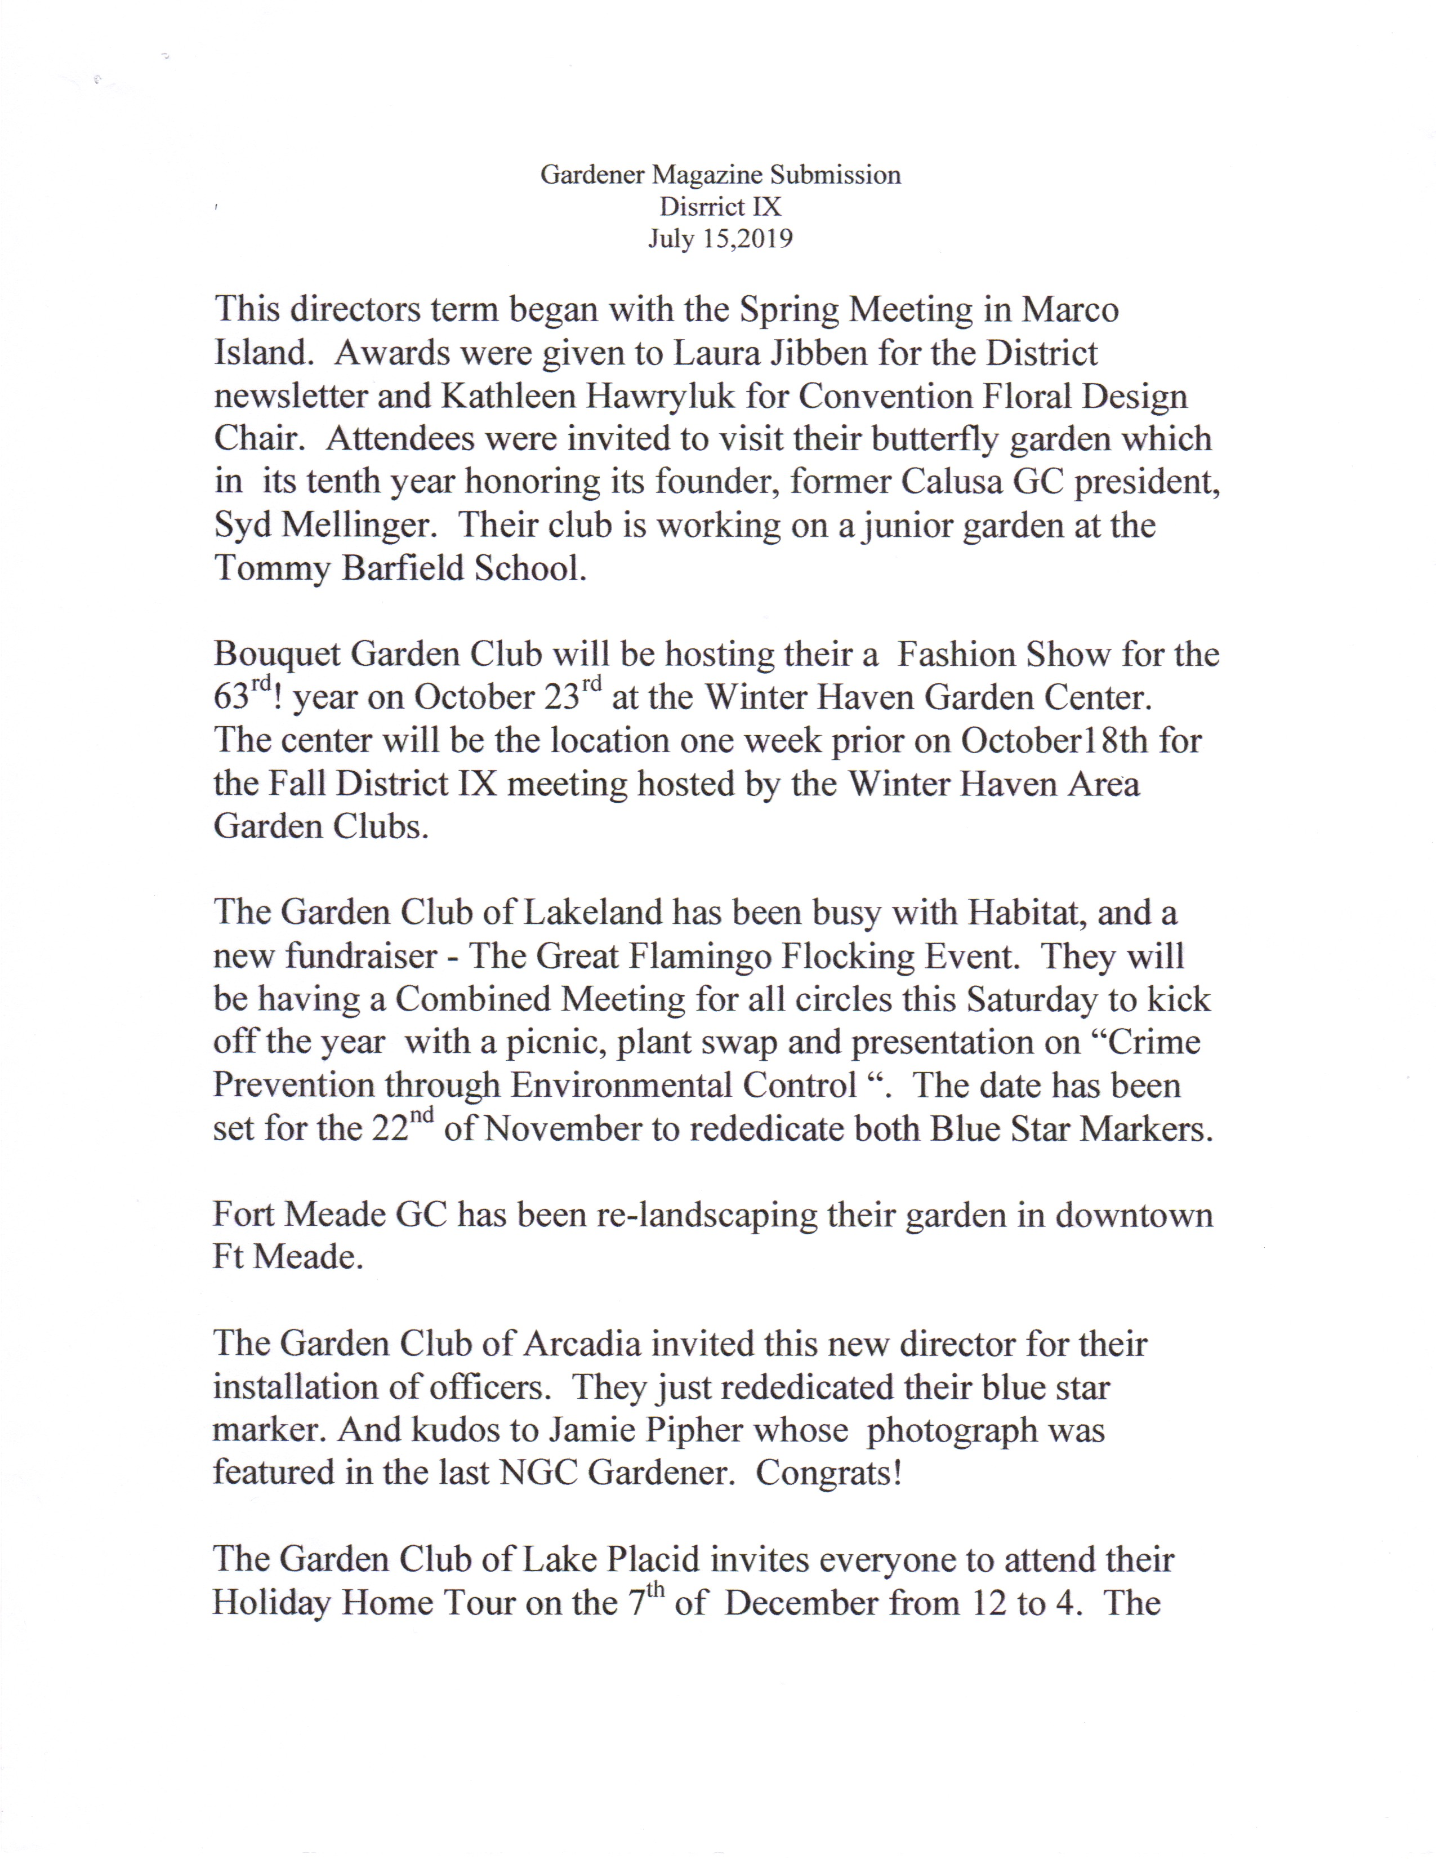
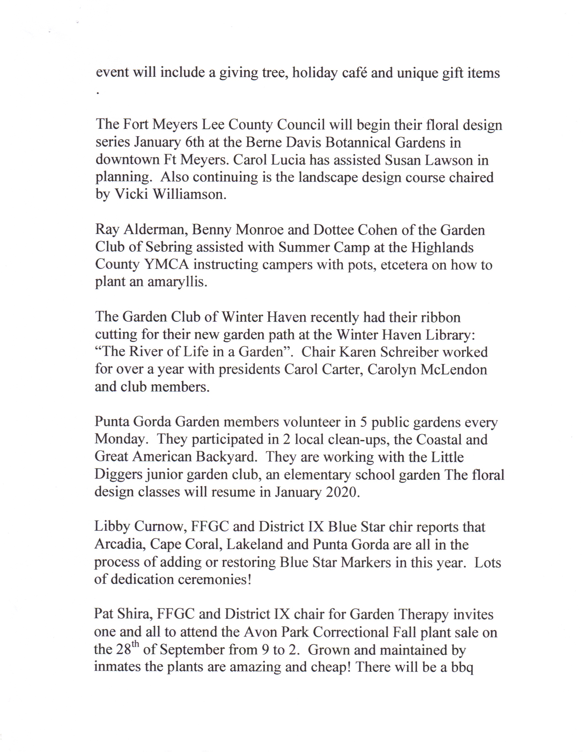

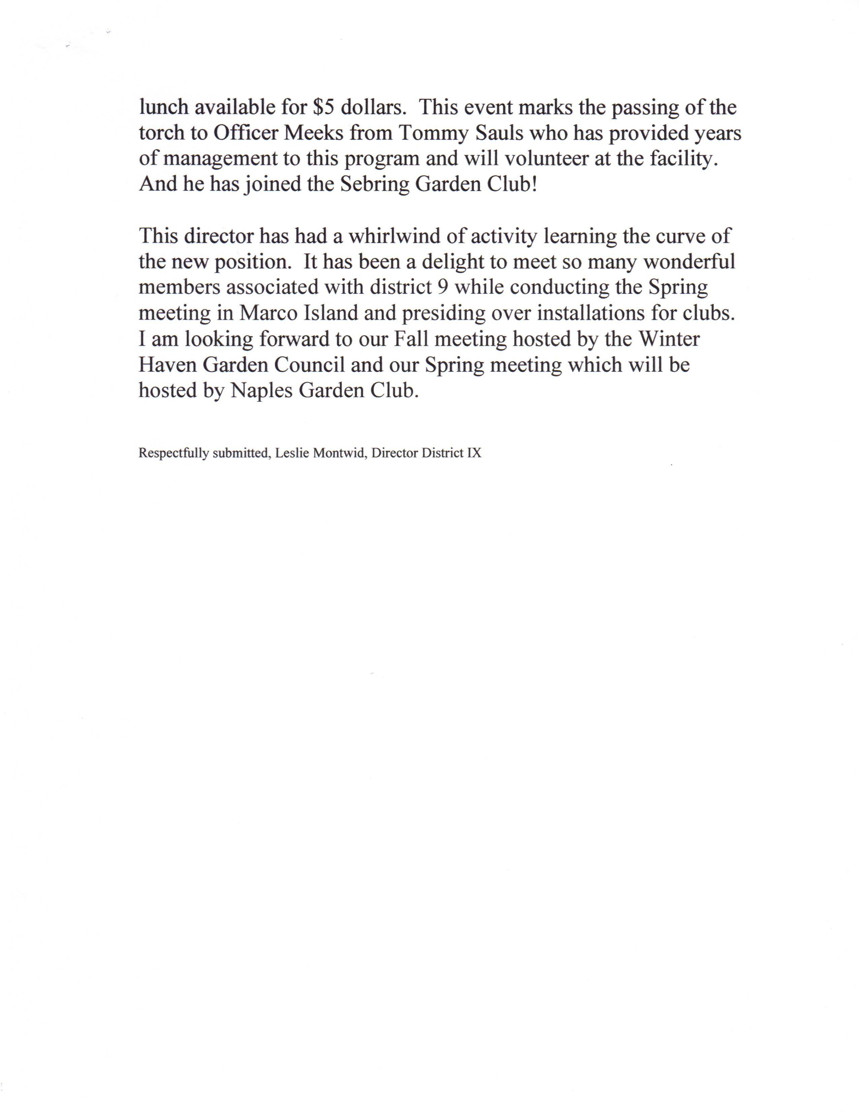

District X Report
District X Report
Director of District X
Carol Coleman
September 11-12, 2019
I am Carol Coleman, District X Director, and would like to thank Mr. President and the FFGC Board of Directors for having the Fall Meeting.
I want to thank my Assistant Director, Michelle Maguire, for writing a wonderful and informative article for Blooming Tales. It is nice to know you have someone stepping in in an instant.
As Michelle indicated, I am a big supporter of youth gardens and continuing education. I encourage all District X presidents to continue or start youth gardens and take advantage of all the educational courses offered in you district. If we take the time to teach our youth and provide educational programs about our environment and the importance of growing both food and flowers, we will secure a future for all.
Important dates to remember are District X “Lunch and Learn” at Pipers Landing Garden Club on September 26, the FFGC District X Fall meeting on October 17 at the Sea Oaks Beach and Tennis in Vero Beach, and NGC Garden School will be holding its first ever courses in District X on November 21 and 22 at Mounts Botanical Gardens. Go to the District X website for more information and registration forms. Our own, Michelle Maguire, is the Chairman of this series.
District X will also be running the 64th annual Tropical Short Course and an NGC Tri-Refresher on January 22 and 23, 2020, also at Mounts Botanical Gardens. Barbara Hadsell is the Chairman.
Please make a point of reading “Blooming Tales” prepared by Cyndi Sable. There are some great articles and a lot of information on what is happening in our district. Make sure to look at what is happening in Boca Raton GC, Ocean Ridge GC, GC of Fort Pierce and Piper’s Landing GC. Also Wellington GC will be unveiling a Blue Star Marker on November 11, 2019 at Veterans Park in Wellington. They are also preparing for a Petite Standard Flower Show February 29-March1.
The Garden Club of Indian River County will host the Fall District X meeting on Thursday, October 17,2019. The program will be “Conservation and Environmentally Friendly Plants” “How it Affects our Area”. There will be some wonderful speakers from Indian River Land Trust and Florida Atlantic University’s Harbor Branch Oceanographic Institute.
I want to thank you for this opportunity to share the exciting things going on in my District. Remember, to increase garden club memberships, not just in Florida, but across the Nation, we must instruct our youth while continuing to educate those who provide them with the knowledge.

District XI Report
District XI Director
JerylAnn B Decker
September 11, 2019
It has been a busy summer for District XI. Our theme for the next two
years is “Be a Do Bee, Not a No Bee”.
In July, we had a presidents’ meeting with a full agenda and were
buzzing with many wonderful ideas and suggestions for our upcoming
year.
We are now on Social Media! We have a Facebook Page and share ideas
on Pinterest, as well as continuing to update our Webpage. As District
Director, I have resurrected our District newsletter “Blooming News”.
One of our District Projects is to assist Cypress Run Education Center of
Pompano Beach with a Sensory Healing Garden with their students that
are in grades 6-12 with emotional and behavioral issues. We are asking
members from all of our clubs to assist with this worthwhile project.
Our second District Project will be restoration of Blue Star Markers and
possible new Blue Star Marker placement.
Our third project will be to contribute scholarship funds to future SEEK
students.
And all of our clubs’ plan on building Diversity in our Gardens and Clubs
Coral Springs Garden Club has already increased its membership and it
now has several men members!
Coral Springs will also be hosting the Fall District XI Meeting at The
Carolina Club Mansion with guest speaker Jeff Nurge speaking on
“Native Plants”.
The Lauderdale by the Sea Garden Club will be having guest speakers
discussing sea turtles, bees, birds, beach restoration and floral design.
Our Pompano Beach Garden Club will be having speakers discussing
Roses, Begonias and orchids.
The Fort Lauderdale Garden Club and District 12 on November 10-13th
will be offering Course 3 for Flower Show Judges.
All our clubs and circles have a variety of speakers and trips scheduled
for the upcoming year. Check out the next issue of Florida Gardening for
more details.
We are all looking forward to learning and sharing our knowing our
youth, seniors and each other.
We are looking forward to learning with our informative speakers,
classes and sharing our knowledge with our youth and each other.

District XII Report
