FFGC September 2019 Board Meeting Reports -- H-Z
Note: to get to a specific report:
- Find the page number in the table of contents for the report you wish to locate.
- Go to lower left corner and click on Page: 1 of 40.
- In the Go To dialog box that appears enter the page number you wish to go to and then click on GoTo.
Table of Contents
Habitat for Humanity Report 3
Hall of Fame Report 5
Headquarters and Endowment Report 6
Junior Gardeners Report 8
Landscape Design Membership Report 9
Mead Gardens Liaison Report 11
Membership Report 12
Membership Retention Report 13
Natural Disasters Report 14
NGC Environmental Schools Report 17
NGC Gardening Schools Report 18
NGC Gardening School Message from Gay Austin 19
NGC Environmental Schools Report 20
NGC Landscape Design Schools Report 21
NGC and Deep South Scholarships Report 22
Penny Pines Report 23
Planned Giving Report 24
Plant America Report 25
Programs and Speakers 26
Protocol Report 27
Roadside Beautification/Pathways of Sunshine 28
SEEK Conference 29
Short Course North Report 30
Short Course Tropical Report 32
Smokey Bear/Woodsy Owl 33
Strategic Planning Report 34
Trees and Restorations Report 35
Water and Wetlands Report 36
Wekiva Youth Camp Report 37
Wildflower Foundation Report 39
Wind and Solar Energy Report 40

Habitat for Humanity Report

Report
Habitat for Humanity Landscape Project
Pat Caren
September 11, 2019
The Habitat for Humanity Landscape Project was launched in 1999 when NGC formed a partnership with Habitat for Humanity to encourage local garden clubs to share their expertise in gardening and landscaping with the owners of Habitat homes.
This chairman has been contacting district directors for information on what their clubs are doing.
In Walton County, Green Thumb Garden Club is teaming up with the Master Gardener program. The Master Gardeners do the landscaping and the Garden Club has been providing funds for gardening tools, including a lawnmower for each family.
In Nassau County, Bartram Garden Club's Civic Beautification Committee has landscaped three homes in the past year and is actively seeking to do more. They applied for and received Award #47. An even greater reward for them was the appreciation they received from the new homeowners, which made all that hard work a pleasure.
Gainesville Garden Club teams up with Women Build, a program in which women support the construction of Habitat houses for single women with families. They were involved with two new houses last year. Club members prepare lunches for workers during the building process and do the landscaping once the house is complete. They furnish plants and sod and plan and install a Florida Friendly landscape, working side by side with the family. They also provide gardening tools and mentor the new homeowner in the care of her landscape.
Some clubs participate in smaller ways, by planting a fruit tree, landscaping the entryway, or presenting a potted plant or gift basket to the new homeowner at the dedication of the home. Other clubs send checks to the local affiliate to go towards landscaping.
Some clubs would like to do more but run into roadblocks. In some areas, a “landscaping” company is hired even though local garden clubs are willing to do the work. One contact said that a local nursery does the landscaping. A few clubs reported having problems getting the local affiliate to return their calls. In one case, this chairman called the affiliate and received an apology and reassurance that they would be in contact with the club’s representative. One goal of this chairmanship is to address these issues.
Installing “cookie cutter” landscapes seems to go against Habitat for Humanity’s goal of owner participation. A Garden Club can give the personal touch a new homeowner needs to learn how to take care of the exterior of the home and consequently take pride in it. Involving the homeowner in selecting the plants, digging the holes, and doing the planting helps bring about a connection with the Earth. It helps the homeowner learn to appreciate nature and the importance of the outdoors. This is a way to raise environmental awareness.
Many clubs want to get involved and need information about how to go about it and whom to contact. That’s where this chairman can help. A Garden Club doesn’t have to do everything alone. Businesses will donate materials or sell them at a discount. Youth groups and other volunteers can help with the heavy work.
These are things you can do to promote the Habitat for Humanity Landscape Project:
- If your district has an HfH chairman, have her or him contact this chairman. If not, please appoint one if possible.
- If you are aware of problems or unmet needs a Garden Club is having, urge them to contact this chairman.
- This chairman can provide you with a list of affiliates in your area.
- After you have helped a new homeowner landscape their property, visit them from time to time to give advice, answer questions, and provide replacement plants if needed. Older landscapes may need to be spruced up.
- Apply for Award #47.
- If you like to shop, there is another way to help—visit a Habitat ReStore. Profits help support Habitat for Humanity, and they also accept donations.
There are various ways Garden Clubs can participate in Habitat for Humanity Landscape Projects. The idea is to share their expertise with Habitat homeowners. More Garden Clubs are encouraged to take part. Such involvement benefits the club, the community, and the environment.
Pat Caren
Habitat for Humanity Landscape Project Chairman

Hall of Fame Report

REPORT
HALL OF FAME
Mary Collins, Chair September 11, 2019

This report covers the period from April 8, 2019 through September
11, 2019.
During this time this Chairman was requested to issue two Hall of Fame certificates. These names will be added to our Hall of Fame roster on our website.

Summary: Two Hall of Fame Certificates were issued during the period from to April 8, 2019 through September 11, 2019. Names were sent to Headquarters to be listed on website.

Headquarters and Endowment Report

Headquarters & Endowment Committee
Sue Angle, Chairman
September 11-12, 2019

Our H&E Trustees have continued to be busy over the summer making sure our Headquarters building and grounds remain in tip top shape. We are blessed to have Susan back with us, not that she ever stopped coming here and doing her work, but we missed her at our meetings.

As you know, our Office Manager has taken a Leave of Absence and will be back to work on October 23. In the meantime, her assistant, our temporary employee Robyn Clifton is working Tuesday through Thursday each week from 9:00am to 1:00pm. The answering machine is monitored by President Al, and the message gives two telephone numbers to call for immediate response. Sue Roberts is updating the website and Joanne Mulinare is helping while we are here during our board meetings. We appreciate your patience and understanding during this time of Liea’s absence.

Because of the success of our contracts with Cocktails Catering who handle our headquarters rentals, as well as the benefits of our agreement with the Center for Spiritual Living for Sunday mornings and evening classes, we have been in a position to be able to accomplish much needed repairs and maintenance to our almost 60 year old building.

The outside paint had discolored and chalked over the many years since last being painted, while the water marks had stained the bricks across the front entrance of our building and it was therefore as we reported at our convention business meeting the decision was made to have the entire building painted. This was accomplished at the end of May at a cost of $8,730.

When the rains came in July the flat roof over the kitchen again began to leak, then an area in the gift shop and around the skylight in the foyer. The kitchen roof had been repaired many times over the last ten years, so quotes were received to replace its flat roof with a pitched roof eliminating the skylight so the water would run off, the foyer skylight was removed and replaced and the roof surrounding it repaired, and gift shop leak was repaired. The total cost for roof repairs was $7,800.00.

A $1,000.00 donation was received from a member for the new landscaping in front of our building and it is greatly appreciated. It has begun with plants at the north end of the front and will continue as the cooler weather arrives.

As she has done for the last 15 years, Susan Mello watches over and works in our gardens and before I turn this over to her to tell what’s been going on, I’d like us all to have the opportunity to thank her with a big round of applause.

Susan told us about the beetles she was able to get without charge from IFAS and FDA in Gainesville who are breeding the beetles for central FL. Hopefully this will begin to irradiate the invasive potato vine that has been covering and smothering our bushes. She released them at the end of August and we can already see the results by the now lacy effect of the leaves they have been devouring. We are so pleased and hope more can be obtained during the summer season next year.

This Chairman would like to thank all the Trustees of our Headquarters and Endowment Committee for their dedication – President Al Latina, 1st Vice President Marge Hendon, Jana Walling, JoAnn Guise, Susan Mello, Cissy Richardson, Sue Roberts, and Karen Smith. Will you please stand. Thank you.

Sue Angle
Chairman
Headquarters & Endowment Committee

Liea Ward, Office Mgr., is on a Leave of Absence from 8/27 – 10/23, and Temp Assist Robyn Clifton works Tues through Thurs from 9am–1pm. Outside painting of building completed at end of May at cost of $8,730. Flat roof over kitchen, skylight in foyer and area in gift shop leaked in July. Repairs made at cost of $7,800, eliminating skylight in kitchen. Susan Mello released beetles gotten free from IFAS and FDA in Gainesville to combat potato vine.

Junior Gardeners Report

Report
Junior Gardener
Lynda Penry, Chairman
September 12, 2019

Being the first year as FFGC Junior Master Gardener Chairman, this chairman is still trying to grasp the responsibilities. Marci Wilcox and Valerie Seinfeld have been very helpful in this endeavor.
This chairman has contacted all twelve District Directors to determine if they have a district Junior Gardener Chairman. Six of the twelve districts do, indeed, have a Chairman. Corresponding with district chairmen helps with the communication part of this job. This chairman’s concern is individual garden club leaders may not get the correct information needed to aid them in their endeavors. Therefore, this chairman asks directors in the following districts to let me know of their individual junior gardener club leaders so they may be contacted.
Districts: II, VI, VIII, IX, XI, XII. Thank you for your assistance.
It is time for us to order the three-year pins for club leaders. These pins will be awarded during the Fall District Meetings. This chairman is contacting as many clubs as possible, but if anyone attending the Board meeting, please let this chairman know if you have someone meeting the requirement.
This chairman’s goal this term is to have more Junior Gardeners guidance at the Wekiva leadership training. We have good resources on the web site, but conversations with like-minded leaders would be beneficial.
This chairman welcomes any suggestions to make our Junior Gardener program more effective and fun!!!

Summary –
Junior Gardeners meet the FFGC mission statement, “instill in in our youth the love of gardening and the respect and protection of the environment.
Each district can assist in this by promoting Junior Garden Clubs in the respective district. Together, we can reach the next generation so they may experience the joy of gardening and pass on the love of nature.

Landscape Design Membership Report

Judi Davis
LDCC Membership Committee
Tri-Council of FFGC
LDCC Meeting
September 10, 2019 Meeting
Membership Report for Landscape Design Consultants Council (LDCC)
Paid members 57
Emeritus members 3
Total members 60
August 31, 2019
Judi Davis
Judi Davis
Membership Chairman

Landscape Design Consultants Report

Sheryl Perkins
Presented by Phyllis Weber, Master Landscape Design Consultant
Tri-Council (TC) of Florida Federation of Garden Club (FFGC)
Landscape Design Consultant’s Council (LDCC), President Report
September 10, 2019
Good Morning, Madam Tri-Council President, Environmental Council President, Gardening Council President, members of the Landscape Design Consultant’s Council, members of the other councils, and guests.
I apologize for not being at my first Tri-Council / Landscape Design Consultant’s Council meeting as President. I had planned this week over a year ago to attend a Family Reunion cruise. Judi Davis, LDCC Vice President, also wants to apologize for not being at the meeting, she made other plans in advance also.
I want to inform you of current issues / programs / events, Judi Davis and I are actively working on for the Landscape Design Consultant’s Council (LDCC) to participate in over the next two years. We will provide more specifics at the January 2020 meeting. If you are interested in helping on one of the committees, please call me.
a. Unsolicited Landscape Design Award.
1. This award will be given by the Landscape Design Consultant’s Council in each participating District. Recognition categories are small businesses, public facility, private facility, private residences of merit. Any Garden Club member may submit a nomination.
2. To help consultants use what they learned at the National Gardening Landscape Design School, specifically the LDS Form 17, Standards for Evaluating Landscape Design. I have called consultants within the Council, asking if they would chair or be on their District Panel in their FFGC District. I have talked to each District Director and provided the consultant’s name. Currently, only District X has done an outstanding job with this Award. I am hoping the other districts will send awards to LDCC. Deadline is April 1st, 2020.
b. LDCC is co-sponsoring an Advocacy Workshop Dinner with Sierra Club, League of Women Voters, and Oleander Garden Club on January 22, 2020 at the Mounts Botanical Garden. A panel discussing various methods of advocacy and current legislative issues will be composed of members of the Sierra Club and League of Women Voters as well as any of our legislators able to attend. Attendees will be able to ask questions and will be given a helpful handbook/primer published by FFGC’s Marion Hilliard. If this is well received, we may bring this educational activity to other parts of Florida.
(See attached)
c. LDCC sponsor a Garden Show along with Flower Show, at FFGC Convention 2021.
1. In Netscape, the NGC Landscape Design Consultants newsletter, the Connecticut State Flower Show also held a Gardening Show. Judi and I are researching information from other states, to see how the Landscape Design Consultant’s Council would Sponsor a Garden Show, asking vendors to produce a small space garden. Consultant’s who have completed the school would be used as judge for exhibit using the NGC LDS Form 17, Standard for Evaluating Landscape Design. This would be another avenue for consultants to use their expertise learned from the School.
d. Landscape Design Consultant’s Council Scholarship.
1. Some of our Garden Members have mentioned they have not attended the school because of cost. We started a committee to evaluate this, rules to provide the scholarship, who would be eligible, etc. Update will be provided at the January 2020 meeting.
Thank you
Sheryl Perkins
Tri-Council of FFGC
Landscape Design Consultant’s Council (LDCC)
President
1 Attachment
Advocacy Workshop Dinner, January 22, 2020

Mead Gardens Liaison Report

Report
Mead Garden Liaison
Cynthia Pesch
Sept. 11-12, 2019
Mead Garden Liaison

Board meetings of Mead Botanical Garden were attended in April, 2019 through August, 2019. Plans are in the works for Backyard Biodiversity Day to be held Saturday, Oct. 19, 2019, and for the GrowVember plant sale to be held Saturday, Nov. 2, 2019. The Great Duck Derby was extremely successful at the end of March, netting $16,000 in profits. Their Young Naturalist Summer Camp was sold out and the students had a very successful camp experience. They continue to improve the property.

Cynthia Pesch
Chairman of Mead Garden Liaison

Mead Botanical Garden will be hosting Backyard Biodiversity Day on Oct. 19th, and GrowVember on Nov. 2nd. They continue to improve the property.

Membership Report

Report
New Membership
Ed Nendick
Sept. 12,2019
Last Year’s successes include;
- Monthly newsletters published containing new suggestions for District Directors to forward to club Presidents and their Club New Membership Chairperson.
- Oral presentation by the MR. (Master Recruiter) and MRS. (Membership Retention Specialist) at January 2019 board of directors meeting unleashed a new beginning to our powerful team dedicated to encouraging District Directors to get behind a movement to increase our membership.
- Our hour-long presentation at the convention in St. Augustine FL. brought great reviews and great questions.
- The Florida Federation of Garden Clubs Membership Brochure in both English and Spanish got rave reviews.
- Several New Clubs have called about joining FFGC.
This Year we will build upon the ideas that got new members
- The App, Next door APP must be taught and pushed hard by all District Directors and Club Presidents and their Membership Chairperson. Our first newsletter will give instructions on how to get the APP, how to use it, and how often to publish your clubs meeting times, dates, and programs.
- We will use the publicity budget of $1,000.00 to reprint our Handouts in English and especially Spanish as we need to bring in a Diverse membership!
Our second newsletter will address how to start a new club. Every District Director should have this knowledge.
- The National Garden Club has set a goal of 20% increase in membership overall. This chairman proposes we create an award for all clubs who reach that goal this year. If the award already exists as an every other year award, we need to make it every year.
- Publish on our web site as written on our Membership Brochure.
- Benefits of Membership
- What we Do

MR. Ed Nendick
SUMMARY: In summary, with the disappearance of the Welcome Wagon organizations, we are the place new people moving in can go to make friends, learn about their communities, learn what grows in their communities, and make a difference in those communities. There are 1,085 new people moving into Florida every Day!

Membership Retention Report

REPORT
MEMBERSHIP RETENTION
JANE NENDICK, RETENTION CHAIR
FFGC BOARD OF DIRECTORS
SEPTEMBER 2019
WE ARE SO EXCITED TO SHARE THE FOLLOWING IDEAS FOR “GARDEN CLUB NEW YEAR BEGINNINGS”:
- SEND A NOTE OF APPRECIATION TO EACH OF YOUR MEMBERS. HAND WRITE IT AND MAKE IT PERSONABLE. TELL THEM WHY YOU APPRECIATE THEM AND HOW MUCH THE MEMBERSHIP IS DEPENDING ON THEM!
- IF SOMEONE MISSES A MEETING, FIND OUT WHY! THE MEMBERSHIP CHAIR SHOULD SEND EITHER A “GET WELL” CARD OR A “THINKING OF YOU” CARD! LET YOUR MEMBERS KNOW THEY ARE TREASURED AND MISSED!
- TWICE A YEAR, SEPTEMBER AND FEBRUARY ARE RECOMMENDED, GIVE YOUR MEMBERS A “SATISFACTION SURVEY”. (AN EXAMPLE OF THIS WAS GIVEN TO DISTRICT DIRECTORS LAST JANUARY AND AGAIN IN THE PACKET HANDED OUT AT OUR SEMINAR AT CONVENTION.)
- EVERY CLUB GATHERING SHOULD BE AN ADVERTIZED EVENT! MEMBERS WANT TO BE A PART OF SOMETHING EXCITING!
- COMMUNICATE, COMMUNICATE, COMMUNICATE WITH YOUR MEMBERS THROUGHOUT THE YEAR! WE HIGHLY ENCOURAGE A MONTHLY CLUB NEWSLETTER THAT CAN BE SENT IN EMAIL FORM!

SUMMARY: TO RETAIN YOUR MEMBERS, CARING AND FREQUENT COMMUNICATION IS THE KEY!

Natural Disasters Report

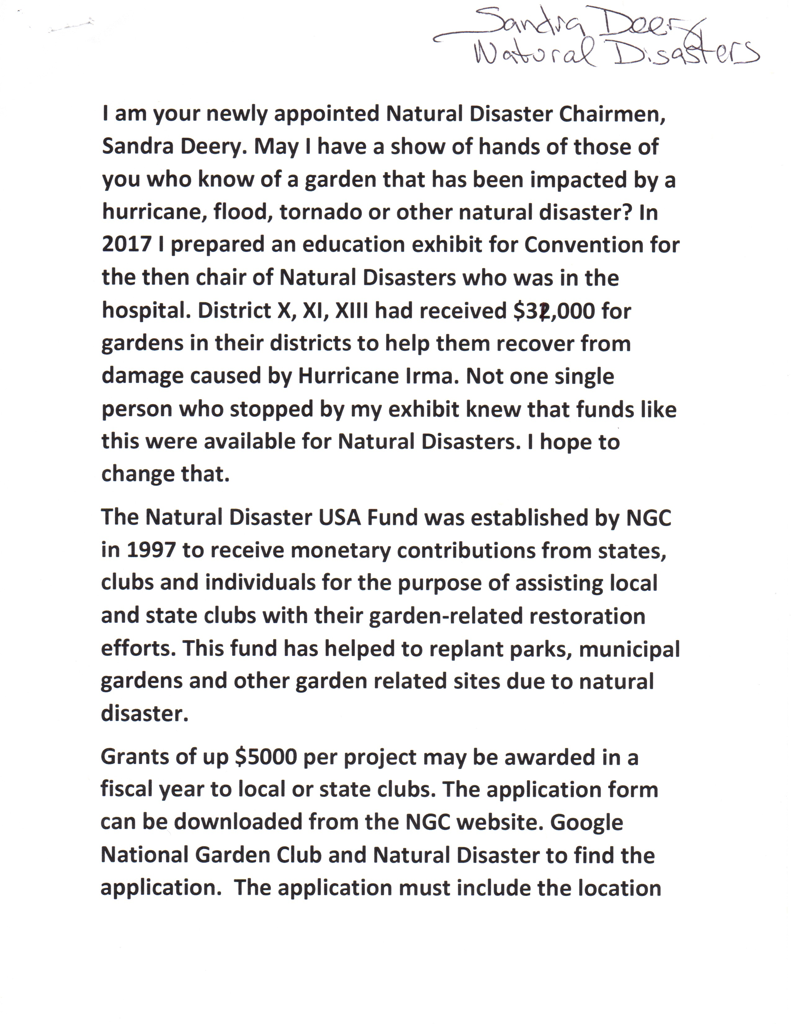

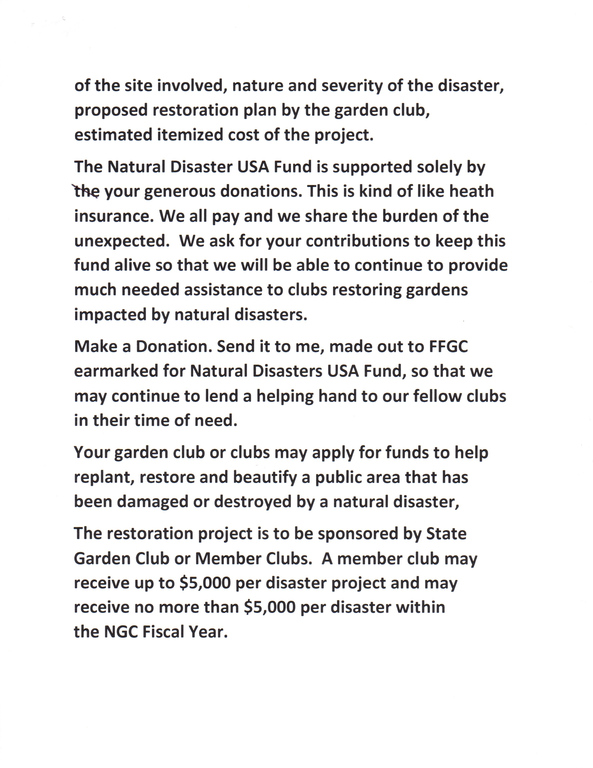

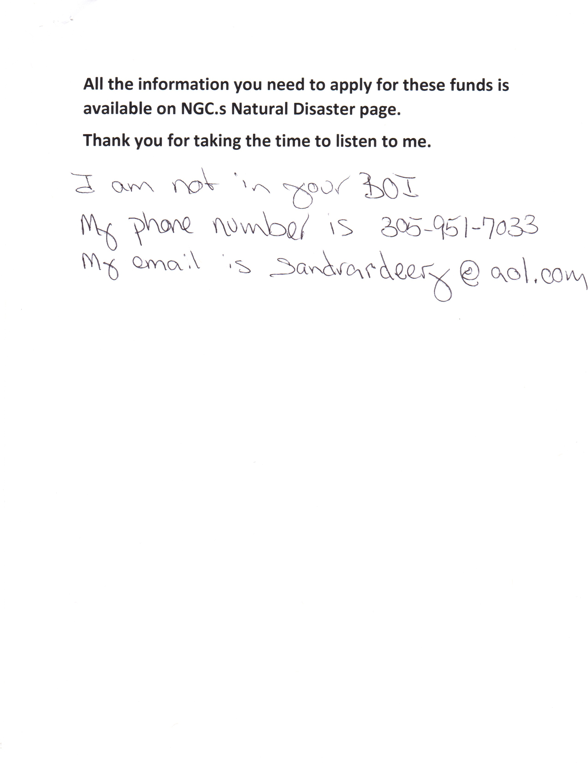

NGC Environmental Schools Report

Environmental Schools
Nancy Richards
Currently there are 63 Environmental Consultants in good standing in the state of Florida. I am proud that our consultants have taken the opportunities to refresh so far in 2019, with six refreshing in Gainesville in June, five at the Deep South Tri-Refresher in the spring, and two at Course 1 in New Smyrna Beach in March.
New Smyrna Beach is the location of our latest environmental school. Course 1 was held in March. Course 2 will be held in November, followed by course 3 in January. This is a great opportunity to refresh or start anew on NGC environmental education, especially with the top-notch instructors who are participating.
Don’t forget! These courses can be taken in any order, and the student has seven years to complete all four courses and become a consultant.
Please check the table in the foyer for information on these courses.
SUMMARY –
Florida’s NGC Environmental Consultants are continuing their environmental education with the many opportunities to refresh. Series XIII is currently being offered in New Smyrna Beach.

NGC Gardening Schools Report
Gardening School
Chairman
Barbara Hadsell
Sept. 11, 2019

NGC GARDENING SCHOOL
There are 93 Gardening Study Consultants in Good Standing in FFGC at this time plus four others have
Emeritus status. Four GS Consultants need to refresh in 2019. All have been notified. They can refresh at the NGC Gardening Courses in Deland or West Palm Beach in November or apply for a one year Extension. Fifteen Gardening Consultants need to refresh by 12/31/2020. Three TriRefreshers are being given in FL in 2020 and four NGC Gardening Courses. All fifteen have been notified.
Series 8 will begin in November hosted by the Deland Garden Club and chaired by Jennifer Condo, club President. And Series 9 will also begin in November, hosted by District X and is being held at the Mounts Botanical Garden in West Palm Beach. It is being chaired by Michelle Maguire, Assist. District X Director.
By the way, all tests in NGC Gardening, Landscape Design and Environment Schools are now Open Book, Open Notes. And the new NGC GS, ES, and LDS Handbook is available electronically under Schools on the NGC website and you may copy it free of charge. All three Schools are using identical interactive forms and only showing Pass/Fail—no test scores and using only multiple choice questions—no essay or fill in the blank questions.
Please consider sponsoring a Gardening School in your area. Again, all of those who have not completed the four courses have 7 years to finish.

Your challenge—“Help Plant America and Diversity in the Garden “ with Gardening Schools in your area!

Summary: NGC Gardening Schools are being offered in District VI and X starting in Nov. 2019

Barbara Hadsell
FFGC-NGC Gardening School Chairman

NGC Gardening School Message from Gay Austin

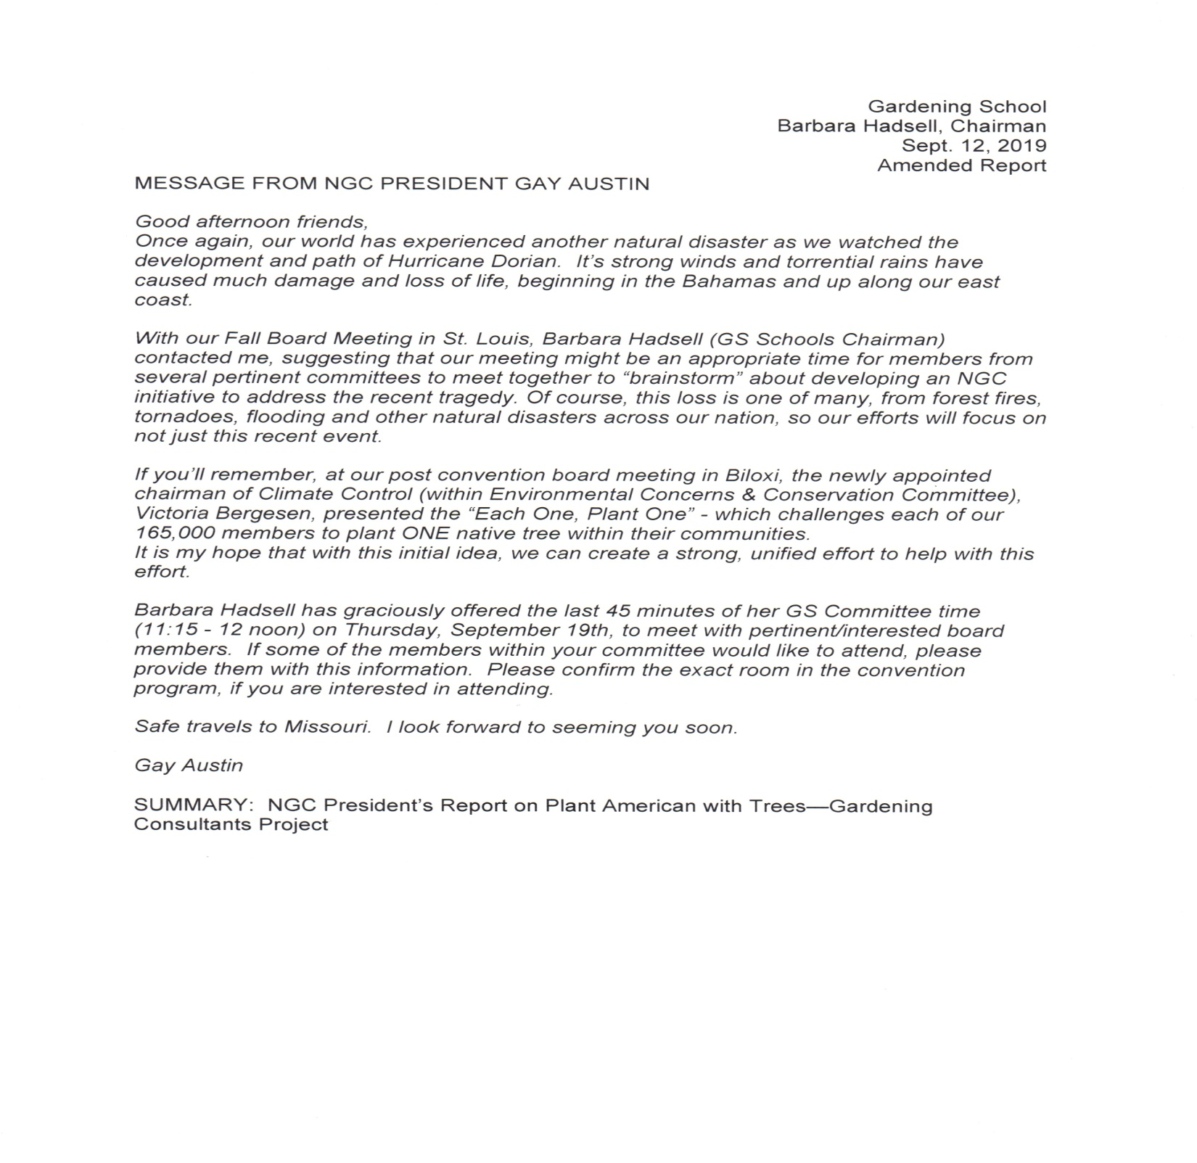

NGC Environmental Schools Report

Environmental Schools
Nancy Richards
Currently there are 63 Environmental Consultants in good standing in the state of Florida. I am proud that our consultants have taken the opportunities to refresh so far in 2019, with six refreshing in Gainesville in June, five at the Deep South Tri-Refresher in the spring, and two at Course 1 in New Smyrna Beach in March.
New Smyrna Beach is the location of our latest environmental school. Course 1 was held in March. Course 2 will be held in November, followed by course 3 in January. This is a great opportunity to refresh or start anew on NGC environmental education, especially with the top-notch instructors who are participating.
Don’t forget! These courses can be taken in any order, and the student has seven years to complete all four courses and become a consultant.
Please check the table in the foyer for information on these courses.
SUMMARY –
Florida’s NGC Environmental Consultants are continuing their environmental education with the many opportunities to refresh. Series XIII is currently being offered in New Smyrna Beach.

NGC Landscape Design Schools Report

LANDSCAPE DESIGN SCHOOL
Susan Roberts
Sept. 11, 2019

FFGC has the following Landscape Design Courses scheduled for 2019-2020:
Series 36, course 3, Ft. Myers, Oct. 25-26, 2019
Series 36, course 4, Ft. Myers, April 24-25, 2020
Series 37, course 1, Lakewood Ranch, Feb. 3-4, 2020
Series 37, course 2, Lakewood Ranch, Feb. 5-6, 2020
Series 37, course 3, Lakewood ranch, March 16-17, 2020
Series 37, course 4, Lakewood Ranch, March 18-19, 2020

The Lakewood Ranch series is unique. It is the first series using the revamped NGC curriculum. This new design has a student project of redesigning a portion of your own home landscape. This is a fantastic opportunity to get a professional critique of your own personal plans. Also this series is being run in a much shorter time frame for all four courses than any other previous series. Comments from the students after the fourth course in March will be valuable and interesting.

For those needing to refresh in 2020 the Lakewood Ranch series is an opportunity as is the Tropical Short course tri-refresher in West Palm Beach in January, the Deep South convention in Tampa in April and the FFGC/UF Short course (a tri-refresher) in Gainesville in June. At present there is nothing scheduled in the 2nd half of 2020 so those needing to refresh should plan ahead.

If any district or club would like to sponsor a Landscape Design Series in the 2nd half of 2020, please let the Fl. state Chairman (Sue Roberts) or your District Director know.

Landscape Design presently has 5 emeritus master consultants, 33 Master Consultants, 58 consultants and 145 students.

NGC and Deep South Scholarships Report

NGC and DEEP SOUTH SCHOLARSHIPS
CHERYL HOWARD CHAIRMAN
SEPTEMBER 11,12, 2019

As NGC and Deep South Scholarship chairman I have researched and asked those in leadership positions what this chairmanship involves and have not yet received a response. I have researched the websites for a job description and have not yet found one. I do take this chairmanship seriously as the education of our young people especially important to me. However, to do this job effectively I need to know exactly what is expected of me.

I will continue to find the information I need to fulfill successfully this position.

Penny Pines Report

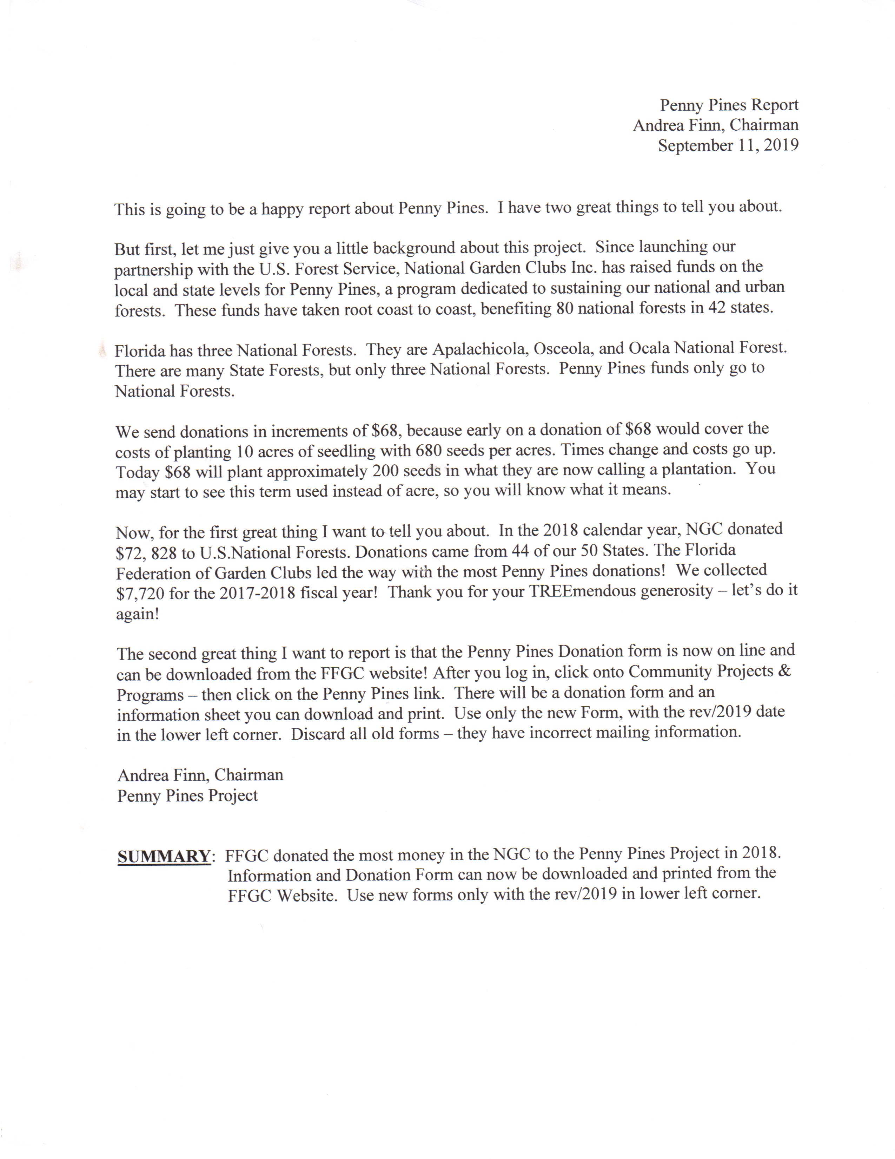

Planned Giving Report

REPORT
PLANNED GIVING
Carolyn Schaag
September 11, 2019

A letter from a garden club member wishing to donate funds to FFGC was forwarded from the FFGC office to this chairman for action. Because of the nature of the letter and
requiring immediate action, it was referred to FFGC President Al Latina and also FFGC Treasurer Jana Walling who were able to provide the necessary information. We will continue to follow up with the member.

Plans are to have the Planned Giving Committee meet at January FFGC Board Meeting.

Carolyn Schaag, Chairman
Planned Giving

SUMMARY: An inquiry on gift giving from a garden club member was handled by
FFGC President as this Chairman was not available.

Plant America Report

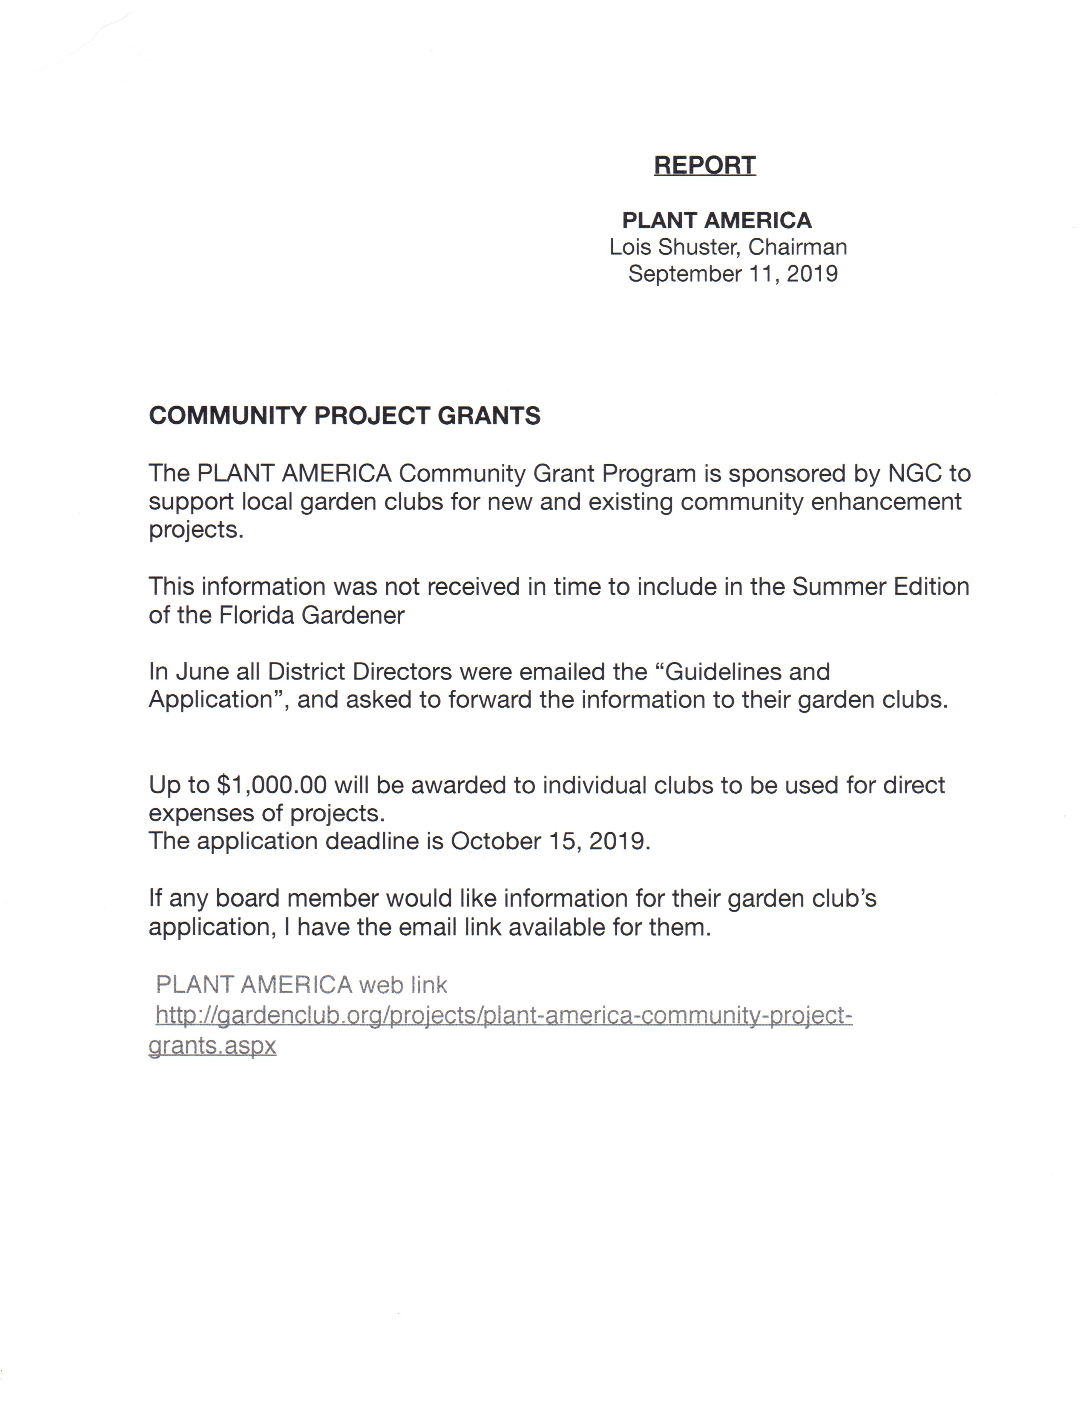

Programs and Speakers

Report
Chairmanship: Programs and Speakers
Donna Thomas
September 2019 BOD meeting

This chairman has been perusing the 2018 Garden Club yearbooks provided by previous chairman for the purpose of gleaming pertinent information. This information together with the 2019 yearbooks obtained October will provide the program information to update the current list on the FFGC website. In addition, this chairman is compiling a list of resources to augment and update the current resource list on the FFGC website.
The specific location of these two lists on the FFGC website will be sent to the District Directors for distribution.

Protocol Report
Protocol
Jo Ann Guise
September 11, 2019

This chairman worked with and assisted the FFGC President Claudia Bates,
2019 FFGC Convention General Chairman Helen Purvis, and incoming FFGC President Al Latina before and at the annual convention in St. Augustine FL .

This chairman is awaiting further information from the FFGC President Al Latina and 2020 FFGC Convention Chairman Christy Linke regarding the needs for the 2020 FFGC Convention.

SUMMARY: This chairman is awaiting information from the FFGC President and 2020FFGC Convention Chairman regarding the needs for the upcoming Convention. She also assisted at the 2019 Convention.

_____________________________

Jo Ann Guise
2019-21 FFGC Protocol Chairman

Roadside Beautification/Pathways of Sunshine

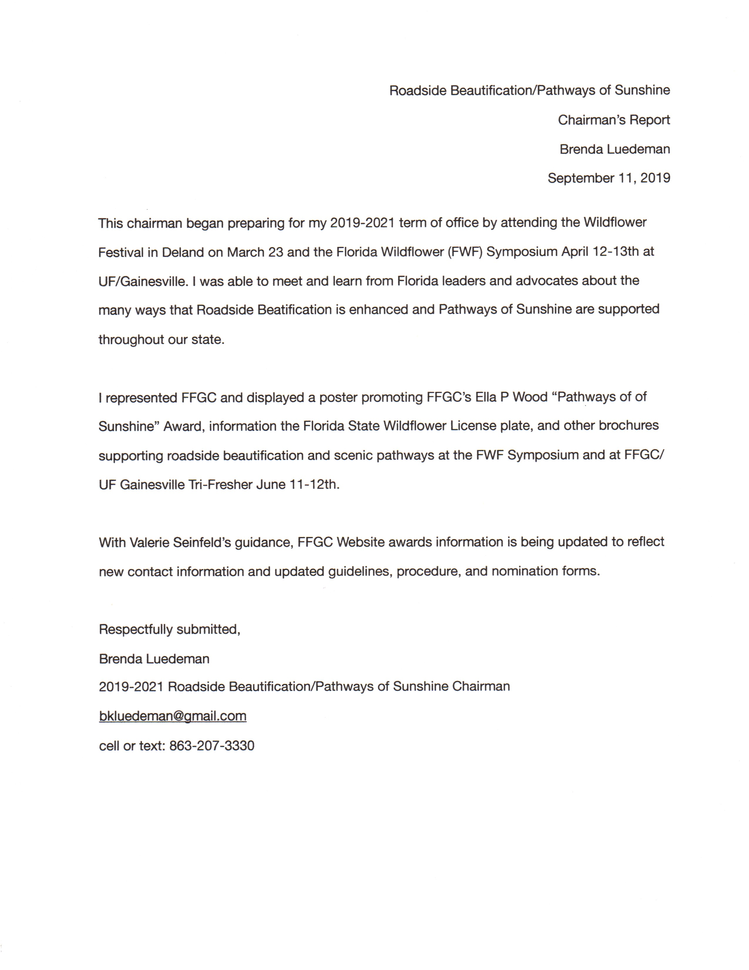

SEEK Conference

SEEK Board Meeting Report – September 2020
Save Earth’s Environment through Knowledge (SEEK 2020) “University of Florida”

SEEK 2020 Report
Mary Ann Whisler/Chairman
September 12, 2019

This year’s SEEK was held at Chinsegut Reserve and Retreat located north of Tampa. The program focused on wetlands, lakes and forest as well as introducing more career opportunities in the environmental fields. SEEK 2019 was very fortunate to have Gina Long/Director of the Chinsegut Conservation Center with the Florida Fish and Wildlife Conservation Commission helping us create an exception agenda. The attendees worked with biologist from USF and the Florida Wildlife Commission. They visited to the USDA Plant Materials Center and the Webster Bass Conservation Lab. Speakers from Florida Wildlife Commission presented land management and conflict programs, prescribed fire, sensitive land management and law enforcement of the environment.
SEEK 2020 will move to the University of Florida/Gainesville Campus. Attendees will live in dorm housing and visit various labs around the campus and as well as offsite locations. The UF Staff is working hard to put together a very comprehensive environmental program. The SEEK Committee will have more information on the agenda in January 2020. The date of SEEK 2020 is June 15 to June 18, 2020. Registration will begin on January 1^{st.}. Look for updated information as it comes available on the FFGC.org website.
The SEEK Committee would like to thank all the Districts, Garden Clubs and individuals that contributed to SEEK by sending students and providing donations. The committee ask that clubs and garden club members contact their local high school counselors and science teachers to identify interested students. The SEEK Committee will help by providing fliers and registration forms. Without YOU this program would not exist. The only way we can find attendees is through the local garden clubs.
The SEEK Committee thanks FFGC for the opportunity to provide this valuable program to our high school youth. With your support we will make a difference in the young lives of tomorrow and bring hope to a more beautiful and cleaner environment. Thank you FFGC!
Summary:
SEEK 2020 held at University of Florida
Three full days of hands on learning
Thank you to all the Clubs and Districts

Mary Ann Whisler/SEEK Chairman
(mary.whisler66@gmail.com)

Short Course North Report
Short Course North
Sharon Johnson
September 11, 2019

The eleventh annual Short Course North was held 8 and 9 August 2018 at the Santa Rosa County Extension Service in Milton FL. This course was sponsored by FFGC District I. The theme for this year was “All the Things I Love” inspired by the 1960’s Jewel Akens song “The Birds & The Bees.” Topics relating to this theme were selected by extension agents in cooperation with the committee so Master Gardener Advanced Training credits (CEUs) would be granted. We had 92 registered this year with two cancellations and eight no shows: 59 indicated they were from a garden club while 22 indicated they were Master Gardeners or public. We were honored to have four state officials with us: Carolyn Nation, FFGC Parliamentarian, Tina Tuttle, 2d VP, Majorie Hendon, 1st VP, and Al Latina, FFGC President. Cost remained $50 for garden club members for two days. Non-Garden Club members were asked to pay $65 but were given the option of having the extra $12 go toward “Subscription Only” membership in FFGC and NGC.
Seven non-members requested to become Subscription Only members and are currently listed as non-voting, subscription only members. One was recruited as a member of her local garden club and the others being actively sought after by local garden clubs.

The course was advertised in the spring and summer issue of The Florida Gardener. The budget was approved at the January Finance meeting. Registration forms were available online at the FFGC.org web site and were sent to all club presidents and extension office agents. All prospective instructors and vendors were contacted and contracts were issued. Many fun Door Prizes were given as well as an opportunity drawing for rare plants. Five vendors sold plants, yard art and jewelry. Meals were arranged by the Food Chairman Sandra Sherman.

The program followed the schedule below:

Thursday:

Carrie Stevenson, UFL IFAS “The Unsung Beauty of the Wetlands.”
Beth Bolles, Escambia County Extension Agent, "Growing Edible Flowers.”
James Stegall’s, Horticulture Photographer “Let’s Shoot Flowers, Photographing Gardens”
Pam Murfey, MG & Past President Panhandle Butterfly House, “Beyond the Monarch.”

Matt Lollar, Cty Commericial Horticulture Agent, “Attractive Heirloom Edibles.

Friday:

Christina Verlinde, SRC Extension Agent, “Stormwater Solutions, Green Infrastructures.”
Mary Salinas, SRC Extension Agent, “Native Milkweeds”
Mike Robertson, Proprieto, Trees & Palms as Accents Less than 30’
Bonnie Satterthwaite, Espoma Marketer, “There was No Miracle Gro in the Garden of Eden”
Barbara Albrecht, Conservation Chair, “Attracting Birds with Natives”

Each day, Linda Henderson, National FS Judge and State Certified Floral Design Instructor, conducted an optional hands-on class creating contrived flowers and using them in a design.

A shared profit check in the amount of $1,552.05 is presented. Additionally we are presenting a check in the amount of $84; the dues from our seven new/continuing Subscription Only members. Dates for next year’s Short Course are 6 and 7 August 2020.

Submitted by:

Sharon Johnson, Chairman

Summary: Short Course North was held 8 and 9 August in Milton FL with 92 registered 2 cancellations and 8 no-shows. This year’s theme was “All the Things I Love.” Shared profit totaled $1,552.05. Seven Subscription Only FFGC members ($84 dues) were realized from this course and one has already joined a local club.

Total of 92 registered:
82 attended day one
72 attended day two
2 cancelled and were refunded the amount
59 Garden Club Members
22 Master Gardeners or public

Short Course Tropical Report

Tropical Short Course
Chairman
Barbara Hadsell
Sept. 11, 2019

District X of the Florida Federation of Garden Clubs presents the 64th Annual Tropical Short Course, “Tropical Adventures”, an NGC Tri-Refresher, featuring exceptional presenters who will both challenge and delight our attendees.

Why did we name this year’s event Tropical Adventures? We want you to explore the many aspects of your surroundings—our coral reefs, gardening for birds in our back yards, helping our schools “ go green”, landscaping with edibles, understanding what salt water intrusion means to your garden and learning about the behind-the-scenes efforts which are changing the Mounts Botanical Garden. Floral design presentations by Claudia Bates and Jan Griffin will challenge and delight you.

We will have a raffle tables each day with baskets and plants donated by the clubs, vendors with that perfect plant or a delightful gift, and docent-led tours through Mounts Botanical Garden.

The two-day registration fee is $65, which includes continental breakfast and a box lunch. Remember, there is numbered seating by date of registration.

Mark your calendars and plan to attend Mounts Botanical Garden in West Palm Beach on January 22 and 23, 2020. Go to www.districtx.org for the brochure and interactive registration form. If you have questions, contact Barbara Hadsell, barbarahadsell@cs.com. 561-635-8809

Summary: Tropical Short Course, Jan. 22 and 23, 2020 has returned to the Mounts Botanical Garden in West Palm Beach and is an NGC Tri-Refresher.

Smokey Bear/Woodsy Owl

Report
Smokey Bear & Woodsy Owl Poster Contest
Jill Anderson, Chairman
Sept 28, 2019
SMOKEY BEAR IS 75 years old and WOODSY OWL has been part of a campaign to encourage people to care for the environment since 1971.
Smokey Bear’s message of, "Only You Can Prevent Wildfires!" and Woodsy Owl’s to "Lend a Hand, Care for the Land!" are important in today’s world.
The U.S. Department of Agriculture Forest Service and the National Garden Clubs, Inc. are giving students the opportunity to demonstrate their understanding of wildfire prevention and protecting the environment through original drawings of Smokey Bear and Woodsy Owl.
- Children from first through fifth grade are invited to participate in the 2020 National Garden Clubs, Inc. Poster Contest!
- Any group of children may participate. Scout troops, after school programs, and the like are perfectly appropriate. They do NOT need to be registered as Jr. Gardeners, but all poster entrees must be sponsored by a local Garden Club.
- Posters must feature Smokey Bear or Woodsy Owl and must not feature both together.
- Smokey Bear posters must include Smokey’s wildfire prevention message: Only you Can Prevent Wildfires!
- Woodsy Owl posters must include Woodsy’s conservation message: Lend a Hand, Care for the Land!
- All rules are listed on the NGC web site: http://gardenclub.org/resources/sbwo/2020_Poster_Rules.pdf or from this chairman; Jill Anderson, jillandersn@aol.com.
- Deadline for posters must be received by this chairman by January 8, 2020.
- A Smoky Bear balloon will be featured in this year’s Macy’s Thanksgiving Day Parade to commemorate his 75th birthday. It was last seen on Smokey’s 50th birthday
Summary: Deadline for poster to e received is January 8, 2020. All rules are listed on the NGC web site: http://gardenclub.org/resources/sbwo/2020_Poster_Rules.pdf

Strategic Planning Report

Report
Strategic Planning Committee
Gina V. Jogan, Chairman
September Board of Director’s Meeting, 2019

YOUR Strategic Planning Committee serves in an ADVISORY capacity ONLY. It is a non-budgeted committee.

It is the mission of the committee to look at ALL aspects of the Florida Federation of Garden Clubs, Inc. to assess the immediate needs, those needs for tomorrow and needs into the future of the organization.

Suggestions and research on issues done by committee members are brought to the President and/or the Executive Committee for further discussion, implementation, enactment, referral to other committees, to be brought to you, the BOD for informational purposes, etc. Since this is YOUR committee, we will certainly entertain any issues that YOU bring to us to research.

Part of the goal of this committee is to continue discussing the following issues, some of which are new and some which are from previous meetings and need follow up:

Our membership platform, how to save and store our aging records, membership issues, Wekiva Youth Camp, the Duties of the various vice presidents, committee job descriptions, our library and garden shop, raising funds and supporting the 100th Birthday of our organization…and the list continues.

Please feel free to give opinions on these or other topics; give us a list of the items you would like this committee to research and report on. Tell us what YOU think needs to be looked at. We are here to serve this organization now and into the future.

SUMMARY: This is an Advisory, non-budgeted committee here to see to the issues facing FFGC now and into the future. It Is happy to take suggestions from the members of the BOD to research and report back.

Trees and Restorations Report

Trees and Reforestation Chair
Fall Recap of T&R Activity
Kathy “Kat” Spieker
spkfreedom@embarqmail.com
FFGC Board of Directors Meeting Sept 10-12-2019

TREE PLANTING RECORD TWO YEAR PERIOD

During the previous administration, garden clubs statewide reported their tree planting efforts with the results tabulated at the end of each year. Certificates of Appreciation have been awarded to the top ten clubs for their efforts each year. The certificates are presented at the annual convention. We will continue to plant trees and keep a record of them.

Throughout this next two-year period I will be sending out reminders, tips and “how-to’s” so your clubs can give you accurate information. Begin your tabulations now so that you will have a final total to report to me by the end of March, 2020 in time for the convention. A simple Excel spreadsheet is an excellent tool that you can plug in data whenever you have a tree planting event or someone reports to you that they have planted a tree. You’ll have a running total, and BOOM! All done by the time reporting comes around.

For the record, during the period between February 1, 2017 through February 28, 2019 our wonderful clubs have planted nearly 200,000 trees which represent 221 different tree species. Do you suppose we can plant 250,000 this year? Why not!!

I would like to thank all the clubs who have participated and encourage you to continue your efforts to plant Florida’s lovely flowering trees and embrace our new president, Al Latina’s theme, “Diversity In The Garden”.

Respectfully Submitted,
Kathy “Kat” Spieker

Water and Wetlands Report

Water and Wetlands Report
Water and Wetlands' Chairman
Jackie Host
September 10, 2019
While there are many threats to Florida's water supply, a large majority of them
are caused by overpopulation, which is draining our water supply and polluting it.
Another serious threat to Florida is climate change which will alter the landscape of
our coastal areas forever, because the ocean is rising. A recent Florida Atlantic
University study estimated that just 6 more inches of sea level rise, in the next two
decades, would cripple about half of South Florida’s flood control capacity. Overall,
sea level rise is expected to be 4 ft above high tide by 2050. More than half the
population of over 100 Florida towns and cities lives on land below that 4-foot line.
By 2030, it is projected that Florida’s population will grow to 23,609,000, a 26
percent increase over 2010. In 2015, the total amount of water withdrawn in Florida was
estimated at 15,319 million gallons per day. To sustain this population growth it is
predicted Florida will need an additional 1.3 billion gallons of water a day by 2030.
It is imperative that Floridians establish a water ethic that will put a priority on
conservation of our water and wetlands over individual and corporate financial profits.
Education is key to helping people understand the urgency of protecting our natural
resources. FFGC members have an opportunity to do this through NGC Environmental
Schools.
This Chairman would like to challenge each Director to host an Environmental
School during their term of office. Education is the key to helping people realize the
looming disaster we all face because of water pollution and the depletion of the
Floridan Aquifer. Our Environmental School Chairman, Nancy Richards and this
Chairman will be glad to help you undertake this task. We need to get this message to
all of our garden clubs and hope they will take it to their communities. Depleting our
potable water supply is not an if situation, it is a reality that we can no longer ignore.
This is one of the most important things you can do for Florida.
Summary: Florida's potable water supply is in jeopardy because of pollution and
depletion of the Floridan Aquifer. A major cause of this problem is because of
overpopulation. Education is key to helping Floridians realize the severity of the water
situation in our state. Developing a water ethic that puts conservation of water over
financial profits by corporations and individuals
Respectfully submitted by Jackie Host, Water & Wetlands Chairman, FFGC

Wekiva Youth Camp Report
Wekiva Youth Camp Report
Tina Tuttle
11 September 2019

Wekiva Youth Camp was in session from 16 June until 27 July 2019 and celebrated its 45th anniversary.
Very special thanks to Marge Hendon and Christy Linke for serving as camp chairman in my absence.
Camp set up, Counselor orientation and Lifeguard training took place from 5-15 June.
American Camping Association “visit” held 18 July. Wekiva passed without any noted discrepancies on the 198 inspection items.
Created the design for and contracted with Joe Bastian in Ohio for 325 2019 camp T-shirts. Contracted with Great Impressions for 600 water bottles and 600 stickers.
Purchased all camp set-up items including OTC medications for clinic, photo holders, closing ceremony candles, etc. Purchased items needed for each camp session: Nature’s photography items, Craft supplies, camping equipment and curriculum items (rope, first aid supplies) for 7th grade tent camping.
Procured 600 copies of educational materials from US Forestry Service on Trees for all attendees. Cut 100 pieces of bamboo for 7th grade programs walking sticks.

Camp was 100% full paid with max attendance of 640-- very few no-shows.
Contracted staff personnel: Director, Assistant Director, Waterfront Director, the Nature and Craft coordinators, as well as the Cleaning company and kitchen staff. Requested and received event insurance and contracted LIT transport and facility rental at Crystal River Marine Science Station. Contracted with Century Link to have burned out phone and internet lines moved and installed in Ais and Tequesta. Sent tax certificate to Century Link so we will no longer be charged state tax. Obtained tax cards for Walmart, Hobby Lobby and Best Buy.
Welcomed Lindsay A. Loftin and Mandy N. Howell as new coordinators for 7th grade tent camping and Critter Camp, respectively. Mandy also served as Waterfront Director.
Of the 81 volunteers, 63% (51) were garden club members. Ten of the volunteers came for more than one week! Twenty-four volunteers attended the Wekiva Volunteer Training held last February.
Processed over 80 volunteer fingerprinting and level 2 background checks through Florida Agency for Healthcare Administration.
Contacted volunteers by phone and email for required medical and insurance information.
Working closely with registrar, Betty Moxley, assisted over 30 families with Financial Assistance for camp registration fees.
Made deposits. Coordinated reimbursements and bill payment.
Revised the Wekiva Dress Code with help from Circle Leaders and counselors. Our Camp Songbook is under revision.
Assistant Director created an online survey for parents. Results are very positive.
Coordinated volunteers to assist with check-in, lice check, sale of camp items, Canteen and check-out.
Fully participated in Naturalist program led by Kalia Balliene during week 4.

Inventoried all FFGC held items stored and used at camp. Packed out camp into the shed and HQ on 27 July.
Purchased new Amana Washer and Dryer for camp, to replace those lost in the fire, using Wekiva B&M account. Replaced faucet in the kitchen using B&M money. Purchased a new computer tower, surge protector and 2 Wifi extenders fried in lightning strikes. Lightning also took out the new air conditioner in Nature Hut. Parts were ordered.
Donated to Goodwill or disposed of Lost and Found items and items no longer useful to camp.

Held End of Camp meeting with State Park personnel and later with staff on 22 July.
Confirmed dates for WVT and Open House 7-9 February 2020
Confirmed dates for 2020 camp sessions: Wednesday, 3 June-Saturday, 25 July.
Discussed rebuilding of clinic/office building, which burned 28 April, and possible $80,000 shortfall in insurance for replacement of clinic/office. New building will not be ready for 2020 camp session so we will continue to be short by 8 beds. Plan to create “Go Fund Me” account with goal of $50,000 to help ease shortfall. Park Service has asked Wekiva Wildlife Trust and Larking group to assist in raising funds.
Short and Long-term goals and objectives for camp have been developed and submitted.
Plans for next year include adding an additional week of boys 7th grade tent camping, implementing new clinic procedures, starting a phased replacement of aging items (carts, tents, swim rescue items, etc.) and changing the financial functions and contracting of staff personnel.
Our theme for next year is “Nature Detective” and will focus on Birds.
All remaining 2018 and 2019 camp t-shirts are available in the gift shop for the reduced price of $5 each.

Tina Tuttle, FFGC 2VP, WYC Chairman

I have a motion from the Wekiva Youth Camp Committee and endorsed by the FFGC Finance Committee:
I move that Wekiva Youth Camp registration fees be increased by 10% across the board beginning with 2020 registrations: The Non-sponsored camper fee will go from $315 to $350, garden club sponsored camper fee will go from $240 to $275 and volunteer sponsored camper fee will go from $120 to $150. Critter Camp will go from $90 to $100. LIT will remain at $350.

Rational: Actual cost per camper is $312. When campers are sponsored by a garden club or volunteer, the camper is subsidized by donations generously given. This year donations were down and did not meet budgeted income by $18,562. A comparison with other overnight camps in Florida show that our camp is by far the least expensive in the state by well over $200 per week and that our staff and counselors are among the lowest paid.

I have another motion from the Wekiva Youth Camp Committee and endorsed by the FFGC Finance Committee:
I move that our Wekiva Youth Camp staff be given a 10% raise and our Director and Assistant Director be paid for a seventh week, Orientation week: Counselors-in-training (CITs) will go from $90 a week to $100 a week, Junior Counselors will go from $100 a week to $110 a week, Senior Counselors will go from $240 a week to $265 a week, Circle Leaders will go from $325 a week to $360 a week. A seventh week for our Director will be an additional $1000 and for our Assistant Director, an additional $500. Our Nature and Craft coordinators will go from $250 to $275 a week.

Rational: A comparison of pay with other FL overnight camp counselors and staff show that our camp is paying on the lower end of the $8.44-$16.34 per hour scale. Even including room and board of $194 a week, our counselors are working 19 hours a day for little compensation compared to responsibility.

Wildflower Foundation Report

REPORT
FLORIDA WILDFLOWER
FOUNDATION LIAISON
Carolyn Schaag
September 11, 2019
September 2, 2019 marked the 20th anniversary of the first meeting of what is now the Florida Wildflower Foundation. The event was held at Leu Gardens in Orlando. This chairman was elected the Treasurer of the organization and served in that capacity for 14 years; and still serves on the FWF Board, longer than any other member. Business for that day included approving the proposed design of the first state wildflower specialty plate which was approved by the State Legislation that spring. The tag was presented by Governor Jeb Bush at a State Legislative Meeting in Bartow the following spring. A “Coming Out” Party was held at the FFGC Headquarters in Winter Park.
Over $4,250,000 has been raised from the sale of the tag and used for Wildflower education, planting, and research. In addition many large grants have been received by the Foundation to support the mission. A new Wildflower Specialty Plate was introduced on September 29, 2018; and sales have increased.
The FWF Symposium held at the UF/IFAS Center in Gainesville on April 12-13, 2019, was well attended. The agenda included speakers, programs, workshops, plantings, tours, and an evening pizza dinner in an outdoor Beer Garden and featured a new Wildflower Beer brewed for the occasion!
This chairman continues to coordinate and promote educational activities, events, programs, and information between both organizations, and provides wildflower literature and pamphlets to FFGC members. Florida Wildflower Foundation has been an excellent partner with quarterly advertisements in The Florida Gardener, speakers, educational materials, Seeds for Schools, and affiliate membership.
Carolyn Schaag, Liaison
Florida Wildflower Foundation

SUMMARY: New Florida Wildflower Specialty Plate has increased sales. The Wildflower
Beer brewed for the Annual Symposium held at UF/IFAS on April 12-13, 2019, was enjoyed by all attending!

Wind and Solar Energy Report

Chairmanship: Wind and Solar Energy
Chair: Margaret Chodosh
9/11/2019
This is a large and complicated subject. There is virtually no wind energy production in Florida.

In 2017 national solar energy production amounted to 53 GW. Solar accounted for 30% of new generating capacity in 2017. It is estimated that solar photovoltaic modules covering 0.6% of the US land area could meet national electricity demand. The cost of photovoltaic cells has plummeted over the past several years, making solar electric production more appealing.

Regarding Florida, solar energy is the state’s most abundant energy resource. Florida solar photovoltaic capacity in 2018 was 2.289 GW, and concentrated solar power (which involves collecting and concentrating the heat from the sun to produce electricity) amounted to 0.075 GW.

